Process to Apply for Residency Teacher First Issue Certificate – June 2017

Evergreen’s Certification Office (Maggie Foran) has begun the Residency Teacher First Issue recommendation for your certification in the state’s eCert system at <https://eds.ospi.k12.wa.us> and will mark the recommendation as complete the morning of June 16 with your endorsements areas based on your faculty’s and Dr. Naughton’s approval.

You can then go to the eCert website the afternoon of June 16 or later and “Apply for your College Recommendation”.  **Do not apply before the afternoon of June 16**. If it has been more than 90 days since you set up your eCert password, you may have to set up a new password (at least 8 characters, one uppercase letter, one lowercase letter, one number, & one symbol). You will need to have a credit card and the fee is $74. Your application will be processed, hopefully in the next 2-4 weeks. If it important to check the email you use on your eCert account (should not be an evergreen email) to see if there are any emails from the certification office that need to be answered to clear up any items of confusion that might delay the processing of your certificate. Once your application is reviewed, it can take 5-7 business days to receive an email from the OSPI Certification Office. Once your certificate is issued, you may print out a copy from your eCert account. No certificate will be mailed to you. If you need a letter to a school district that you’ve been recommended for certification and your application is being processed, inform Maggie of person and address to send an official confirmation letter to from the college.

If you plan to start teaching in a summer position, or start substitute teaching right away, then the district you are working with will need to contact the OSPI Certification Office and ask for a “rush” request to process your certificate. If you want to apply for the lifetime substitute certificate, please let Maggie know so she can recommend you for that certificate also (although you can do this anytime in the future). Then apply for the substitute certificate (additional $54). It is strongly recommended you wait to apply for the substitute certificate until after your residency certificate is processed and issued. If you wait, the process goes very quickly. If you do it at the same time as you apply for your residency certificate, it slows issuing both down.

Congratulations on reaching your goal to be a certified teacher!

***To begin to claim your college recommendation:***

Have your OSPI user name and password, credit card, copy of your transcripts (unofficial is fine), your job history information and the name, address and phone numbers of 3 references available before you start.  You don’t need to upload any of this information but you may need it to complete the application.

Follow these steps:

1.    Log in to your OSPI account at <https://eds.ospi.k12.wa.us/Login.aspx>

2.    Click on “My Applications”

3.    Click on “E-Certification”

4.    From the “Home Page”, choose “Apply for Your College Recommendation Here” *(may need to scroll toward bottom of page, see icon below which should be visible)

a.    Click on “Apply for Credential” to the far right **

b.    You’ll be taken through a multi-step (18) wizard.  Complete the information and pay the certification fee to request your certificate

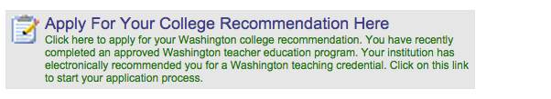

**

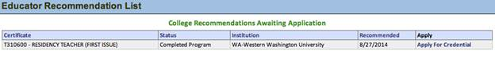

There is more specific guidance on this process and a copy of screen shots in the E-Certification College and University Candidate User Guide, pages 15-27, at: http://www.k12.wa.us/Certification/e-Cert/E-CertificationCollegeCandidateUserGuide.pdf

If you have any difficulty with this procedure, please contact [CustomerSupport@k12.wa.us](mailto:CustomerSupport@k12.wa.us) or 800.725.4311 or 360.725.6400