*Evergreen’s Certification Office (Maggie Foran) has begun the Residency Teacher First Issue recommendation for your certification in the state’s eCert system at* [*https://eds.ospi.k12.wa.us*](https://eds.ospi.k23.wa.us) *and will mark the recommendation as complete the morning of June 10 with your endorsements areas based on your faculty’s and Dr. Naughton’s approval. You do need to have current fingerprints and clearance for the recommendation.*

*You can then go to the eCert website the afternoon of June 10 or later and “Apply for your College Recommendation”.  Do not apply before June 10. You will need to have a credit card and the fee is $74. Your application will be processed, hopefully in the next two weeks. If it important to check the email you use on your eCert account to see if there are any emails from the certification office that need to be answered to clear up any items of confusion that might delay the processing of your certificate. Once your certificate is issued, you may print out a copy from your eCert account.*

*If you would like a Temporary Teacher Certificate Permit, so you can start teaching right away, email Maggie Foran at* [*foranm@evergreen.edu*](mailto:foranm@evergreen.edu) *after you have applied for and paid for credential following the process outlined below and say “please send me a Temp!”  The Certification Office will issue and email you a permit. If time permits, Maggie may scan and upload permits for the whole cohort to your eCert accounts between June 13-15 if she is in town, so school districts can see you have a permit while you are waiting for your official certificate to be processed by OSPI.*

*If you want to apply for the lifetime substitute certificate, please let Maggie know ASAP so she can recommend you for that certificate also. Then apply for the substitute certificate (additional $54). It is strongly recommended you wait to apply for the substitute (not emergency or intern sub) certificate after your residency certificate is processed and issued. If you wait, the process goes very quickly. If you do it at the same time as you apply for your residency certificate, it slows issuing both down.*

*Congratulations on reaching your goal to be a certified teacher!*

***To begin to claim your college recommendation:***

Have your OSPI user name and password, credit card, copy of your transcripts (unofficial is fine), your job history information and the name, address and phone numbers of 3 references available before you start.  You don’t need to upload any of this information but you may need it to complete the application.

Follow these steps:

1.    Log in to your OSPI account at <https://eds.ospi.k12.wa.us/Login.aspx>

2.    Click on “My Applications”

3.    Click on “E-Certification”

4.    From the “Home Page”, choose “Apply for Your College Recommendation Here” *

a.    Click on “Apply for Credential” to the far right **

b.    You’ll be taken through a multi-step wizard.  Complete the information and pay the certification fee to request your certificate

*

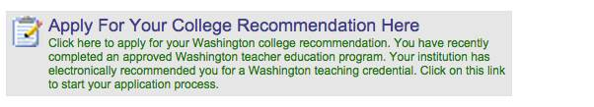

**

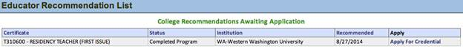

This message and any attachments are intended only for the use of the addressee and may contain information that is confidential. If the reader of the message is not the intended recipient or an authorized representative of the intended recipient, you are hereby notified that any dissemination of this communication is strictly prohibited. If you have received this communication in error, notify the sender immediately by return email and delete the message and any attachments from your system.

If you have any difficulty with this procedure, please contact [CustomerSupport@k12.wa.us](mailto:CustomerSupport@k12.wa.us) or 800.725.4311 or 360.725.6400