To: Maggie Foran, The Evergreen State College

From: Mea Moore, PESB

Subject: Educator Retooling Scholarship for Justine Cantrell

Date: January 12, 2010

Please accept this memo as verification from the Professional Educator Standards Board that we will approve an Educator Retooling scholarship for Justine Cantrell in the amount of $4,312.00. Upon return of Ms. Cantrell’s previous scholarship award and receipt of her new application, the scholarship in the amount above will be sent to Ms. Cantrell.

If you have additional questions, please feel free to contact me.

Best regards,

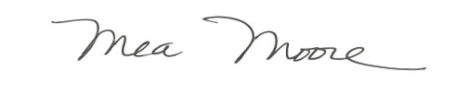

Mea Moore

Coordinator, Educator Programs and Standards

Old Capital Building

600 S. Washington Street

P.O. Box 47236

Olympia, WA 98504

(360) 725-6276

mea.moore@k12.wa.us