State of Washington
PROFESSIONAL EDUCATION PERMIT
Granted in Accordance with Professional Educator Standards Board
NAME
Wayne Olson Stauffer

CERTIFICATE TYPE
Residency Teacher
ENDORSEMENT(S)
added endorsement in: Social Studies
EFFECTIVE DATE EXPIRATION DATE  8/26/13 2/23/14 | 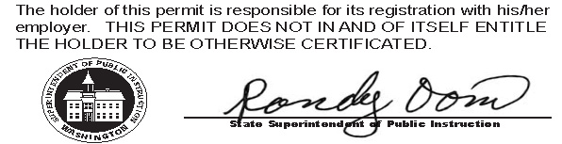
RECOMMENDED BY
The Evergreen State College
AUTHORIZED SIGNATURE
Maggie Foran
Certification officer

. . . . . . . . . . . . . . . . . . . . . . . . . . . . . . . . . . . . . . . . . . . . . . . . . . . . . . . . . . . . . . . . . . . . . . . . . . . . . . . . . . . . . . . . Cut here Cut here Cut here

West-E scores: OSPI has your test results and school districts in Washington State can look up whether you passed. If you need official score reports you will need to request them from the test vendor @ www.west.nesinc.com Your results are listed below for your reference: 271

