State of Washington
PROFESSIONAL EDUCATION PERMIT
Granted in Accordance with Professional Educator Standards Board
NAME
Shawn L Parks
CERTIFICATE TYPE
Continuing Teacher
ENDORSEMENT(S)
added endorsement in: English Language Arts
EFFECTIVE DATE EXPIRATION DATE  12/06/13 6/6/14 | 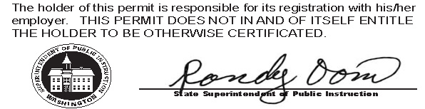
RECOMMENDED BY
The Evergreen State College
AUTHORIZED SIGNATURE
Maggie Foran
Certification officer

. . . . . . . . . . . . . . . . . . . . . . . . . . . . . . . . . . . . . . . . . . . . . . . . . . . . . . . . . . . . . . . . . . . . . . . . . . . . . . . . . . . . . . . . Cut here Cut here Cut here

