State of Washington
PROFESSIONAL EDUCATION PERMIT
Granted in Accordance with Professional Educator Standards Board
NAME
Michael Andrew Crouch
CERTIFICATE TYPE
Intern Substitute Teacher for the classroom of Bob Frey, Puyallup School District
ENDORSMENT(S)
Social Studies
EFFECTIVE DATE EXPIRATION DATE  04/16/14 06/30/14 | 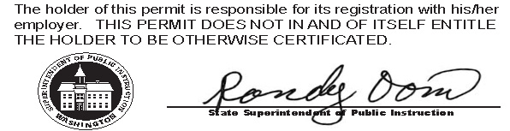
RECOMMENDED BY
The Evergreen State College

AUTHORIZED SIGNATURE
Maggie Foran Certification Officer

. . . . . . . . . . . . . . . . . . . . . . . . . . . . . . . . . . . . . . . . . . . . . . . . . . . . . . . . . . . . . . . . . . . . . . . . . . . . . . . . . . . . . . . . Cut here Cut here Cut here

The above permit may be given to the School District where you are applying for employment.

