State of Washington
PROFESSIONAL EDUCATION PERMIT
Granted in Accordance with Professional Educator Standards Board
NAME
Lynette M. Madsen
CERTIFICATE TYPE
Residency Teacher
ENDORSEMENT(S)
Added endorsement: English Language Arts
EFFECTIVE DATE EXPIRATION DATE  5/18/15 6/18/16 | 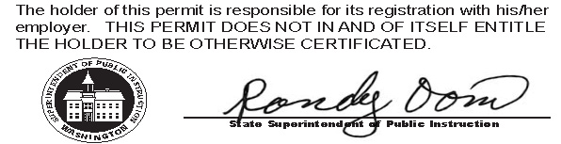
RECOMMENDED BY
The Evergreen State College
AUTHORIZED SIGNATURE
Maggie Foran
Certification officer

. . . . . . . . . . . . . . . . . . . . . . . . . . . . . . . . . . . . . . . . . . . . . . . . . . . . . . . . . . . . . . . . . . . . . . . . . . . . . . . . . . . . . . . . Cut here Cut here Cut here

