State of Washington
PROFESSIONAL EDUCATION PERMIT
Granted in Accordance with Professional Educator Standards Board
NAME
Kathryn M Govan
CERTIFICATE TYPE
Residency Teacher (First Issue)
ENDORSMENT(S)
Designated Arts: Visual Arts
EFFECTIVE DATE EXPIRATION DATE  06/15/2015 06/15/2016 | 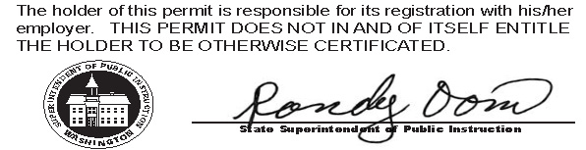
RECOMMENDED BY
The Evergreen State College
AUTHORIZED SIGNATURE
Maggie Foran
Certification officer

. . . . . . . . . . . . . . . . . . . . . . . . . . . . . . . . . . . . . . . . . . . . . . . . . . . . . . . . . . . . . . . . . . . . . . . . . . . . . . . . . . . . . . . . Cut here Cut here Cut here

The above permit may be given to the School District where you are applying for employment.

Please read the important information below:
Residency Teacher Certification: The Certification Office will recommend you to the Washington State Office of Superintendent of Public Instruction (OSPI) for a Residency Teacher Certificate (first issue) when:
- All program requirements are verified as completed
- All character and fitness clearances through OSPI are valid
- Baccalaureate degree has been transcribed
You will be contacted by email by the Evergreen’s certification officer when your certificate arrives from OSPI to see if you want to pick it up or have it mailed to your permanent address.
Your Residency Teacher Certification (First Issue) is valid until you are reported by a WA school district as having completing 1.5 full-time equivalent (FTE) years of contracted teaching experience accumulated over a minimum of two years. You will then be directed by your school district to apply for a Residency Certificate valid for an additional 3 years. To keep your certificate valid beyond the expiration date you must earn a Professional Teacher Certificate. A two year extension is available to those who have started but not completed the required portfolio process.
Fingerprint clearance: Your fingerprint status is posted to the OSPI certification database which is accessible to WA school districts.

West-E scores: OSPI has your test results and school districts in Washington State can look up whether you passed. If you need official score reports you will need to request them from the test vendor @ www.west.nesinc.com

