State of Washington
PROFESSIONAL EDUCATION PERMIT
Granted in Accordance with Professional Educator Standards Board
NAME
Catalina Jeanne Kenevan
CERTIFICATE TYPE
Substitute Teacher #435041R
ENDORSEMENT(S)
Social Studies; History
EFFECTIVE DATE EXPIRATION DATE  6/24/14 12/20/14 | 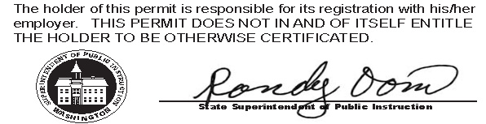
RECOMMENDED BY
The Evergreen State College
AUTHORIZED SIGNATURE
Maggie Foran
Certification officer

. . . . . . . . . . . . . . . . . . . . . . . . . . . . . . . . . . . . . . . . . . . . . . . . . . . . . . . . . . . . . . . . . . . . . . . . . . . . . . . . . . . . . . . . Cut here Cut here Cut here

