State of Washington
PROFESSIONAL EDUCATION PERMIT
Granted in Accordance with Professional Educator Standards Board
NAME
Kelly L Lovall-Jones
CERTIFICATE TYPE
Residency Teacher First Issue
ENDORSEMENT(S)
English Language Arts; Designated Arts: Theatre Arts
EFFECTIVE DATE EXPIRATION DATE  11/16/14 5/14/15 | 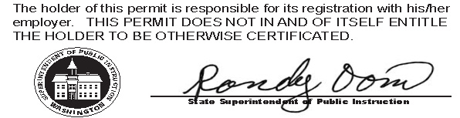
RECOMMENDED BY
The Evergreen State College
AUTHORIZED SIGNATURE
Maggie Foran
Certification officer

. . . . . . . . . . . . . . . . . . . . . . . . . . . . . . . . . . . . . . . . . . . . . . . . . . . . . . . . . . . . . . . . . . . . . . . . . . . . . . . . . . . . . . . . Cut here Cut here Cut here

