State of Washington
PROFESSIONAL EDUCATION PERMIT
Granted in Accordance with Professional Educator Standards Board
NAME
Elizabeth Kirkham Gordon
CERTIFICATE TYPE
Residency Teacher
ENDORSEMENT(S)
added endorsement in: Middle Level Humanities
EFFECTIVE DATE EXPIRATION DATE  6/23/14 12/19/14 | 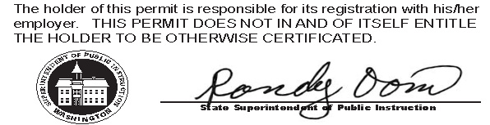
RECOMMENDED BY
The Evergreen State College
AUTHORIZED SIGNATURE
Maggie Foran
Certification officer

. . . . . . . . . . . . . . . . . . . . . . . . . . . . . . . . . . . . . . . . . . . . . . . . . . . . . . . . . . . . . . . . . . . . . . . . . . . . . . . . . . . . . . . . Cut here Cut here Cut here

