State of Washington
PROFESSIONAL EDUCATION PERMIT
Granted in Accordance with Professional Educator Standards Board
NAME
Melissa Ann Gilliam
CERTIFICATE TYPE
Substitute Teacher
ENDORSEMENT(S)

EFFECTIVE DATE EXPIRATION DATE  6/14/13 12/10/13 | 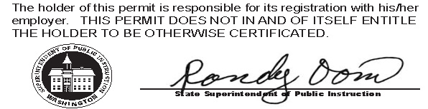
RECOMMENDED BY
The Evergreen State College
AUTHORIZED SIGNATURE
Maggie Foran
Certification officer

. . . . . . . . . . . . . . . . . . . . . . . . . . . . . . . . . . . . . . . . . . . . . . . . . . . . . . . . . . . . . . . . . . . . . . . . . . . . . . . . . . . . . . . . Cut here Cut here Cut here

The above permit may be given to the School District where you are applying for employment.

Please read the important information below:
Residency Teacher Certification: The Certification Office will recommend you to the Washington State Office of Superintendent of Public Instruction (OSPI) for a Residency Teacher Certificate (first issue) on graduation day. All education permits have a standard 180 day expiration period, and during that time your official certificate with certification number should be returned to Evergreen (generally within 2-4 weeks). At that time you will be notified by email to indicate your preference on whether to come pick up the certificate or have it mailed to you.

Your Residency Teacher Certification (First Issue) is valid until you are reported by a WA school district as having completing 1.5 full-time equivalent (FTE) years of contracted teaching experience accumulated over a minimum of two years. You will then be directed by your school district to apply for a Residency Certificate valid for an additional 3 years. To keep your certificate valid beyond the expiration date you must earn a Professional Teacher Certificate. A two year extension is available to those who have started but not completed the required portfolio process.
Fingerprint clearance: Your fingerprint status is posted to the OSPI certification database which is accessible to WA school districts. Evergreen cannot provide this information to school districts.

