State of Washington
PROFESSIONAL EDUCATION PERMIT
Granted in Accordance with Professional Educator Standards Board
NAME Rachele Rose Chertok

CERTIFICATE TYPE
Residency Teacher (First Issue)
ENDORSEMENT(S)
Addition: Special Education
EFFECTIVE DATE EXPIRATION DATE  7/31/13 1/26/14 | 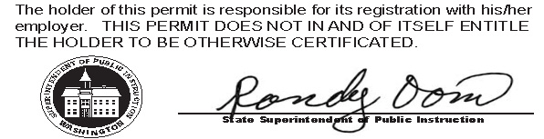
RECOMMENDED BY
The Evergreen State College
AUTHORIZED SIGNATURE
Maggie Foran
Certification officer

. . . . . . . . . . . . . . . . . . . . . . . . . . . . . . . . . . . . . . . . . . . . . . . . . . . . . . . . . . . . . . . . . . . . . . . . . . . . . . . . . . . . . . . . Cut here Cut here Cut here

The above permit may be given to the School District where you are applying for employment.

