State of Washington
PROFESSIONAL EDUCATION PERMIT
Granted in Accordance with Professional Educator Standards Board
NAME
David B. Cauthers
CERTIFICATE TYPE
Initial Teacher Renewal
ENDORSEMENT(S)
Added endorsement: English Language Arts
EFFECTIVE DATE EXPIRATION DATE  4/1/15 6/30/15 | 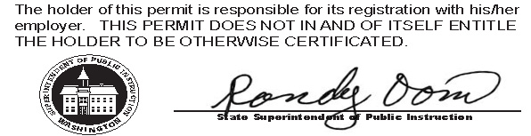
RECOMMENDED BY
The Evergreen State College
AUTHORIZED SIGNATURE
Maggie Foran
Certification officer

. . . . . . . . . . . . . . . . . . . . . . . . . . . . . . . . . . . . . . . . . . . . . . . . . . . . . . . . . . . . . . . . . . . . . . . . . . . . . . . . . . . . . . . . Cut here Cut here Cut here

