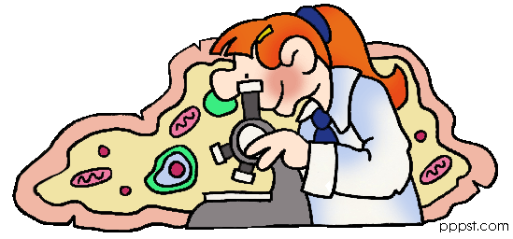
This week in Middle School Science…
…Week 11, Wednesday, December 15, 2010

Topic:
Variables & Natural Selection

Learning goals:
At the end of today’s class you will be able to…
… explain the importance of variations in organisms.
… relate how gradualism and punctuated equilibrium describe the rate of evolution.
… determine which variables should be kept the same, which variable should be changed, and which variable is to be measured and recorded.
… report any variables not controlled and explain how they might affect results

Agenda:
- Opening Activity – Hypothesis review activity
- Character Trait – Self Control
- Scientific Method -
- Notes: Variables
- Practice – Identifying Variables & Controls worksheet #1 - 15
After Lunch
- Survival of the Beaks
  - Extreme Beaks Intro PP
  - Survival of the Beaks - Lab
- Assessment – Identifying Variables & Controls worksheet #16 - 19

Homework:

- Study Guides 6.3 and 6.4 Due on January 5, 2011
- Sponge Bob Variables and Controls #1 Due on January 5, 2011
- Complete all missing assignments. Last day to turn in missing work is January 5, 2011

