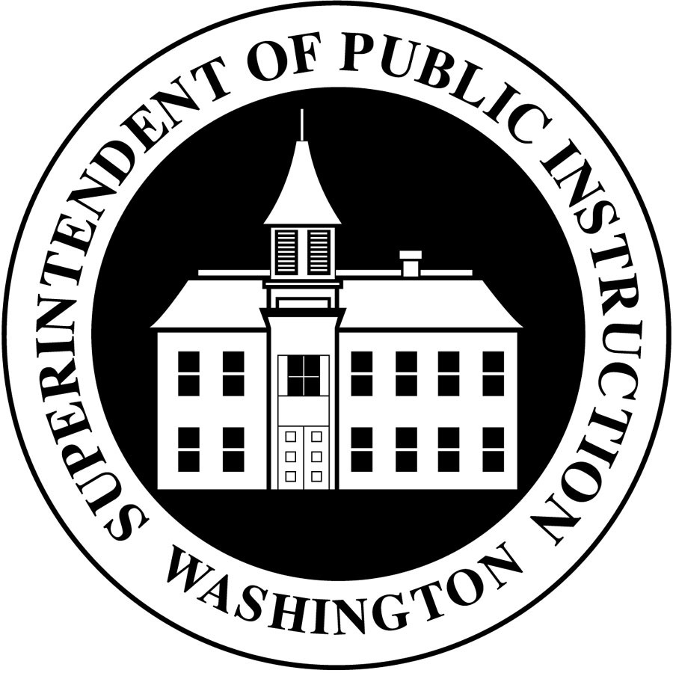

STANDARD I: PROFESSIONAL EDUCATION ADVISORY BOARD-PROFESSIONAL CERTIFICATION FOR TEACHERS Building on the mission to prepare educators who demonstrate a positive impact on student learning based on the Improvement of Student Achievement Act of 1993 (HB 1209), the following evidence shall be evaluated to determine whether each Professional Certificate program is in compliance with the program approval standards of WAC 181-78A- 515 (1) Professional Education Advisory Boards.

STANDARD I – PROFESSIONAL EDUCATION ADVISORY BOARD (PEAB)
 | Unmet |  | Met |  | Exemplary  In addition to met standard, the following are examples of exemplary performance/practice:
(1) | The PEAB established for the pre-service program does not serve as the advisory board for the Professional Certificate program. |  | The PEAB established for the pre-service program serves as the advisory board for the Professional Certificate program.
(2) | The PEAB has not participated in the development of the Professional Certificate program and/or did not recommend approval of the program by the State Board of Education. |  | The PEAB has participated in the development of the Professional Certificate program and has recommended approval of the program by the State Board of Education.
(3) | The PEAB has not reviewed the annual summary on the status of all candidates in the program required by WAC 180-78A-525(7). |  | The PEAB has reviewed the annual summary on the status of all candidates in the program required by WAC 180-78A-525(7).
(4) | The PEAB has not made recommendation(s), as appropriate, for program changes to the Professional Certificate administrator. |  | The PEAB has made recommendation(s), as appropriate, for program changes to the Professional Certificate administrator.
(5) | The Professional Certificate Administrator has not implemented or responded to the recommendation(s) made by the PEAB in a timely manner. |  | The Professional Certificate Administrator has implemented or responded to the recommendation(s) made by the PEAB in a timely manner.

