**MPA Program Assistant Duties (mostly)**

**Opening the Office—**On the way up or shortly after you get here check the MPA mailboxes down in the program secretaries’ office on first floor for mail and bring up to distribute. Check to see if our reception area’s plants need water. Also please check the plant in Mike’s office to see if it is thirsty. Another housekeeping chore is to refill the paper towels in the grad lounge area. The towels are located in the Science Store on the 2nd floor. Tell them it’s for the 2 sinks in the lounge and fishbowl. You and the MES office assistant also keep the calendar for the fishbowl meeting room at the end of the hall. The calendar is located in the O drive under MES.

**Radius Brochures—**another nearly daily job is to check Radius to see who has requested an MPA brochure. You will use the big envelopes in the box under the right side of the desk to mail them out. There is mail pick-up in the secretaries’ office down on first floor. You also staple an assistant’s business card on the brochure—Puanani’s for Tacoma or Tribal requests and Anna’s on the others.

**Orientation—(**2 beginning this year, one here on campus and one in Tacoma). The room has been reserved this year but in coming years reserve early as spaces big enough for it go fast in the fall. This year you are in 4300 in the Library. The last 2 years were in Purce Hall in the big classrooms. Food needs to be ordered (probably through Aramark the campus food service for Olympia and yet to be determined in Tacoma) as lunch is served to the new students, faculty and staff. It is important to stay within a budget and have something easy to pick up. The last 2 years we used the sandwich buffet that came with platters of meat, cheese and veggies and assorted breads and 2 large salads of your choice, cookies and water. Keep in mind the vegan and gluten free people. Ahead of times name tags need to be printed out for the students. The last several years we use the simple stick on ones instead of the string around the neck variety. The sticky ones are arranged alphabetically on a table for easy pick up. The ones left let you know who isn’t there so you don’t have to have the students sign in. You will get there early to help set up the room.

**Space Scheduling—**You no longer have to reserve classroom space for the faculty as they do that themselves, but you do need to have a list of the adjuncts teaching classes and the dates of those classes to give to Tricia Bateman who puts them in the system for the adjuncts. You will schedule space for meetings, orientation, and other events that aren’t classes. The scheduling is done through MyEvergreen under Schedule Evergreen.

**Creating the class schedules for online Catalog and other Adminweb uses—**The director will give you a list of the new classes and instructors and it is your job to put them into admin web under Graduate Programs Curriculum. Making changes later is done under Graduate Programs Manage Curriculum. If you are not familiar with Adminweb, you will be trained. Professors and adjuncts will supply you with course description paragraphs that you will insert before each quarter begins. Start asking for the descriptions week 2 or 3 before the next quarter begins. Usually several requests have to go out…On week 5 or 6 you need to request the syllabi for the classes which you will post on the Syllabi page on the MPA website. There are several done for fall quarter but as soon as you get here in August, request the missing ones.

Admin web is also used to look up class counts as students register and class lists and email addresses of students in each class. There is a white notebook of class enrollments in the director’s office that you will update with the new enrollment numbers after a quarter is up and running.

**Business Cards and Name Tag Ordering—**This is now done through Administration & Business under Staff and Faculty on the Evergreen web page. An account needs to be made before you can place an order. The MPA budget # 25201 to pay for the order.

**Change Registration Page on the MPA Website & Special Student Registration—**After the quarter is underway, you need to go into the CMS, <https://www.evergreen.edu/admin/workbench> go to registration and update the dates. The instructions can be left pretty much the same.

Special Student registration begins a week before the quarter starts and gives a chance for unadmitted students to try out a class and also helps fill the classes up. A win-win. Your job is to keep looking at the enrollment #s (on dashboard of manage curriculum on adminweb) to let students know which classes have room. If they find a class they want, you email registration letting them know that the student has MPA permission to register. The registration page gives this information.

**Keep Track of Students who finish stats—**Admitted students are required to have a current (within 3 years) stats class. If they don’t at the time of admittance, they need proof of finishing before September 15. You will receive either hard copy transcripts or emailed transcripts. The hard copy ones you open, copy and make note of on our stats excel sheet and then send to the graduate office to Amanda Mobbs. Make a note on the envelope of the transcript that it was opened by MPA and is still official. The emailed transcripts you also make note of on the excel spreadsheet and then forward the email to Amanda Mobbs and either Anna or Puanani depending on which cohort the student as been admitted to.

**Meal and Light Refreshment Form—**This form must be filled out ahead of any food order, signed by the director and then put in Michelle Bartlett’s red folder in her mailbox in the program secretaries’ office or handed to Michelle who will take it to the financial people to be OKed.

**Files—**There are 3 file drawers you are in charge of. In the cabinet next to the door, the middle drawer are folders of Tribal Cohort students who have graduated since 2012. The bottom drawer are PNAPP students who have graduated since 2012. The 3rd drawer are students currently enrolled. That drawer is the big upper drawer to the left of the window. You will need to make new folders for each of the new students. Ask Puanani if she wants her new Tacoma students in the same drawer or if she prefers to have them in her office.

**End of the Year Survey—**we have used various methods to do this, but currently the end of the year survey is on Word Press. You will need to update it, mostly by changing dates in it before it is sent out.

**Hooding Ceremony—**Preparation for the hooding ceremony begins months in advance. You will have several jobs -- producing a program is an important one. This year programs were done in house instead of being sent to Tumwater Printers which did in the past. You will purchase special paper (bottom drawer in metal filing cabinet has the remains of this year’s. I bought it at Office Max in Lacey). The programs from years past are in the o drive to use as templates and one program from each year I’ve been here are in the bottom drawer to the right of the computer. Getting the names of the grads who want to be included in it is probably the most frustrating part. Our copy center on campus did the printing and folding. We printed 400 this year.

We do serve light refreshments after the ceremony. The food used to be catered by Aramark, but this year due to new rules we actually bought food at Costco and had to set it up and clean it up. In the cupboards in the grad lounge, there are platters and tongs that we purchased to use for the hooding ceremony. You will also need to make name cards to put alphabetically on each graduate’s chair and keep track of which of their guests need special seating that require more name card markers.

We have used regalia that we let students use so they don’t have to buy it. Early spring quarter let it be known that there are hoods, gowns and caps to borrow. Keep a list of who wants what and have them come in to pick up and try on. The ones returned so far are in the bottom drawer under current student files. You will probably get more back as the summer goes on.

**Make Quarterly Course Schedule Sheet—**Use past ones as a template—in the O-drive under schedule and course info and schedule. It is a handy tool for you to use and I think the assistant directors like them too:

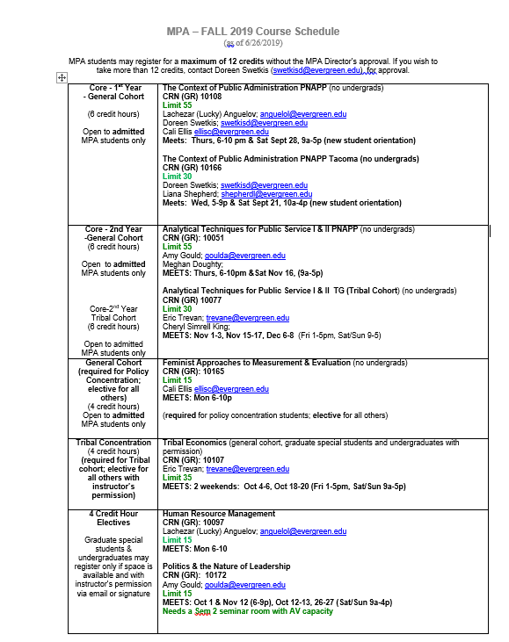

**Make Certificates—**for thank you or recognition sometimes you are requested to make a certificate. I will put the frame and wording we sometimes use in the o-drive under MPA and then pictures. Use special paper—some in the bottom file drawer at your left, OR the paper left over from the programs in the bottom drawer of the metal filing cabinet.

**Finally**--You have great people to work with here so I know they will help you get settled and learn the ins and outs of the job. I live close by and am willing to answer questions or come over and walk you through stuff. I will be around even if you don’t call me! Phone 206-235-2460. Email: fenwickthecat@yahoo.com