**MPA Curriculum Meeting 01.16.20**

Present: Mike Craw, Anna Rhoads, Eric Trevan, Amy Gould, Doreen Swetkis, Cali Ellis, Lucky Anguelov, Meghan Doughty, Puanani Nihoa, Cheryl Simrell-King, Yoichiro Tsuzuki, Dhara Katz (note taker), and Mike Fraidenburg (facilitator, DRC).

**Homework from Last Curriculum Meeting:**

* In groups or individually, discuss and summarize pros and cons of cohort model B, i.e. the 4 core + 2 concentration model, to bring to next meeting
  + 1. What do we mean by a model?
    2. Which values are you trying to achieve?
    3. What does implementation look like?
    4. Each workgroup come prepared with its proposal visually illustrated in some way on flip chart paper

**Presentations from Each Workgroup (see photos and addendums):**

1. **Meghan and Amy**
   1. 4 Credit Core & 2 Concentration Courses-each faculty would teach a 4 credit core and a 4 credit elective; retains current cohort structure. A full-time student on a 2-year track would take 4 hours in core and 6 credit hours in electives each quarter.
      1. Note: in the last decade we’ve begin offering many more weekend classes, 2 credit offerings and ILCs
   2. Model follows a caucus mentality; creating a comfortable space for each cohort to do their best work in addition to providing more opportunities for cohorts to mingle in class and in electives
   3. Crucial to have hybrid learning environments
   4. Unity across instruction hours across the curriculum; cohesion in naming courses to provide more clarity for students
   5. Separate out capstone as a 2nd year class,

*Values: Social equity, rigor, outstanding alternative education, student empowerment, practitioner focus, cohesive and consistent curriculum, recruitment, retention.*

1. **Doreen, Puanani and Anna**
   1. 4 Core + 4 Concentration; first year is scripted (36 hours); keep concentrations; maintain Tacoma and Tribal cohorts; 3 concentrations instead of 2 (Tribal Governance, Public Policy, and Public and Nonprofit Administration); 24-hour core, 12-hour concentrations, and 24 hours in electives
   2. Tribal Governance has some curriculum choice, which they don’t currently have
   3. Path to Sovereignty be required for all students to take as part of the concentration requirement

*Values: Equity, rigor, student choice, student centered, simplicity, cohesive and consistent curriculum, recruitment, retention, provides an easy model to sell to students.*

1. **Cali and Lucky**
   1. Core: 48 Core Credits out of 60;
   2. PNAPP Core would meet on Tuesdays and Thursdays would offer core skills in different areas of reasoning with a different set of 2 person teaching teams on Tuesdays and Thursdays; no electives offered in first year
   3. No concentrations because core would be expanded
   4. Operating off of model 64 seat hours = 8 credits
   5. Focus on integrating methods throughout the core curriculum (e.g Tuesday night theory, Thursday night quantitative/data).
      1. Note: With a graduate assistant, instructors can do more than a 15:1 student ratio
      2. Note Resident and non-resident students will pay the same amount above 10 credits
      3. Example of reasoning skills students need: getting data from the website, putting into Excel and talking about it in front of a group

*Values: Options, flexibility, meeting the learning needs of students, meeting the expectations of employers, provide a fair and equitable teaching load for faculty in line with peer programs and   
our CBA.*

1. **Eric**
   1. Change 6 credit core into a 4 credit core class; 12 hours in cohort-specific courses (2 credit hours in each quarter); and 12 hours in a concentration (which is not exclusive to cohort)
   2. Remove cohort-specific labels from core classes; pick a certain time that the cohort would have exclusive time together; required cohort courses would define the cohort
   3. Flexible Core: cohorts based on buckets of electives; flexibility around student’s work schedules
   4. Flexibility about which campus faculty teach on
   5. Some Native American content in all of the cohorts (Path to Sovereignty or a similar course required of all students); have Tribal Governance classes with other concentrations
   6. Consistent core would be taught the same so there would be a meta-teaching team for core

*Values: Equity, meeting student demand, flexibility, relevant, rigor, whole program to have more time together, reduce student barriers, generate more funds for the college.*

**Q&A and Discussion of Presentations:**

General consensus to either eliminate or change the current statistics pre-requisite. If changed, the requirement could be broadened to allow research design and methods, philosophy of science, or indigenous research methods to fulfill the requirement (students could state what they’ve taken that would count towards our requirements in their application.) This would help with recruitment and it would require research methods to be embedded within MPA to ensure that students leave the program with those skills and that they show up on their transcript.

Idea to integrate policy analysis into the Analytic Techniques sequence. Important to continually find ways to be relevant to students with regards to their careers and advocacy interests.

We need to create more flow between first-year Core and second-year Core to help students adapt to the change in the program.

We should stay competitive with other MPA programs that are beginning to offer more and more certificates.

Let’s not forget that we’re creating agents of transformational change that are asking the bigger questions and that’s what makes our program “special.”

**Next Steps:**

Use the models presented today and the resulting discussion to synthesize and develop two new models to consider at our next meeting: 2 teams/2 proposals that include a student planning worksheet.

Team members are:

a. Puanani, Lucky, Amy, Doreen, Mike

b. Anna, Cali, Meghan, Eric, Mike, Cheryl

*Next MPA Curriculum Meeting: February 20th, Thursday 11:00am-1:00pm in Lab I – 3033*

Homework presentations

Team 1: Amy and Meghan

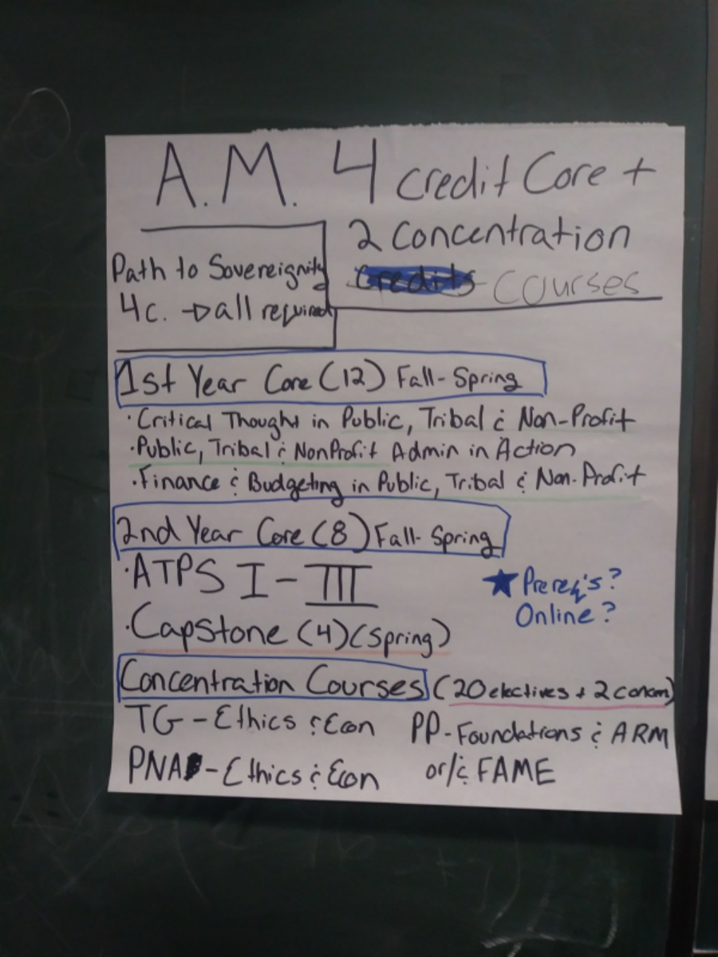

Team 2: Anna, Doreen, and Puanani

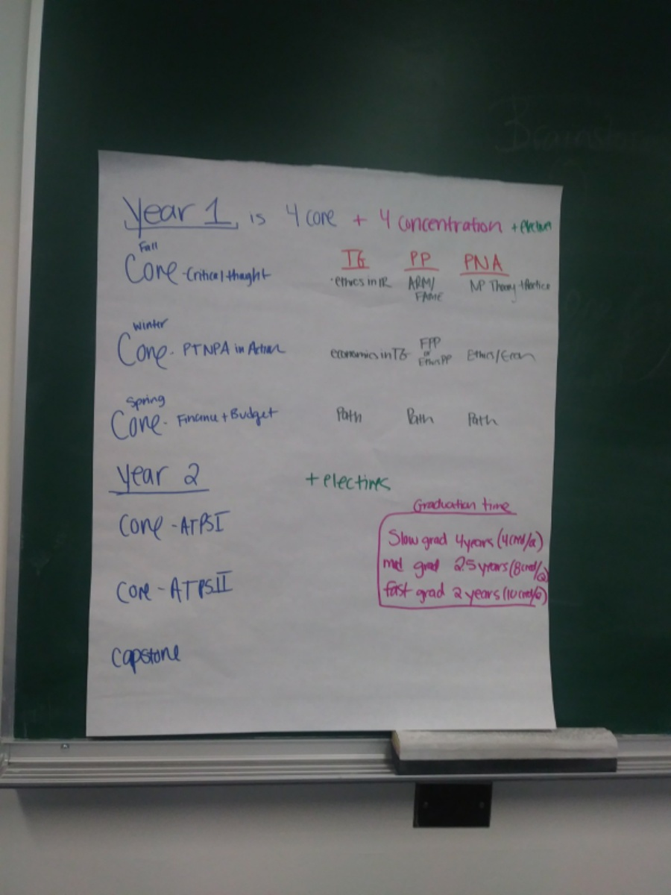

Team 3: Cali and Lucky

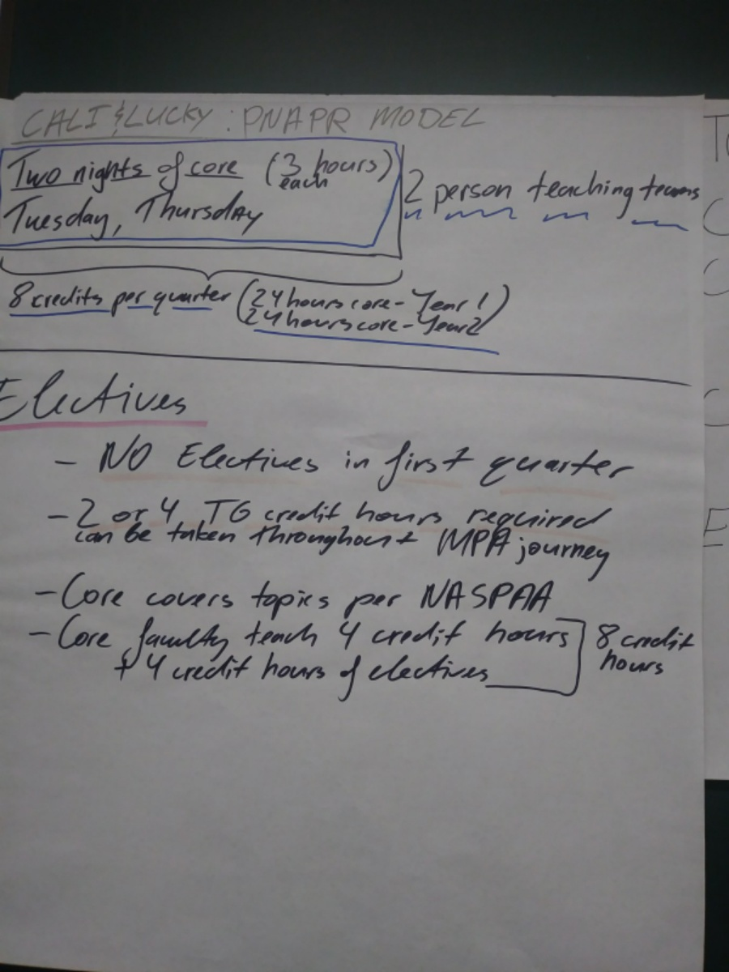

Team 4: Eric

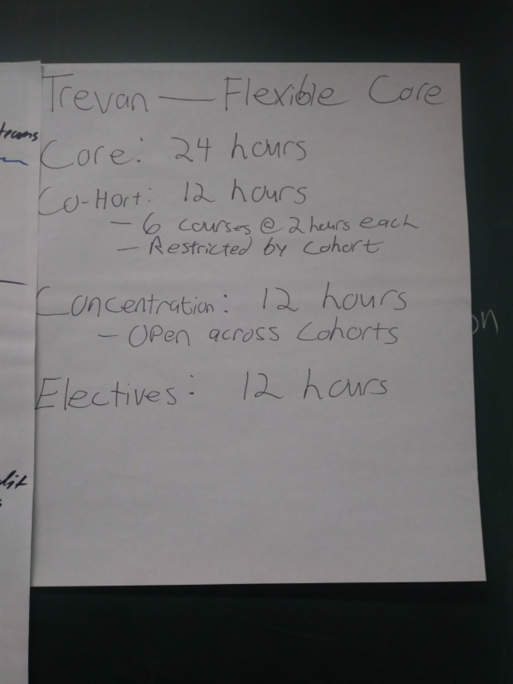

Appendix: Proposals