**MPA Curriculum Facilitated Meeting 11.12.19**

Present: Mike Craw, Anna Rhoads, Eric Trevan, Cheryl King-Simrell, Amy Gould, Doreen Swetkis, Yoichiro Tsuzuki, Cali Ellis, Lucky Anguelov, Dhara Katz (note taker), Lesli Dalaba (observer, Dispute Resolution Center-DRC) and Mike Fraidenburg (facilitator, DRC).

**Discussion of Meeting Goals:**

* Options presented by Facilitator
  + Get clear on and rank-order goals for curriculum review
  + Evaluate and choose between three curriculum models currently on the table
  + Flesh out these three models further and choose one model at the next meeting
* Options presented by MPA Group
  + Rank our goals and then do a pros and cons analysis
* Final decision for this meeting
  + Vote on goals and then consider preliminary models

**Rank-ordering Goals for Curriculum Review:**

Mike Fraidenburg, asked in an email before the meeting that each MPA member come to the meeting with their shortlist of (2-4) goals “that might be good candidates for improving the MPA Program.” Each participating member of the MPA then taped these goals on the board. The facilitator asked that a few of the MPA participants rearrange the goals on the board according to categories. Below are the resulting categories and goals (in their final rank-ordering):

1. **Student Centered Goals**
   1. Have consistent and predictable course offerings in both sites covering major topics
   2. Improve program access
   3. Student/human centered design of curriculum
2. **Equity (Meta)**
   1. Equity in class hours concentrations competency
3. **Core Goals**
   1. Fix core – students are not happy
   2. Clarifying the content and purpose of core so that it remains consistent between cohorts
4. **Concentration Goals**
5. Have separate non-profit concentration (Tacoma?)
6. Fix concentration requirements-inequitable
7. Develop a local regional governance concentration (longer term)
8. Increase flexibility of choice for Tribal Governance students
9. Better fit coursework to concentrations +2 elective development
10. 2 Courses per concentration – what are they?
11. Equity between concentrations
12. Revise Curriculum: core and electives

1. **Faculty Centered Goals**
   1. Workload for graduate programs
   2. Ensure MPA faculty teach a workload consistent with the CBA
2. **Planning (Meta)**
   1. 2019 NASPAA Accreditation standards: Universal Required Competencies
      1. To lead and manage in the public interest
      2. To participate in, and contribute to, the policy process; to analyze, synthesize, think critically, solve problems and make evidence-informed decisions in a complex and dynamic environment;
      3. To articulate, apply and advance a public service perspective;
      4. To communicate and interact productively and in culturally responsive ways with a divers and changing workforce
   2. 2 year strategic plan

7. **Community Goals**

1. Relevant-align classes/governance/community
2. MPA=Local+State+Federal+Tribal=Government

The facilitator then suggested that each MPA member put 4 green dots on their top goals. They were told that they could put more than one dot on a goal. The dot voting method produced the below results (listed in ranked order):

1. Student Centered Goals - (8 dots)

2. Equity (Metta) - (7 dots)

3. Core Goals- (7 dots)

4. Concentration Goals- (6 dots)

5. Faculty Centered Goals - (4 dots)

6. Planning (Metta) - (3 dots)

7. Community Goals- (1 dot)

**Evaluating Preliminary Curriculum Proposals:**

A chart was then created from the top four goals applied to the three curriculum models *however after further group discussion, a fourth curriculum model, an 8 credit model, was added.* Then MPA participating staff (two MPA members abstained) wrote a number in each corresponding box (number 1-5 with 5 representing highest priority).   
The final chart looked like this:

|  |  |  |  |  |  |
| --- | --- | --- | --- | --- | --- |
|  | Student Centered | Equity | Core | Concentration | **Total** |
| Model 1 * (4 -Credit) | 39 | 39 | 34 | 39 | 151 |
| Model 2 ** (4+2 Credit) | 35 | 30 | 34 | 35 | 134 |
| Model 3***  (6 Credit) | 27 | 18 | 14 | 22 | 81 |
| Model 4 **** (8 Credit) | 16 | 15 | 17 | 25 | 73 |
| **Total** | 117 | 102 | 99 | 121 |  |

*Note: after consideration of the numbers written in chalk on the board that were very difficult to read, the note taker arrived at the above figures that differ slightly from the totals written on the chalkboard during the meeting. If you would like a photo of the table as it appeared on the chalkboard, please contact me at* [*dhara.katz@evergreen.edu*](mailto:dhara.katz@evergreen.edu)*.*

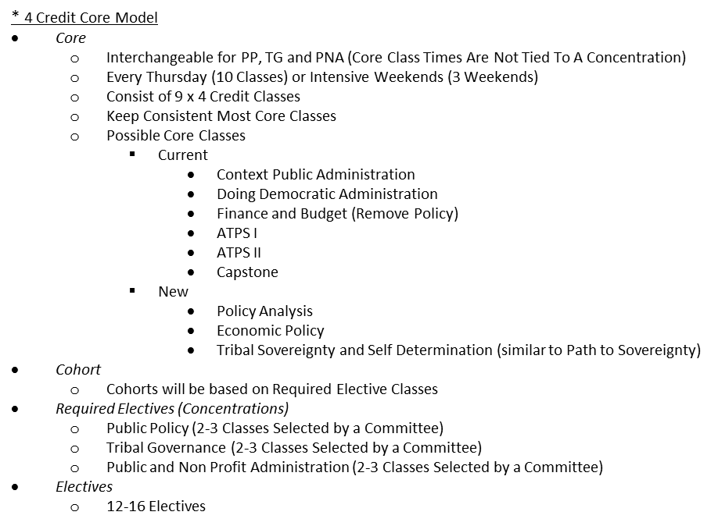

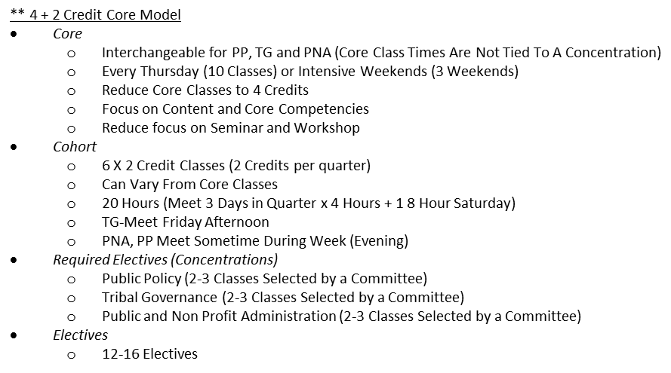

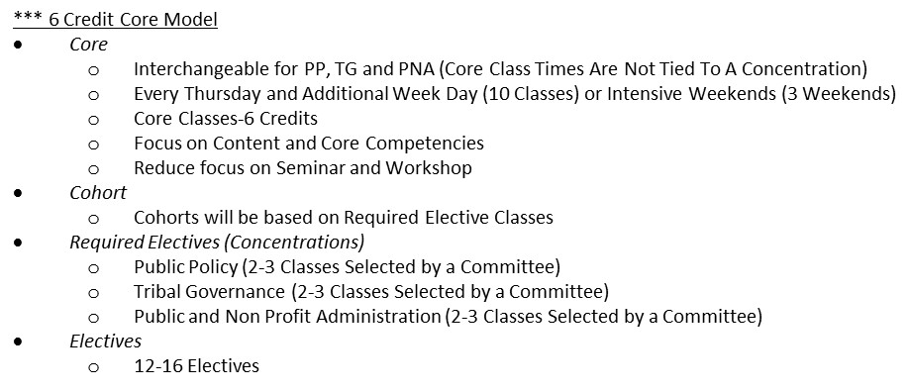

**** 8 Credit Core Model

* Y1 Core at 8 credits, 2 nights of 4 hours each/Year 1 Core (all 3 quarters):

|  |  |  |  |  |
| --- | --- | --- | --- | --- |
| Mon | Tues | Wed | Thurs | Fri |
| Elective | Core (4) | Elective | Core (4) | 0 |

* Year 2 Core (Fall only):

|  |  |  |  |  |
| --- | --- | --- | --- | --- |
| Mon | Tues | Wed | Thurs | Fri |
| Elective | Core (4) | Elective | Core (4) | 0 |

* If we were to adopt this model for MPA:
  + Students would have 28 core credits completed by the end of Y1 (32 remaining for electives – 8 concentration electives = 24 other electives)
  + Students would have 36 core credits completed by the end of Y2 (24 remaining for electives – 8 concentration electives = 16 other electives)
  + Core faculty would be required to teach two evenings during the week at 4 hours each (per quarter)
  + Year 1 Core faculty would not have any electives at all, unless they rotate out of core for one quarter (and would then teach 8 credits of electives in that quarter)
  + Year 2 Core Faculty would not have any electives in Fall only (and would teach 8 credits of electives in winter and spring)

**Next Steps:**

1. Models
2. Goals

* Intent to broaden experiential base by sitting in on MPA program classes to become more familiar with classes other than those that each Faculty member is teaching
* **Important parked discussion is the configuration of core**

*Next MPA Curriculum Meeting: December 3rd, Tuesday 11am-12:30pm in Lab I - 3033*