EMPLOYERS
(n=27)

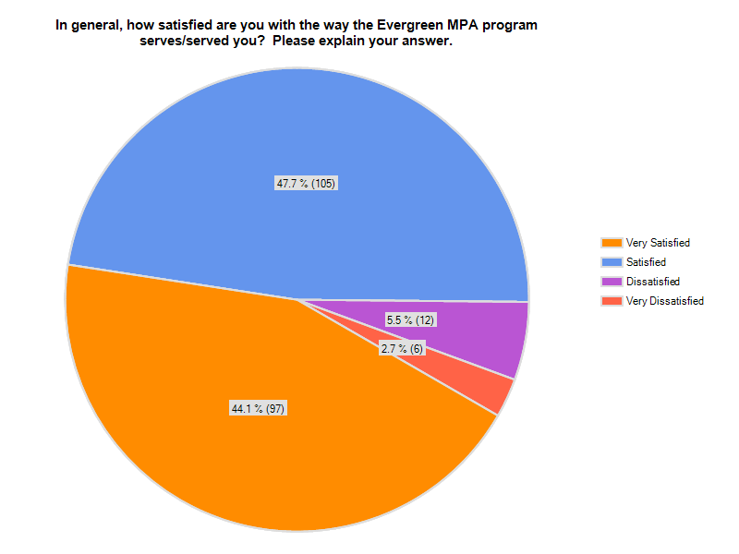
What knowledge, skills and abilities do interns/alumni bring to your organization? (n=26)

Financial systems and ability to review corporate documents, how businesses work, reporting systems, legislature processes

Characterize how to work with the Native American populationl. Awareness of where Native Americans came from and where we are proceeding by receiving our education.

systems-thinking, people skills

Good writing and critical thinking skills.

So far, most of the students I've had as interns have been in the early stages of the program, so they're bringing a strong professional work ethic and eagerness to learn, but not necessarily strong skills in non-profits yet.

They seem to have a hightened awareness of the community and how it can be utilized to shape government.

Ability to think broadly about public policy issues; critical thinking skills

The main strength of my Evergreen MPA alum has been a commitment to inclusiveness. They are eager to invite many parties to the table when decision making is made.

They tend to start with a working and practical knowledge that sets them apart from some other programs, very impressive! We need to do less training and supervision overall!

Dedication, intelligence, writing ability, ability to get along with other staff

Ability to collaborate with others, and share ideas.

insight & connections to community & resources within

I've only dealth with one, but that individual's analytical and process improvement abilities were enhanced by the Evergreen MPA.

Great skills researching topics of significance to the organization.

understand organizational leadership

Organizational skills, data collection and analysis, stakeholder facilitation and great research skills.

Critical thinking and a willingness to approach complex problems and invent creative ways to address them. Respect for diverse opinions and experiences. Ability to contribute to a team effort.

Not sure

Critical thinking, effective communicator, analytical skills, adaptablility, and adept at research.

Good research skills, healthy curiousity, and interest in doing quality work.

Background in research, critical thinking skills and excellent customer relations/communication skills

Thinkers, problem solvers able to self-start and figure things out. Able to add to solutions

Outcomes/mission focus Teamwork and team forming skills Even disposition;not easily flustered Good communicator Demonstrates patience with others

good people and problem-solving skills, confidence in tackling new subject matter

Broader perspective of non-profit management, a sense of how to find resources, start a project unfamiliar to them, strategic thinking, baseline of skills, including budget management and grantwriting.

our Evergreen MPA bring the ability to tackle projects that require a lot of background investigation to gain proficiency.

Any Special KSAs? (n=24)

public policy, policy analysis, financial systems and corporation analysis

Students inegrate their know of Native Americans plight and how the struggle continues to educate the next generation. Perseverance, attitudes of warriors, not in the sense of fighting, but continuing due dillegence in the arena of improving our lives.

Hard to answer. Not sure what you are asking.

Many of them have been strong researchers and editors when working on grants, not all have had the skills to work on grants independently, even after having taken the grants course. Some though have excelled in this area. All have had great attention to detail and good project management skills.

public policy

public policy, research

public policy, research and policy analysis

Research and policy analysis seem especially good.

Public policy, human rights, public administration, policy analysis

staff who are extremely dedicated to the personal/professional missions

The Evergreen MPA grad's wholistic approach to policy analysis is worthy of note.

Research and policy analysis; attention to issues of disparate populations, public policy

Evergreen MPA program provides for a broad understanding of policy at the senior level.

Education policy and program research skills and strong abilities to present data to make case for programs.

What stands out when comparing Evergreen MPA alumni to other employees is a desire to understand the deeper context of an issue or problem, rather than simply find a quick surface-level solution and move on to the next task. Also, there is a tolerance for difficult, messy issues and an intellectual and personal interest in helping to address them. I can count on the fact that these students and alumni have experience working with others.

Policy

Public policy and policy analysis.

Public policy and public sector budget skills...or at least aptitude.

research and policy analysis

research and policy analysis

Works well in collaboration with non profit partners

public policy, research and policy analysis, program development, program evaluation

Non profit management

research and policy, program and procedure development and implementation

In your experience, when compared to people with MPAs from other colleges and universities, do Evergreen MPAs bring different knowledge, skills and abilities to your workplace? Please explain your answer.

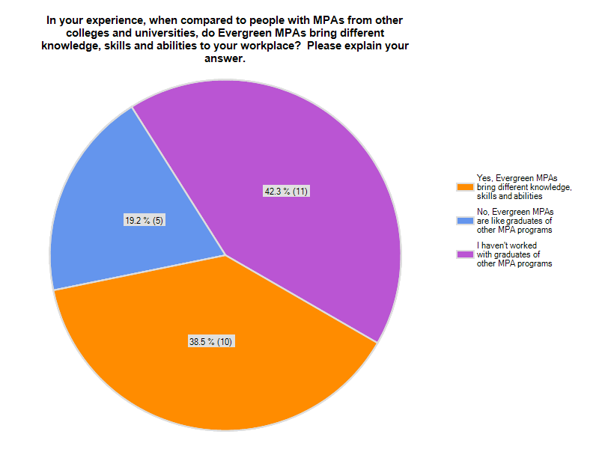
Awareness of what really matters, is evidenced through MPA student's bonds and ties to one another.

Again, TESC MPA-types have a tendency to be better writers and thinkers in comparison to other programs.

I have no other basis from which to compare.

Seemed interested in the human aspects of the work, and had local knowledge, especially of state government.

Can't compare all that much, as I've had only a few friends/colleagues with MPA's. I have however, worked with those w/graduate degrees of other kinds, from other institutions, also with my own work in public sector: colleges/universities/state/local govt. Believe me, there is great misunderstanding and appreciation by them, for what TESC has to offer vs. its many stereotypes.

I am an MPA so can compare to myself. We have very similar knowledge, skills and abilities.

Evergreen students come with a desire to fine solutions and listen to non-traditional input.

In terms of who I've supervised, I haven't had other MPA's (just MBA, MS, MURP, BA's). But, I do work with other MPA alumni within my institution and on various interagency committees and boards. In those encounters, the Evergreen MPA's tend to share a willingness to hear others' perspectives, are diligent about considering the impact on citizens and those being served (not just the simplest way to meet the demands of legislators or agency heads). I would say there are underlying values and considerations that help such colleagues find common ground. It can be particularly powerful when I'm working across agencies on teams with several Evergreen alumni (and sometimes MPA faculty), because there can be a critical mass of participants willing to take a little time to consider context and impact of policy as opposed to business-as-usual, get-to-the-decision, everyone nod and say "aye" and keep checking your blackberry approach that can unfortunately dominate some policy work.

I've had good experiences with students from other MPA programs. Overall, TESC MPA students have become increasingly competitive in recent years.

They are predisposed to be colloborative.

Less individualistic, better communication and problem-solving skills, more confident in tackling subject matter outside of their core area of studies.

Wish Evergreen MPA program provided but didn't? (n=21)

NA

Real world human resource management and admin experience.

Longer/stronger skill building in grants and fundraising

I have no idea - I'm not sure what the MPA program provides, which calls into question the overall usefulness of this survey.

Perhaps a little more emphasis on group dynamics-- that is, most of our offices are team-based, where employees work on one part of a project. It takes a little skill to fit into a group so that the whole project is kept in mind and progress is made towards the group goal, not just the individula's part.

I employed extraordinary graduates, but I suspect that some others might not have the same abilities. I'd be worried about writing ability, reasoning ability, and ability to communicate respectfully and diplomatically.

Below is an own example of why I believe there are negative sterotypes in the community, and what I wish the program could have given me and the employee who needed the information to do her job: simply basic information about the program so that she could complete her fall/winter work schedule around the program's meeting times. Instead, this is what happened: It took WEEKS of time, if not months, over the course of a summer, to get not just the information, but merely a return phone call or email. This never came to me in a direct or clear form, but left merely as a confusing message from the then Program Director. This response to my call and the call of the current student who was my employee at the time were not answered until I finally contacted the college president's offce to see if they might assist me in getting a response from the Program Director, becuase the information posted online was in conflct with other information also posted online. (i.e. one place said class nights were Tue/Thurs; another said Mon/Wed. When the response finally came from the Program director, he did not even confirm with any clarity. Instead he said "If I do not give you a call back, then the night of the class will be....." Hardly a professional response to a unit of state and local government, waiting, literally for weeks to make its own plans, based upon this extremely poor example of a good administrator. Being a TESC MPA alum myself, this was extremely discouraging. Not days, but several weeks' time. Perhaps this was due to the faculty/program director being off for the summer. Government does not cease to plan or run during summer quarter.

I have nothing to suggest.

I've interviewed people for positions in this agency. When asked about specific coursework, they have been very vague and unclear in their responses. I'd like to know the specific courses that graduates are expected to take and the content of that coursework. This is very important to me as I select the best candidates for positions. It affects how much training and orientation will be needed with new hires.

there is always so much to know. Not sure how to answer this question.

Applied skills in non-profit issues.

Analytical applications. As a hiring authority, the key weakness I see in applicants from Evergreen MPA is little to no experience using the tools of the profession (e.g. creating simple spreadsheets to display basic numeric data like budget proposals or cost/revenue estimates, using a graph to make a point, creating simple summaries of analysis appropriate for an executive audience (that won't read a narrative), understanding how to change that report if the audience was the general public without the same amount of insider knowledge. Unfortunately, the Evergreen MPA students very rarely mention any skills or experience in the technical tools or using a mix of qualitative and quantitative information in their work. So many positions in the public and non-profit sectors require bill analysis, advocacy on behalf of the public, presenting to various kinds of audiences (most of whom have limited time and are already inundated with information), justification of program effectiveness, budget analysis, impact analysis, cost estimates, grant proposals -- it would be great if more of the applications from MPA alumni showed experience in these areas.

Not relevant

Technical writing.

More budget and quantitative skills.

NA

more real world experience

I have only supervised one MPA graduate. From that limited viewpoint I might wish for a greater appreciation of the value of data to document outcomes and performance.

Quality of writing and analytical skills can vary sharply (e.g., seen some embarrassing job applications). I appreciate the social-change coloring of the program but sometimes students don't have enough grounding in how to effectively champion change. I've been surprised at how little grads have tended to know about the workings of state and local governments; theory's great but I'd like to see a stronger grounding in our day-to-day business.

A project that made a difference for the agency. Sometimes employee/students projects were not very meaningful for us but agency staff had to provide support for the project.

nothing to add

Based on your experiences with Evergreen MPA students/interns/alumni, do you recommend the Evergreen MPA program to others? Why or why not?
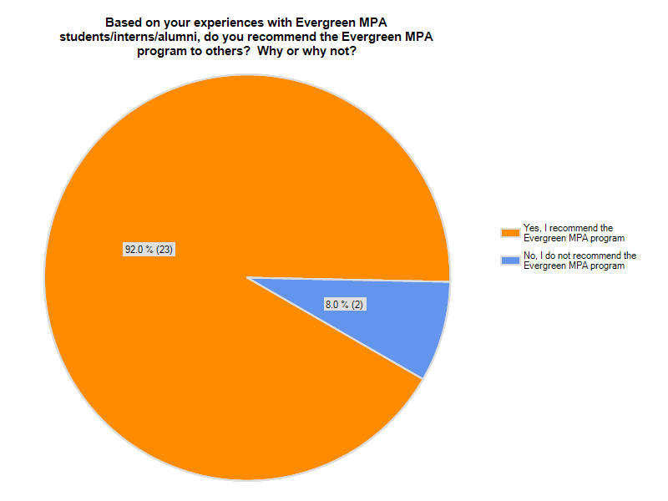
Recommend program? Why or why not? (n=16)

Good information and ability to sort through problems and do research

There is such an array of different Native Amercian tribes in the MPA-tribal program. It is great to be an unpaid ambassador to blow the horn and generate comments of what it was like to be at Evergreen!

seems well-rounded. provides hands-on, relevant experiences that provide real-world context to the learning.

Have recommended it to several of my staff. One took me up on it!

This is a poorly designed survey. Again, I don't know what your program offers and I have no comparitor.

It seems like a practical program with excellent local ties.

Yes, but depending on the student. As a former student advisor in state colleges/university I do not always recommend TESC to students who would clearly not thrive in its unique environment.

I would recommend the Evergreen MPA program, but with the caveat that the approach to grading is not letter-based but conversation-based, and students coming from a more traditionally structured undergrad experience might need to adjust their expectations.

No opinion on this one.

Evergreen MRA program is igniting our students to fine solutions and fine ways to improve organizations.

On the E. coast

I think its a great program. I'm an MPA gradutate so I have personal experience as well as experience with other, more recent graduates.

I have done so to two individuals.

It depends on a prospective student's goals.

I want my organizational leaders to have a relevant masters to get broader experience/knowledge beyond what they can get when works g the front lines.

good quality employees

Any other Comments? (n=14)

I apologize for not answering most of the questions but I am not familiar with Evergreen or what part of the student's skills are attributable to Evergreen.

We survive as Native Americans because of the strong women we grow up with. I knew after fighting to not join the Anglo's higher education, that time dictated my destiny. (start of a poem???)

No.

We love partnering with the Evergreen MPA program!

Thank you, great program!

My views might be skewed by the fact that I've both employed TESC MPA graduates and taught them.

good questions. I found not being able to see much of my responses to be challenging; please forgive: typos, punctuation, clarity....hope this is helpful.

As with undergrad students, Evergreen is not right for everybody. But for MPA students, just as for undergrads, if someone is looking for a different approach to higher education, it might be what they are looking for.

I wish your survey had given me multiple choice responses for all the knowledge, skills, abilities and discipline related questions.

MPA interns contribute so much to local programs and organizations!

The Evergreen alumni we hired has advanced quickly in our organization. In addition to be a hard worker he has demonstrated technical, analytical and leadership skills that our company have come to rely on.

work to increase your positive connection to the community

None

Our unit has attempted to partner with MPA faculty to engage in applied research projects; we have had luke-warm reactions. The prevailing organizational culture seems rather individualistic and contingent. We've had much greater success working with WSU Extension. That's unfortunate, because we're a bunch of Greeners who would much rather work with the MPA program. Evergreen could develop a meaningfui applied research wing if it set its mind to it. Aren't you interested in diversifying your funding base?

