**How to post a job on** [**MPA’s LinkedIN page**](https://www.linkedin.com/company/mpaevergreen/)

Log in to [www.linkedin.com](http://www.linkedin.com)

When you log in, your “Home” page should look like this:

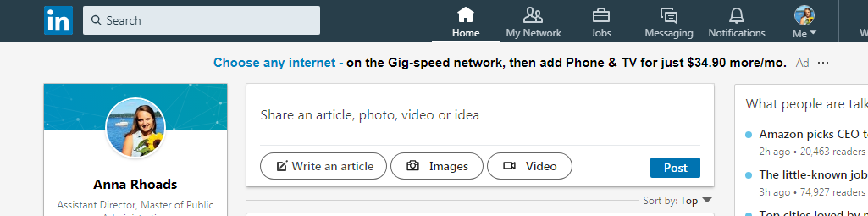

To post a job on **MPA’s LinkedIn page**, you need to access the “Company: MPA at the Evergreen State College” page. To do this, click on the upper right icon that says **Me**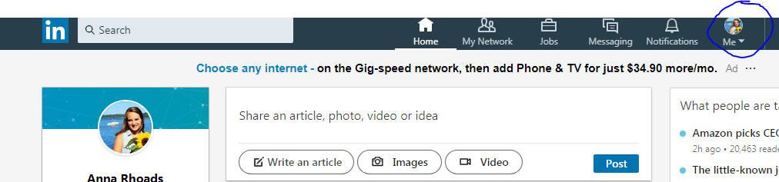

The menu below should pop up when you click Me. From here, click “**Company: MPA at The Evergreen State College”** under Manage.

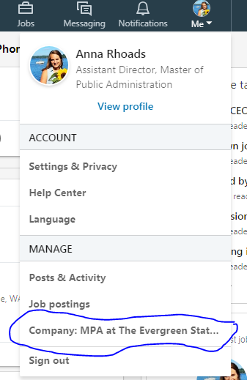  
After clicking on Company: MPA at The Evergreen State College, you will be taken to the MPA at the Evergreen State College Admin View. The Admin View looks like this:

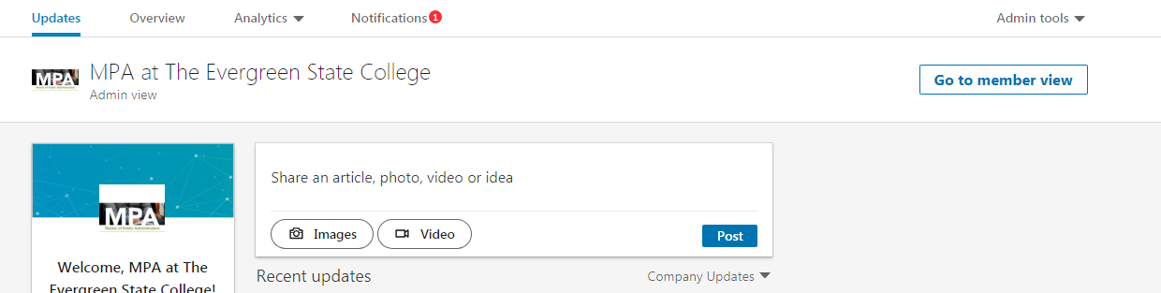

To post a job, simply copy the job’s URL into the post box:

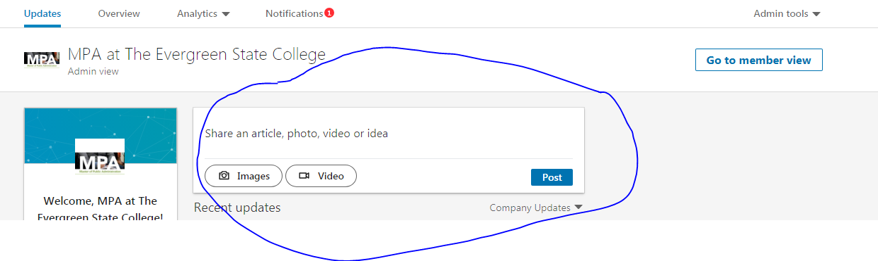

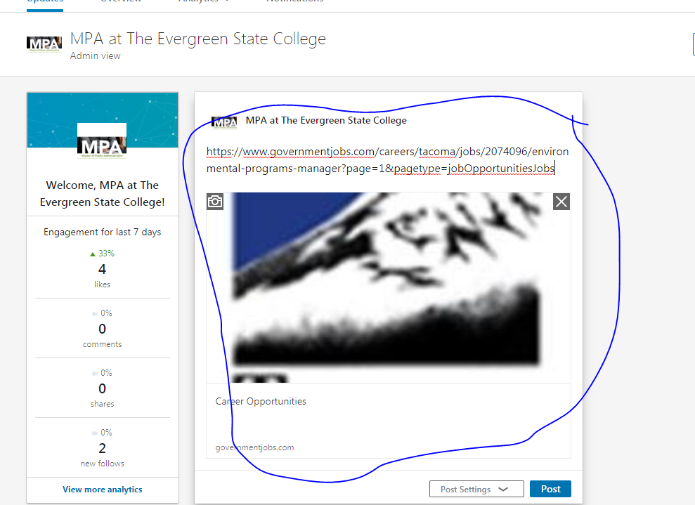

Now, to clean the post up, delete the URL. Users will still be able to click on the image to view the job.

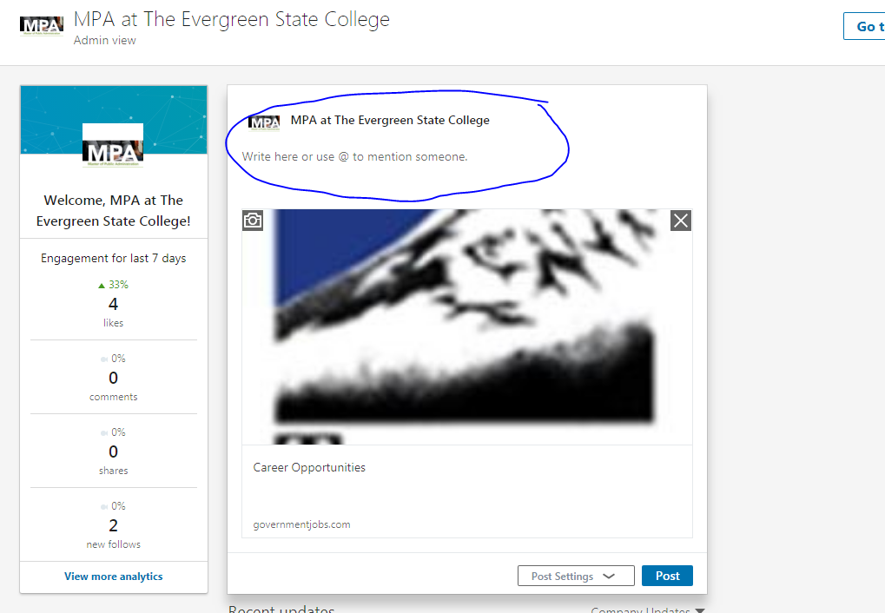

Next, type information about the job: Job title, what company, when applications are due, etc.

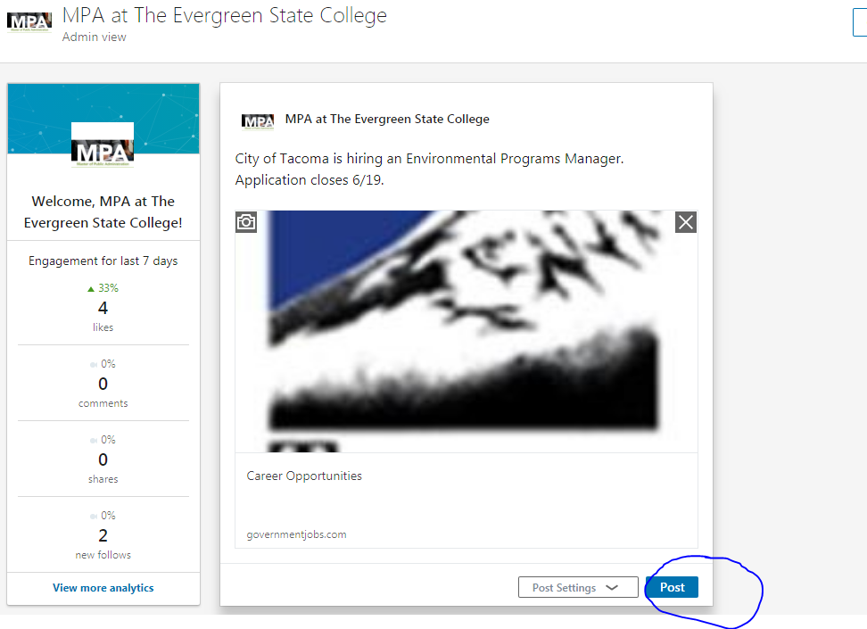

Great! Now you are ready to post the job. Press post in the bottom right corner.

The post will now show up on the **MPA at The Evergreen State College LinkedIn page.**

