April 1, 2020

RE: Recommendation for Lindsay Fujimoto for Graduate Studies

To whom it may concern,

I’ve had the privilege to work with Lindsay in various capacities for the past three years. She served with us as a VISTA member in 2016-17. Her role was as the Hunger-Free Pierce County Coordinator, supporting the work of a countywide group of organizations involved in our local food system. Lindsay was extremely organized, a self-starter, dependable, great with community outreach and facilitation and was a solid team member both within United Way and in the community. Lindsay also took her professional development very seriously, enrolling in many of the AmeriCorps courses, such as Resource Development and Volunteer Management, as well as opportunities in the community.

Once her service term was complete, Lindsay continued with her work fighting hunger by joining Food LifeLine as their Volunteer Coordinator before moving to her current position at United Way of Thurston County (UWTC).

It was at UWTC that Lindsay was able to put her VISTA experience to good use as manager of the UWTC VISTA team. I have worked with Lindsay in that capacity as the sponsor for our United Way of Pierce County VISTA members. She has definitely improved the organization and efficiency of the VISTA program within UWTC. She is a great systems thinker, always being reflective about how something might be done better. She is a great community liaison between UWTC and its partners. She continues to be involved in volunteer management as well.

I believe Lindsay is an excellent candidate for Evergreen’s Master of Public Administration program. She is smart, creative, energetic and motivated. Lindsay has a real passion for public service and will be an asset to any organization in the future.

Sincerely,

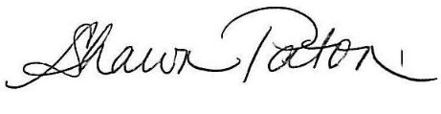

Shawn Parkhurst Paton

Sr. Director, Impact & Innovation

UNITED WAY OF PIERCE COUNTY