September 18, 2020

Dear Evergreen MPA Student,

Welcome to the Evergreen Master of Public Administration Program! You are joining us at a time when our country, state, and communities face particularly difficult challenges. Now more than ever, we need dedicated professionals in the public and nonprofit sectors who are prepared to lead our communities in meeting these challenges. On behalf of the MPA program faculty and staff, we want to thank you for the commitment you have made to public service.

As a student in a professional master’s program, you will find that much is expected of you. You will find first that you will take greater responsibility for your educational experience. More of your learning will happen in the reading and writing you do outside of class. You will also be in a position to more directly guide your own learning in the research you carry out for your courses and in individual learning contracts (ILCs). To get the most out of our program, you should understand your goals and take advantage of opportunities to discuss them with [MPA faculty](https://evergreen.edu/mpa/faculty).

In addition, you will find that MPA faculty have high expectations for academic and professional integrity. Professionals in public administration adhere to the [American Society for Public Administration’s Code of Ethics](https://www.aspanet.org/ASPA/Code-of-Ethics/ASPA/Code-of-Ethics/Code-of-Ethics.aspx). In addition, students at The Evergreen State College are bound to the [College’s Social Contract](https://apps.leg.wa.gov/wac/default.aspx?cite=174-121-010) and by the [Student Code of Conduct](https://www.evergreen.edu/studentaffairs/student-conduct). Find the MPA program’s practices and policies in the [Student Handbook](https://www.evergreen.edu/mpa/studenthandbook). Please carefully review these documents before beginning the MPA program and [contact me](mailto:crawm@evergreen.edu) with any questions about them.

The MPA program’s faculty and staff commit to supporting your academic growth. The MPA faculty work hard to ensure that the MPA program’s Core (the required sequence of six courses you will take) provide a grounding in best practices and theory underlying public administration today. At the same time, we know that each of our students has individual needs, goals, and circumstances. We strongly encourage you to communicate with faculty about your needs so that we can help you meet your goals. At the same time, the MPA program’s Assistant Directors, [Marcia Zitzelman](mailto:zitzelmm@evergreen.edu) and [Puanani Nihoa](mailto:nihoap@evergreen.edu), are available to help students with questions about the MPA program’s policies and processes. And I am personally available to help you with developing your academic plans and your career goals. Please reach out to us for assistance on such matters. Our MPA program’s motto is “Be the Change” and we take pride in the number of our alumni who have created change in the communities we serve. We are delighted you have chosen this path and wish you well as you take your first steps towards completing the MPA program.

Sincerely,

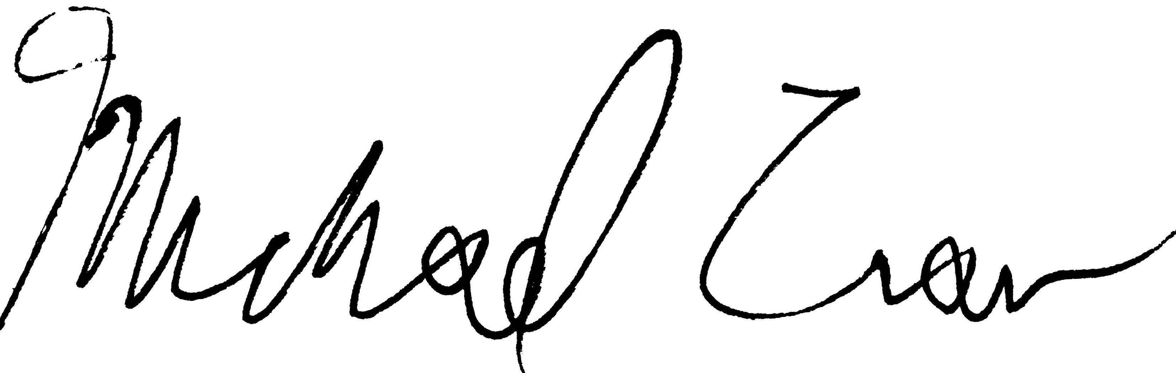

Michael Craw (he, him, his)

Director, Master of Public Administration Program