**Rosina DePoe, Class of 2020 – Tribal Governance cohort**

Deputy Director

Washington Indian Gaming Association

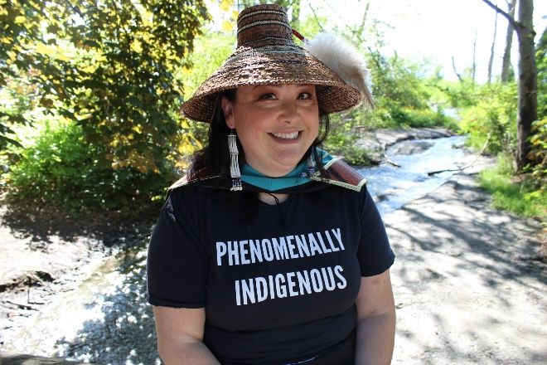

Rosina DePoe is a citizen of the Makah Tribe and 2020 MPA Tribal Governance Cohort Graduate. Rosina is currently the Deputy Director for the Washington Indian Gaming Association (WIGA) a non-profit trade association representing 25 WA Tribes.

Prior to working with WIGA, she was the Chief of Staff for the Makah Tribal Council for almost 4 years, during that time of which she became inspired to apply for the MPA – TG program at Evergreen. Recognizing that in order for her to continue on her path of tribal public administration, she needed to have a good footing in tribal organizational and operational history and further her understanding of the intersecting and overlapping paths of working with not only other tribes, but also federal, state and local governments.

Her work and passion are one of the same, raising awareness while also educating state, federal legislators and agencies on Washington Tribal Treaty Rights, Sovereignty. All while also advocating for education and dissemination of information to the Indian Gaming community, federal and state governments and the general public.

She enjoys spending her recently re-established (now done with school) free time with her husband and two dogs, Rocky and Loki.