**Dawnadair Lewis MPA, CDPT**

**Associate Director The Washington State Native American Coalition Against Domestic Violence & Sexual Assault**

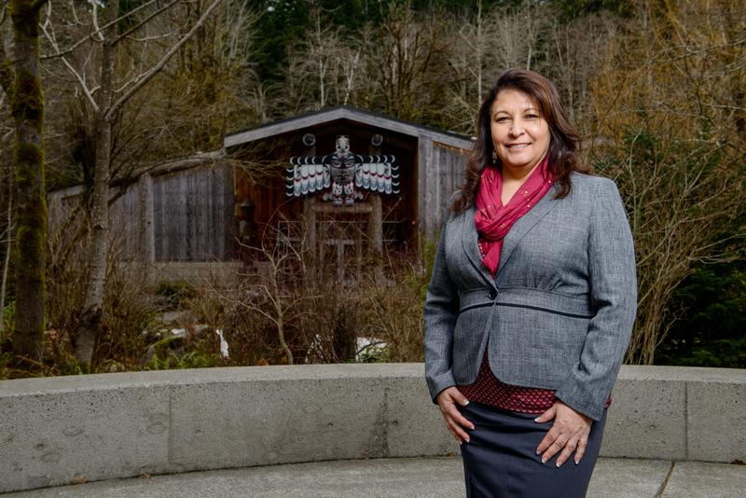

Dawn Lewis is currently the Associate Director of The Washington State Coalition Against Domestic Violence & Sexual Assault.

Dawn is an enrolled member of the Quinault Indian Nation and graduating student of the Masters of Public Administration.

Dawn received her Business Administration Degree from South Puget Sound Community College in 2009. Dawn earned her undergraduate degree in Human Services from The Evergreen State College in 2011. Dawnadair went on to finish with a Masters in Public Administration in Tribal Governance 2014. In addition, Dawn was elected as a recipient of the Evergreen Sustainability Fellowship award to conduct research on Geothermal Energy.

**Biography of Dawnadair Lewis**

While earning an undergraduate degree, Dawn was hired to manage a domestic violence and sexual assault program for a local tribe. In addition, Dawn provided domestic violence & sexual assault education for students at the Oakville school district. Dawn coordinated services with law enforcement and school officials to bring a new bullying curriculum to the school that lacked funding for such services. Dawn worked with survivors of generational trauma and gained first hand knowledge of challenges faced by individuals in and out of the state/tribal court process. While earing her graduate degree, Dawn accepted the position as the Associate Director for The Washington State Native American Coalition Against Domestic Violence & Sexual Assault. Dawn assists with the development of Tribal programs and working to help tribes gain equal access to funding resources. In addition, Dawnadair has joined the Alliance of Tribal Coalitions To End Violence (ATCEV.) The coalition is made up of other Tribal coalitions organized to impact service delivery systems to tribal programs to help end violence against native women and their families. Recently, Dawn attended a High Level 2014 World Conference for Indigenous People held at the UN Headquarters New York City. Dawn’s focus is to strengthen laws and policies to protect the rights of Native Americans and their families.