\***Note:** Only 2 surveys were completed (1) 2014 & (2) 2016 no other survey were completed prior to that.

‘MPA Winter 2014 Elective Survey: Tribal Policy’ (**8 responses**)

Over all comments of *rate of quality of the course*:

Well organized 50% almost always/25% frequently/25%occasionally

Course content was interesting & clear 50% frequently/almost always/50%frequently

Course content matched course objective 50% almost always/12.50% frequently/37.50% sometimes

Faculty feedback was useful & timely 25% frequently/50% frequently/12.50% sometimes &12.50% rarely

Assignments/exercises were

interesting & relevant 62.50% almost always/37.50% frequently

Readings & seminar were interesting

& relevant 28.57% almost always/57.13% frequently &

14.29% sometimes

Student participation 75% almost always/25%frequently

Classroom learning environment was

supportive & respectful 62.50% almost always/25% frequently & 12.50% sometimes

Course was intellectually challenging 62.50% almost always & 37.50% frequently

Below are comments from several students (*not all contributed comments*)

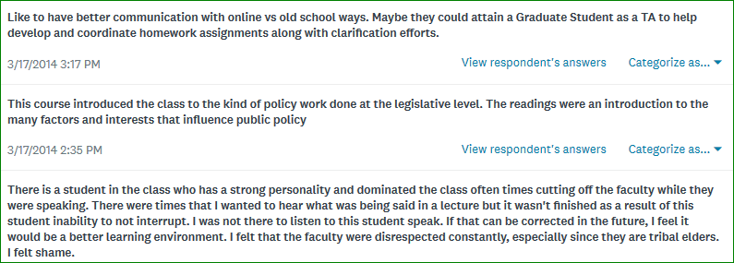

Question below: Should Tribal Policy be taught again? See responses below

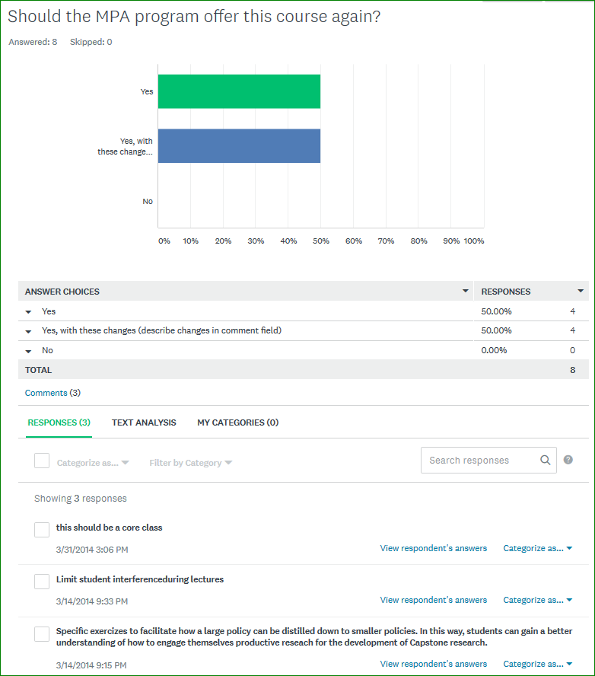

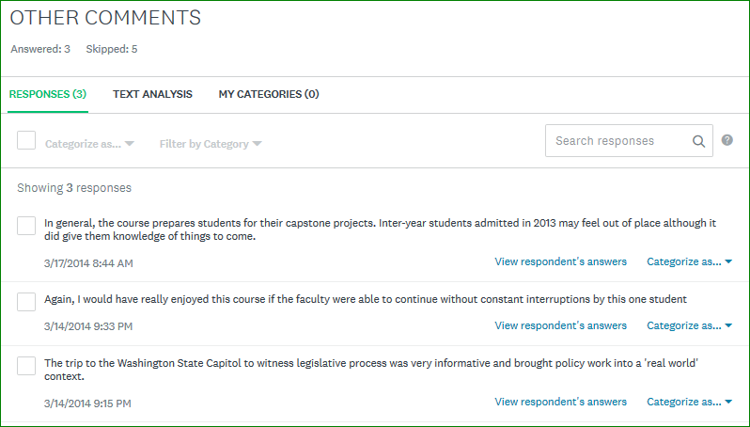

‘MPA Winter 2016 Tribal Concentration Survey: Tribal Policy’ (**5 responses**)

