Native Cases Project Underway

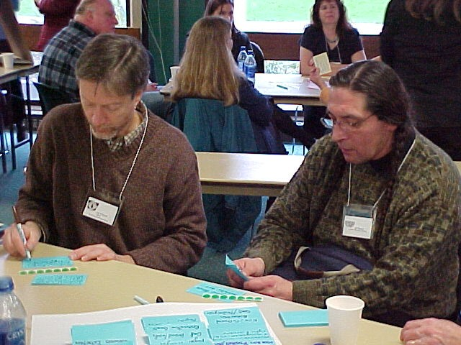
Very serious Ted Whitesell & Jeff Thomas at Native Advisory Board Meeting

With support from Lumina Foundation for Education, The Evergreen State College is collaborating with a number of institutions to develop Native curriculum. Grays Harbor college, Bainbridge Graduate Institute, Salish Kootenai (SKC) and Northwest Indian College (NWIC) are partners in the new project to develop Native case studies on a variety of topics identified by a Native Advisory Board as significant issues that should be in the college curriculum. A four-day workshop on Teaching and Writing Cases was held at Evergreen at the end of June. Over the next three years 20-30 cases will be produced. Topics include what is India art and who is an Indian artist, including Native history in Washington history, the impact of the WASL on Native students, urban Indian health needs, natural resource planning, and many others. A number of final capstone project written by MPA Tribal Administration graduates will be turned into teaching cases. 9Add names?) A Native Cases Workshop will be held each summer for the next two years. For further information contact Linda Moon Stumpff at stumpffl@evergreen.edu

Evergreen Upper Division Program Changes
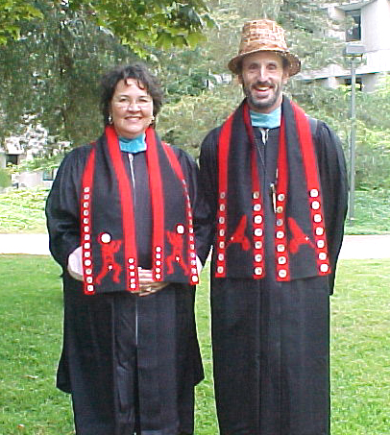
Cutie Pies Michelle Aguilar-Wells and Jeff
Antonellis-Lapp co-direct TESC’s Reserva-
tin-based Program

Beginning in fall 2006 Evergreen’s upper division community-determined, reservation based program will offer students a number of new options including:

A core course common to all reservation sites focusing around a theme. The theme for Fall is “Intergovernmental Relations.”
An workshop called “Intergovernmental Battlegrounds using original cases studies focusing on Native issues, especially in the Northwest
A new series of courses called “Great Books,” through individualized study
An option for upper division students to learn how to make eportfolios
A tech tools competency

Course Redesign Grants Awarded

With support from Lumina Foundation for Education, twelve community college faculty received grants to redesign their online courses for cultural relevance to Native learners.

- Eric Bard , Pierce College, Earth System Science
- Dan Bush, South Seattle CC, AM Government
- Mohammad Ibrahim, Grays Harbor College, Intro Biology
- Lynn Kanne, Seattle Central, Reserch in the 21st Century
- Keith Snyder, Spokane Falls, Health & Wellness
- Wayne Luckmann, Green River, English Com 201
- Vicki Matzen, Skagit Valley, English 095
- Debbie Teed, SPSCC, Cultural Anthropolohy
- Bob Riesenberg, Whatcom, Itro Psychology
- Sheila Palmer, Spokane Falls, Math 107
- Shalin Hai-Jew, Walla Walla, English Comp

All of these courses are part of the GHC reservation-based AA degree program being offered this fall at Quinault, Lower Elwha, Nisqually, Muckleshoot, Squaxin Island, and Sholawater Bay.

2006 Graduation News….

Graduating with an AA degree from the GHC reservation-based program –Harmony Blancher. Graduating with a BA from Evergreen’s reservation-based program are from xxxxxx.

MPA Tribal Administration graduates are ……………………………..

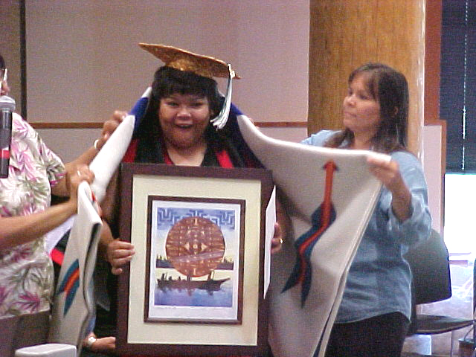
Wow, Mom, look what I did!

Featured Events Fall Quarter…

Native Art Fair at Longhouse

Lumina Foundation Supports Native Education Efforts

