
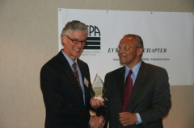  Provost Don Bantz accepting award from J. Paul Blake, President of the Evergreen Chapter, American Society for Public Administration  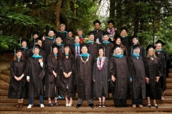  MPA Graduation 2009  Aisheh Moh'd Al-Louzi  Megan Angela Berg  Nichole Helen Black  Petra Marie-Luise Boston  Amy Susan Buckler  Jill Marie Bushnell  Jonathon Eugene Clontz  Randolph C. Corradine  Michael Jerome Dennis  Hillary Kathleen Hunt  Richard Eugene Johnson  Gina Karlsson  Sara Elizabeth Kath  Kimberly Jeannette Lampman  Corey Lee Leneker  Kimberly Ann Libby  Carrie Jean Lybecker  Rebecca Jean Manger  Kelly Leigh McDonald  Scott Edward Morgan  Aaron James Nickell  Jose Ortega, Jr.  Mary Ann Parker  Joshua Michael Proehl  David T Robison  Christopher Geoffrey Saunders  Sheri Shayna Sawyer  M. Anna Schlecht  Colleen Jennifer Uuereb  Shannon Jean Wallace  Dorian Marques Waller  Ryujiro Yamane  MES/MPA Graduates  Faith Taylor-Eldred  In the News  Congratulations to Kara Briggs '10 MPA on the publication of her article on preserving native languages in the Colors Northwest newsletter.  Congratulations to Teresa Mosqueda '06 MPA, Advocacy & Legislative Relations Director for the Children's Alliance, for being named "Lobbyist of the Year" by State Representative Larry Seaquist.  Congratulations to Kimberly Mays '10 MPA for winning the Children's Alliances "Voices for Children Award for 2009" Kimberly represents Pierce County Juvenile Court's Parent-to-Parent Program and the governor's Racial Disproportionality Advisory Committee.  Congratulations to Erin Genia '10 MPA for landing an internship this summer with the Office of Public Affairs at the Smithsonian's National Museum of the American Indian in Washington, D.C.  Following a nationwide search, Kelly Cunningham MPA '09 has been promoted to superintendent of the McNeil Island Special Commitment Center in the DSHS Health and Recovery Services Administration. He assumes the post on Aug. 1.  Do you have news to share? Email Cheryl Simrell King  Running for Local Public Office  Roxanne Murphy MPA '10 is running for City Council in Tacoma.  Adjunct Faculty/Advisory Board member Stephen Buxbaum '80, MPA '88, is running for Olympia City Council.  Best wishes to both candidates! | "You must be the change you wish to see in the world." - Mohandas K. Gandhi  MPA Program Receives Award!  In May,The Evergreen State College Provost (and MPA faculty member), Don Bantz, accepted the 2009 Public Administration Education Program Award from the Evergreen Chapter of the American Society for Public Administration (ASPA). Evergreen Chapter board member, Dorian Waller '05, MPA '05, nominated the program for this first-ever-given award. We are very grateful and proud to receive this award.  Twelve people from Evergreen attended the award banquet, students and staff.  The very attractive award sits in the newly built "trophy case" outside the college's President/Vice Presidents offices. President Les Purce invited us to share our accomplishment with the Board of Trustees at their regular meeting in May. Cheryl Simrell King and Don Bantz represented the MPA program at the Trustee's meeting.  Read more here: ASPA Evergreen Chapter Award  We encourage you to support ASPA and the Evergreen Chapter by becoming a member of ASPA. Three MPA folks sit on the Evergreen Chapter Board: Dorian Waller '05, MPA '09, Leslie Wolff '10 and Director/Faculty Member Cheryl Simrell King. Feel free to email these individuals for more information.  Your MPA Elevator Speech  When people ask you about the MPA Program, what do you say? Here are some quick points you can use to help tell the story of this unique program:  - The program provides professional education supporting careers in local, state, tribal and federal governments, in education, nonprofit and for-profit organizations.  - There are nearly a thousand MPA grads working throughout the Northwest and the world.  - It's a learning community that explores and implements socially just, democratic public service.  - Graduates attain knowledge, skills and abilities to serve their communities.  - MPA alumni are advocates for positive change.  Great 2009 Sendoff for MPA Grads  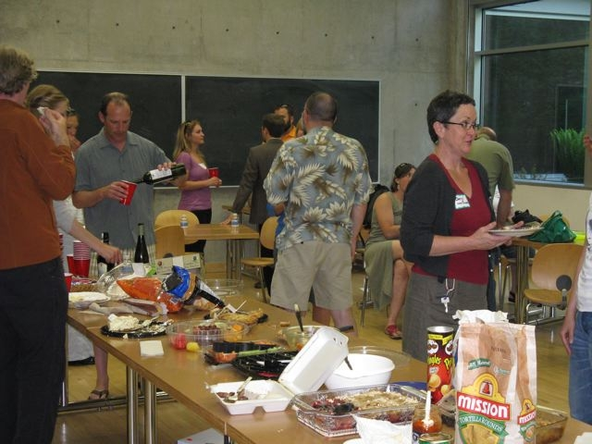  Current MPA students and MPA alumni gathered for the 2009 MPA Networking Potluck honoring graduating MPA candidates and departing faculty members Nita Rinehart and Russ Lehman. The event was hosted by the MPA Student Union with support from Alumni Relations and Career Services.  Originally planned as a job fair and student-alumni networking event, the organizers managed to design a flexible format that suited offered something for everybody. Networking blended easily with causal banter, story-telling and even a good natured roast of Rinehardt and Lehman.  Organizers plan to make the potluck an annual event where students and alumni can make connections and build friendships.  Student's Notebook  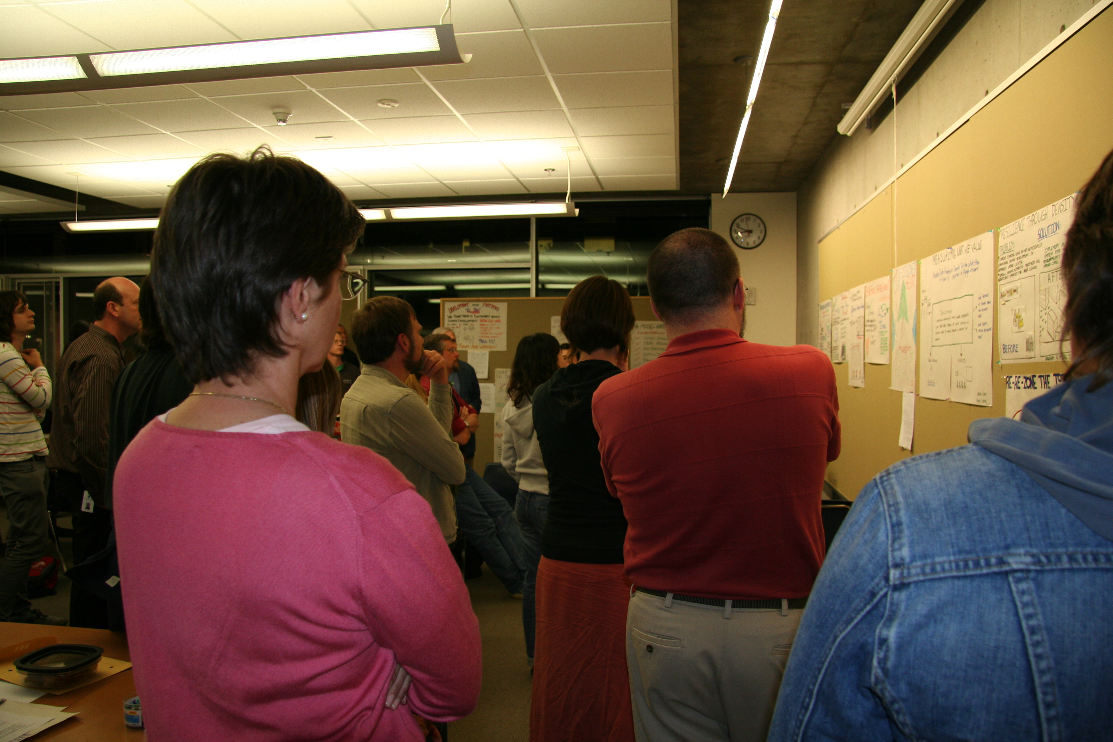  It's about 9:30 on a typical spring night in the Public Works class. Students can be observed putting their final touches to . . . posters.  The scene: hurried consultations; last-minute writing or sketching with markers; just-before-deadline decision-making about presentation. Wandering through the scene is faculty member Rob Knapp calling out reminders of the impending "pin up" time, while MPA Director Cheryl Simrell King reinforces the urgency wrapping it up. In a program known for innovation, the Public Works class (co-offered with the college's Master of Environmental Studies program) stands out. The theme is ecological democracy and involves the intersection of several disciplines: planning, administration, aesthetics and landscape design, architecture, and geography.  The class features alternating weeks of seminar and in-class design projects. For a final project students work in teams to address a real-world design problem such as the need for more walkable green space and an urban core in Federal Way, WA. That work culminated in a poster and oral presentation.  Another feature of the class is involves community interactions with individuals active in planning, building, designing, advocating, and communicating for a better future via a more sustainable and democratic built environment.  Through it all, students are able to dust off artistic skills, make new connections, think about design in both ideal and real situations, and learn about ongoing efforts in local communities. Typical? No. Challenging? Yes. Rewarding? Absolutely.  Greg Cook is beginning his second year in the MPA program and hopes to graduate in June, 2010.  Model Project Brings Sustainablity Practices into Prisions  Evan Johnson 'MPA 10 is part of an innovative partnership pairing the Washington State Department of Corrections with Evergreen faculty and students.  Johnson is working at the headquarters of the Department of Corrections helping to design performance measures, evaluation and analysis plans for activities such as waste reduction efforts within prisons. It's all part of The Sustainable Prisons Project, supported by a two-year $300,000 grant. The mission is to reduce the cost and environmental impact of prison operations by training prison staff and offenders in science, sustainability and skills for the emerging green economy.  The partnership began when Evergreen faculty member Nalini Nadkarni met Cedar Creek Correction Center's Superintendent Dan Pacholke. The outcome: The Sustainable Prisons Project bringing numerous sustainable projects and practices to Cedar Creek.  The project serves as a model for other prisons and enforced residential institutions and supports the notion that prisons - both their facilities and their community of staff and inmates - can "go green" inside and outside their walls.  This project is the perfect marriage of the MPA program and the Master of Environmental Science (MES) program. The MPA intern works on planning, implementation and evaluation while two MES interns work on directly with prison staff and inmates on developing and implementing the actual sustainability practices.  Read more on this exciting project.  MPA Changes Curriculum  A combination of tight budgets, feedback from students and alumni, and recognition of the centrality of the Core to the MPA has led to a change in the MPA curriculum. The new curriculum goes into effect with the Fall 2009 General Cohort.  Credits for quarterly Core classes have increased from 4 to 6, a new Core course has been added to address the feedback that policy, finance and budget issues were not sufficiently addressed in Core, and second year Core now limits the Analytical Techniques class to two quarters, with the Core culminating in Capstone (Capstone, previously, was not part of Core). This increases the amount of credits from Core, more accurately reflecting the importance and centrality of Core to the Evergreen MPA program. This also makes it easier for students to complete the program in two years, if desired.  In addition to changing the credit hours and composition of the Core, faculty and staff are wrapping up a two-year process to identify agreed upon Core Competencies. The Core Competencies reflect our values and perspectives and allow us to more accurately define the unique "brand" of the TESC MPA. The Core Competencies will also guide the teaching and learning environment of our Core curriculum, allowing us to take full advantage of faculty rotation practices at TESC and still feel confident that we are building fairly consistent and high quality teaching and learning environments in our Core curriculum.  New MPA Curriculum  1st Year Core  FALL: Context of Public Administration (6 credits)  WINTER: Doing Democratic Public Administration (6 credits)  SPRING: Policy, Finance and Budgeting for Public Administration (6 credits) (new course)  2nd Year Core  FALL: Analytical Techniques for Public Service I (6 credits)  WINTER: Analytical Techniques for Public Service II (6 credits)  SPRING: Capstone (6 credits)  Tribal Concentration:  1ST and 2nd Year Core (36 credit hours) + 20 Tribal Concentration credit hours + 4 elective credit hours = 60 credit hours  Public and Non-Profit Administration Concentration:  1ST and 2nd Year Core (36 credit hours) + 24 elective credit hours = 60 credit hours  Public Policy Concentration:  1ST and 2nd Year Core (36 credit hours) + ARM and FOPP (8 credit hours) + 16 elective credit hours = 60 credit hours

The Evergreen State College - Office of Alumni Relations
2700 Evergreen Parkway NW, Olympia, WA 98505
(360) 867-6551 • Fax: (360) 867-6799
alumni@evergreen.edu • www.evergreen.edu/alumni

This email was sent to burtr@evergreen.edu. To ensure that you continue receiving our emails, please add us to your address book or safe list.
manage your preferences | opt out using TrueRemove®.
Got this as a forward? Sign up to receive our future emails.
powered by

