
"You must be the change you wish to see in the world." - Mohandas K. Gandhi

MPA Program Receives Award!
In May,The Evergreen State College Provost
(and MPA faculty member), Don Bantz, ac
cepted the 2009 Public Administration Edu
cation Program Award from the Evergreen
Chapter of the American Society for Public
Administration (ASPA). Evergreen Chapter
board member, Dorian Waller '05, MPA '05,
nominated the program for this first-ever
given award. We are very grateful and
proud to receive this award.
Twelve people from Evergreen attended the
award banquet, students and staff.

The very attractive award sits in the newly We encourage you to support built "trophy case" outside the college's ASPA and the Evergreen President/Vice Presidents offices. President Chapter by becoming a mem-Les Purce invited us to share our accom-ber of ASPA. Three MPA folks plishment with the Board of Trustees at their sit on the Evergreen Chapter regular meeting in May. Cheryl Simrell King Board: Dorian Waller '05, MPA and Don Bantz represented the MPA pro-'09, Leslie Wolff '10 and Direcgram at the Trustee's meeting. tor/Faculty Member Cheryl

Simrell King. Feel free to

Read more here: ASPA Evergreen Chapter email these individuals for
Award more information.

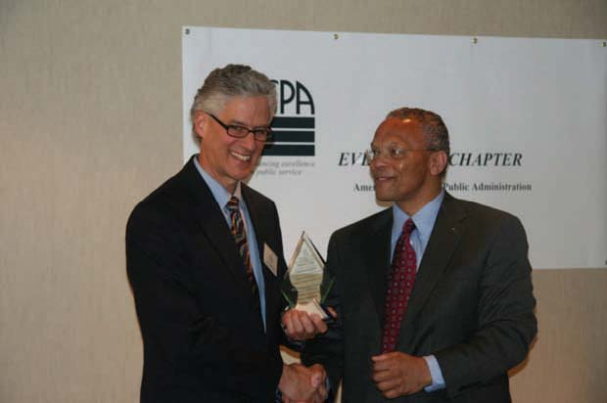
MPA Graduation 2009

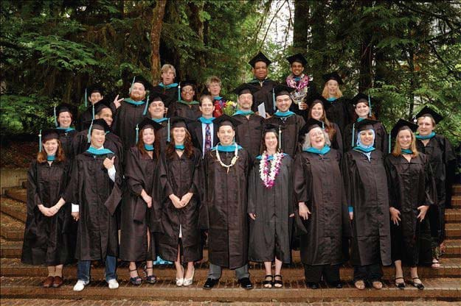

In the News
Congratulations to Kara Briggs '10 MPA on the publication of
her article on preserving native languages
in the Colors Northwest newsletter.

Aisheh Moh'd Al-Louzi Megan Angela Berg Nichole Helen Black Petra Marie-Luise Boston Amy Susan Buckler Jill Marie Bushnell Jonathon Eugene Clontz Randolph C. Corradine Michael Jerome Dennis Hillary Kathleen Hunt Richard Eugene Johnson Gina Karlsson Sara Elizabeth Kath Kimberly Jeannette Lampman Corey Lee Leneker Kimberly Ann Libby Carrie Jean Lybecker Rebecca Jean Manger Kelly Leigh McDonald Scott Edward Morgan Aaron James Nickell Jose Ortega, Jr. Mary Ann Parker Joshua Michael Proehl David T Robison Christopher Geoffrey Saunders Sheri Shayna Sawyer
M. Anna Schlecht Colleen Jennifer Uuereb Shannon Jean Wallace Dorian Marques Waller Ryujiro Yamane

MES/MPA Graduates
Faith Taylor-Eldred

In the News
Congratulations to Teresa Mosqueda '06 MPA, Advocacy & Legislative Relations Director for the Children's Alliance, for being named "Lobbyist of the Year" by State Representative Larry Seaquist.
Congratulations to Kimberly Mays '10 MPA for winning the Children's Alliances "Voices for Children Award for 2009" Kimberly represents Pierce County Juvenile Court's Parent-to-Parent Program and the governor's Racial Disproportionally Advisory Committee.
Congratulations to Erin Genia '10 MPA for landing an internship this summer with the Office of Public Affairs at the Smithsonian's National Museum of the American Indian in Washington, D.C.
Following a nationwide search, Kelly Cunningham MPA '09 has been promoted to superintendent of the McNeil Island Special Commitment Center in the DSHS Health and Recovery Services Administration. He assumes the post on Aug. 1.
Do you have news to share? Email
Cheryl Simrell King

Running for Local Public Office
Roxanne Murphy MPA '10 is running
for City Council in Tacoma.
Adjunct Faculty/Advisory Board member Stephen Buxbaum '80, MPA '88, is running for Olympia City Council.

Public Works class Public Works class
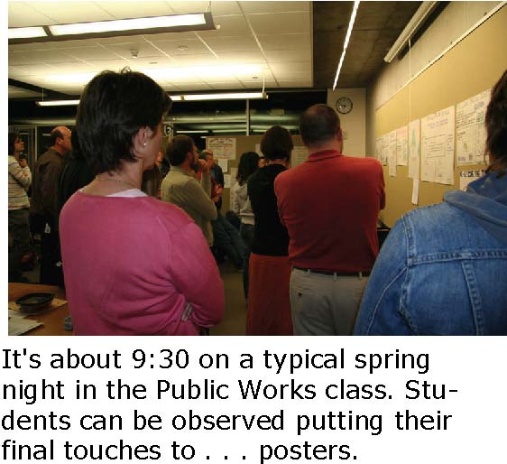

contd..
The scene: hurried consultations; last-minute writing or sketching with markers; just-before-deadline decision-making about presentation. Wandering through the scene is faculty member Rob Knapp calling out reminders of the impending "pin up" time, while MPA Director Cheryl Simrell King reinforces the urgency wrapping it up. In a program known for innovation, the Public Works class (co-offered with the college's Master of Environmental Studies program) stands out. The theme is ecological democracy and involves the intersection of several disciplines: planning, administration, aesthetics and landscape design, architecture, and geography.
The class features alternating weeks of seminar and in-class design projects. For a final project students work in teams to address a real-world design problem such as the need for more walkable green space and an urban core in Federal Way, WA. That work culminated in a poster and oral presentation.
This class also features community interactions with individuals active in planning, building, designing, advocating, and communicating for a better future via a more sustainable and democratic built environment.
Through it all, students are able to dust off artistic skills, make new connections, think about design in both ideal and real situations, and learn about ongoing efforts in local communities. Typical? No. Challenging? Yes. Rewarding? Absolutely.
Greg Cook is beginning his second year in the MPA program and hopes to graduate in June, 2010.

Model Project Brings Sustainability Practices into Prisons
Evan Johnson 'MPA 10 is part of an innovative partnership pairing the Washington State Department of Corrections with Evergreen faculty and students.
Johnson is working at the headquarters of the Department of Corrections helping to design performance measures, evaluation and analysis plans for activities such as waste reduction efforts within prisons. It's all part of The Sustainable Prisons Project, supported by a two-year $300,000 grant. The mission is to reduce the cost and environmental impact of prison operations by training prison staff and offenders in science, sustainability and skills for the emerging green economy. The partnership began when Evergreen faculty member Nalini Nadkarni met Cedar Creek Correction Center's Superintendent Dan Pacholke. The outcome: The Sustainable Prisons Project bringing numerous sustainable projects and practices to Cedar Creek.
The project serves as a model for other prisons and enforced residential institutions and supports the notion that prisons - both their facilities and their community of staff and inmates - can "go green" inside and outside their walls.
This project is the perfect marriage of the MPA program and the Master of Environmental Science (MES) program. The MPA intern works on planning, implementation and evaluation while two MES interns work on directly with prison staff and inmates on developing and implementing the actual sustainability practices.
Great 2009 Sendoff for MPA Grads
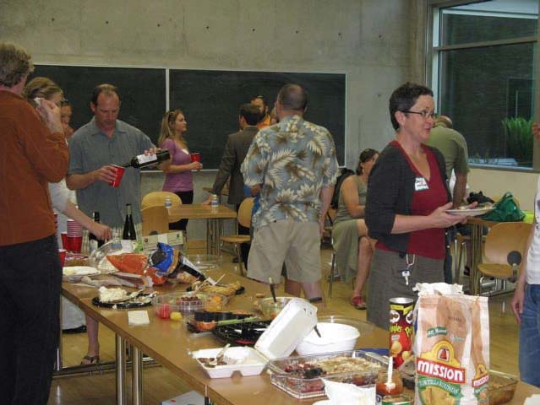
Current MPA students and MPA alumni gathered for the 2009 MPA Networking Potluck honoring graduating MPA candidates and departing faculty members Nita Rinehart and Russ Lehman. The event was hosted by the MPA Student Union with support from Alumni Relations and Career Services.
Originally planned as a job fair and student-alumni networking event, the organizers managed to design a flexible format that suited offered something for everybody. Networking blended easily with casual banter, storytelling and even a good natured roast of Rinehart and Lehman.
Organizers plan to make the potluck an annual event where students and alumni can make connections and build friendships.

MPA Changes Curriculum
A combination of tight budgets, feedback from students and alumni, and recognition of the centrality of the Core to the MPA has led to a change in the MPA curriculum. The new curriculum goes into effect with the Fall 2009 General Cohort.
Credits for quarterly Core classes have increased from 4 to 6, a new Core course has been added to address the feedback that policy, finance and budget issues were not sufficiently addressed in Core, and second year Core now limits the Analytical Techniques class to two quarters, with the Core culminating in Capstone (Capstone, previously, was not part of Core). This increases the amount of credits from Core, more accurately reflecting the importance and centrality of Core to the Evergreen MPA program. This also makes it easier for students to complete the program in two years, if desired.
In addition to changing the credit hours and composition of the Core, faculty and staff are wrapping up a two-year process to identify agreed upon Core Competencies. The Core Competencies reflect our values and perspectives and allow us to more accurately define the unique "brand" of the TESC MPA. The Core Competencies will also guide the teaching and learning environment of our Core curriculum, allowing us to take full advantage of faculty rotation practices at TESC and still feel confident that we are building fairly consistent and high quality teaching and learning environments in our Core curriculum.

New MPA Curriculum
1st Year Core
FALL: Context of Public Administration (6 credits)
WINTER: Doing Democratic Public Administration (6 credits)
SPRING: Policy, Finance and Budgeting for Public Administration
(6 credits) (new course) 2nd Year Core FALL: Analytical Techniques for Public Service I (6 credits) WINTER: Analytical Techniques for Public Service II (6 credits) SPRING: Capstone (6 credits)

Tribal Concentration:
1ST and 2nd Year Core (36 credit hours) + 20 Tribal Concentration credit hours + 4 elective credit hours = 60 credit hours

Public and Non-Profit Administration Concentration:
1ST and 2nd Year Core (36 credit hours) + 24 elective credit hours = 60 credit hours

Public Policy Concentration:
1ST and 2nd Year Core (36 credit hours) + Foundations of Public Policy Methods and Advanced Research Methods (8 credit hours) + 16 elective credit hours = 60 credit hours
The Evergreen State College - Master of Public Administration 2700 Evergreen Parkway NW, Olympia, WA 98505 http://www.evergreen.edu/mpa/

