MPA Graduation Class of 2009

The Evergreen State College Master of Public Administration Program provides high-quality professional education to students pursuing careers within local, state and federal government, tribal governments, education, nonprofit organizations and for-profit firms. Hundreds of our graduates are working in responsible positions throughout Washington State, the Northwest and beyond. Our students, faculty and staff create learning communities to explore and implement socially just, democratic public service. Together, we: think critically and creatively; communicate effectively; work collaboratively; embrace diversity; value fairness and equity; advocate powerfully on behalf of the public; and imagine new possibilities and accomplish positive change in our workplaces and in our communities.

Students in the Public and Nonprofit Administration and Public Policy concentrations meet together as the “general” cohort, to prepare for or advance in careers as administrators in public or nonprofit organizations or as analysts in the public policy arena. Graduates of each concentration gain vital knowledge, skills and abilities to serve their respective communities and become more effective advocates for change.

MPA Graduates

Aisheh Moh'd Al-Louzi
Megan Angela Berg
Nichole Helen Black
Petra Marie-Luise Boston
Amy Susan Buckler
Jill Marie Bushnell
Jonathon Eugene Clontz
Randolph C. Corradine
Michael Jerome Dennis
Hillary Kathleen Hunt
Richard Eugene Johnson
Gina Karlsson
Sara Elizabeth Kath
Kimberly Jeannette Lampman
Corey Lee Leneker
Kimberly Ann Libby
Carrie Jean Lybecker
Rebecca Jean Manger
Kelly Leigh McDonald
Scott Edward Morgan
Aaron James Nickell
Jose Ortega, Jr.
Mary Ann Parker
Joshua Michael Proehl
David T Robison
Christopher Geoffrey Saunders
Sheri Shayna Sawyer
M. Anna Schlecht
Colleen Jennifer Uuereb
Shannon Jean Wallace
Dorian Marques Waller
Ryujiro Yamane

MES/MPA Graduates

Faith Taylor-Eldred

Please note: The names included are those of students who applied for graduation as of a certain date. Every effort has been made to prevent omissions or errors.

The Hooding Ceremony and Graduation Celebration on Friday June 12th, 2009 at the Recital Hall, Communications Building was remarkable there was great enthusiasm and wonderful speeches from all participants, it was a great success.

- The welcoming was by Cheryl Simrell King, MPA Director
- The opening remarks by Thomas (Les) Purce, President, The Evergreen State College and Don Bantz, Provost, The Evergreen State College
- The introduction of MPA Faculty was by Cheryl Simrell King, MPA Director
- Introduction of MPA Student Speaker by Cheryl Simrell King, MPA Director
- Our MPA Student Speaker was: Corey Leneker
- Introduction of Keynote Speaker by Cheryl Simrell King, MPA Director
- Keynote Speaker: Russ Lehman, MPA Faculty
- MES/MPA name read by Ted Whitesell, MES Director
- MPA names read by Randee Gibbons
- Closing Remarks by Cheryl Simrell King, MPA Director

ADD PHOTOS

MPA-Tribal Student-Kara Briggs

Summit Seeks Lifeline for Imperiled Native Languages
by Kara Briggs
Richard Grounds left his work at the University of Tulsa to take on a more pressing task-teaching preschoolers in Sapulpa, Okla., the Yuchi language, which only five elders still speak.
“We’re trying to be smart about it,” says Grounds, a professor of anthropology. “We’re trying to take advantage of the time we have with our elders. We feel blessed to have the opportunity we do have.” Read Now!

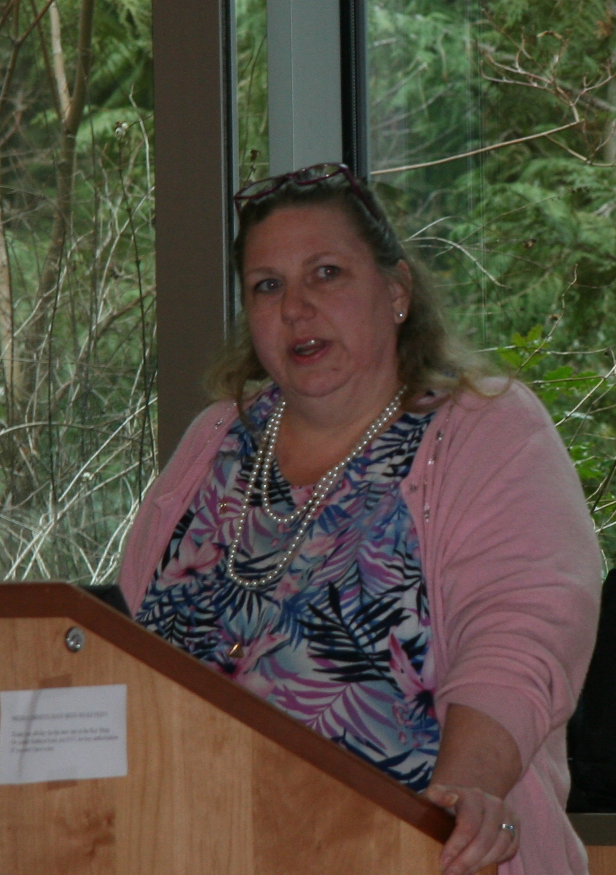
MPA-Tribal Student, Ronice Goforth
Puyallup Tribal Member
Raised in Northwest Oregon, Washington and Central Texas

Ronice has experience working at a Credit Union, Gift Shops, and Ceramics until an opportunity arose to work for my Tribe in 1992. She began as a temporary hire as the Tribal Council Secretary and moved to permanent status within months in the Tribal Employment Rights Office. A few years later began working for the Council for Tribal Employment Rights. She finally came back to the Puyallup Tribe as a temporary fill-in working administrative positions throughout the Tribe. Within a year Ronice became a permanent hire as the Legal Secretary in the Prosecutor’s Office. Within a few years she left to expand a personal owned seafood company. She has volunteer experience in Domestic Violence and Child Support, which eventually lead to a job in the Puyallup Tribe’s Child Support Program, as an Administrative Assistant, then advanced to the Accountant position for over 7 years, now.

She has served 5 years on the Fireworks Committee, 3 years on the Shellfish Committee and still serving as the Vice-Chairman of the TERO Commission (over 11 years).

She earned her Bachelor’s Degree from the Reservation Based / Community Determined Program at The Evergreen State College and is now currently enrolled in the Masters of Public Administration / Tribal Governance Program.

Previous colleges Ronice has attended include The Evergreen State College, Northwest Indian College, Pierce College, Lower Columbia College, Western Business College and Medicine Creak College.

The 2009 MPA Networking Potluck was a great sendoff for graduating MPA candidates, while establishing a connection between current students and alumni.

The potluck was created, with the assistance of Alumni and Career Services, by the MPA Student Union(MPASU) , to give both current MPA students and MPA alumni a chance to meet one another and share their experiences, insight, and wisdom. Furthermore, the potluck was a chance for attendees to honor departing faculty Nita Rinehart & Russ Lehman by sharing stories and thanks to both of them.

The original idea for the event came about during fall quarter '08. The idea was for the MPASU to have a job fair on or near-campus, specifically geared towards MPA students, MPA alumni, and area professionals. The list of invited attendees were to range from local, state, and government agencies, to profit and non-profit interests throughout the region. There was great interest in having such an event when initially proposed to both the Seattle University and UW MPA student unions. However, over the course of the fall and winter quarters, the original idea changed due to a number of reasons, with not the least being the economy and the expectation that invited employers may not attend.

So, through detailed and exhaustive planning, potluck organizers were able to design a flexible format that suited both students and alumni. The hope is that the potluck become an annual event both students and alumni can attend and build strong connections through.

Greg Cook
Newsletter Article

A typical Spring Quarter in the MPA program at The Evergreen State College?
Hardly.
At about 9:30, on a typical night in the Public Works class, an observer could see pairs of students focused on putting their final touches to . . . posters.
The scene: hurried consultations; last-minute writing or sketching with markers; just-before-deadline decision-making about presentation. And wandering through the scene is faculty member Rob Knapp calling out reminders of the impending “pin up” time, while MPA Director Cheryl Simrell King reinforces the urgency of finishing.
In a program known for innovation and ongoing evolution, the Public Works class (co-offered with the college’s Master of Environmental Studies program) stands out. Knapp and King had previously taught a version of the class as a two-quarter undergraduate program. The main theme is ecological democracy and involves the intersection of several disciplines: planning, administration, aesthetics and landscape design, architecture, and geography.
The class features alternating weeks of seminar on selected texts and in-class design projects. For a final project students work in teams to address a real-world design problem such as the need for more walkable green space and an urban core in Federal Way, WA. That work culminated in a poster and oral presentation. Faculty also group teams into panels, and the panels are responsible for making an overall panel poster.
Another feature of the class is a number of interactions with community members active in planning, building, designing, advocating, and communicating for a better future via a more sustainable and democratic built environment.
Through it all, students wae able to dust off artistic skills, make new connections with other students, think about design in both ideal and real situations, and learn about ongoing efforts at change in local communities.
Typical? No. Challenging? Yes. Rewarding? Absolutely.

Greg Cook is beginning his second year in the MPA program and hopes to graduate in June, 2010.

