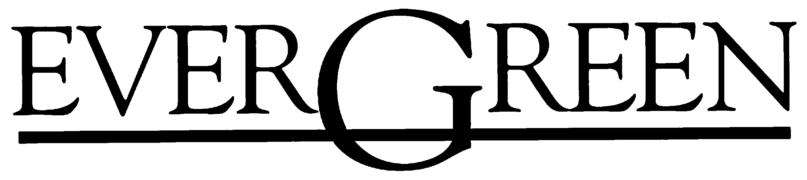
The Evergreen State College
Masters of Public Administration Tribal Governance Concentration Program
2700 Evergreen Parkway NW - Olympia, Washington 98505

Photograph and Video
Student Permission

At various times throughout the MPA Program, photographs or videos may be taken of you during class participation at Evergreen or while you are participating in an internship or field experience in the community. With your permission, the photographs and/or videos may be chosen for college recruitment publications, including the MPA Catalog, website and newsletters. If chosen, the photographs and/or videos will be used exclusively by The Evergreen State College and solely for non-profit purposes related to our education program.

Please check one of the following options and provide your signature. If you have any questions, please call Randee Gibbons, Assistant MPA Director at (360) 867-6554 for MPA-General or Puanani Nihoa, Assistant Director for the MPA Tribal Governance Concentration program at (360) 867-6202 Thank you.

Name (please print):________________________________________________________

Check one of the following:

□ I give my permission for photographs and/or videos taken of me as an MPA student to be used by The Evergreen State College for publication purposes.

□ I do not give my permission for photographs and/or videos taken of me as an MPA student to be used by The Evergreen State College for publication purposes.

Signature:_________________________________________________________________

Date:________________________________

