July 29, 2026

Twylia Dawn Westling STUDENT ID: A00283103
4408 Brown Pt Blvd
Tacoma, WA 98422

Dear Twylia,

I am pleased to inform you, upon recommendation of the MPA Admissions Committee, that you have been accepted into the Tribal Concentration of Evergreen’s Master of Public Administration program for Fall 2011.

Your admission to the MPA program requires that you complete an MPA-approved 4 credit introductory statistics course with a grade of “C” or better before you begin MPA coursework in Fall 2012. For a list of Evergreen and non-Evergreen courses that would satisfy the statistics requirement and other important information about the statistics prerequisite, go to the “statistics prerequisite guide” on the Admissions Requirements page of our website, at: http://www.evergreen.edu/mpa/admissionsreq.htm. After course completion, please submit an official transcript by September 15, 2012 to Jan Hays, MPA Office Assistant, at: MPA Program; Lab 1, Room 3019; Evergreen State College; 2700 Evergreen Parkway NW; Olympia, WA 98505. Your admission to the program will be withdrawn if we do not receive an official transcript documenting completion of the statistics prerequisite by September 15, 2012.

Congratulations on your admission to the Tribal Concentration of the Master of Public Administration program as an inter-year student. We select our entering cohorts with considerable care and admissions are quite competitive. You are part of a diverse, capable, and dedicated cohort of people selected to begin the program this year. We hope you accept this offer and look forward to working with you.

Sincerely,
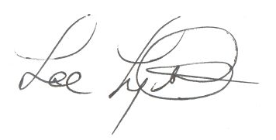
Lee Lyttle.
Director, MPA Program & Member of the Faculty
The Evergreen State College

