WHO SPEAKS FOR THE SAN FRANCISCO PEAKS?
A CLIMATE CHANGE DILLEMMA
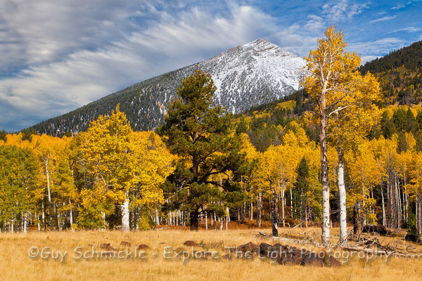

Abstract:
This case explores conflicts that emerged at a point where religion, culture, politics and science intersected in the San Francisco Peaks controversy. The controversy began in 1908 when the Peaks first became part of the Forest Service system. When the Arizona Snowbowl, a private resort concession, came to exist on the mountain, pressures grew: corporate owners saw limitations of profit-making proposals as a “taking.” Expansionary developments threatened the religion and cultural practices of 13 Arizona Tribes. Concern for pristine natural values associated with the Peaks grew after designation of the Kachina Wilderness in 1984. Drought and climate change strained the mountain’s role in recharging the Inner Basin, and the ski resort’s existence.
INTRODUCTION

The Setting

“All around the sacred mountains……
Whenever I need to locate myself
I look for the mountains I know
It doesn’t matter where I am
I look for the mountains I know
North, West, South, East, all around
They are the horizon we’re within.”
(Simon Ortiz)

The San Francisco Peaks rise dramatically from the high desert plateau of Northern Arizona. The Peaks have long fascinated people from different cultures with their beauty and diversity. They inspired many different people. The biologist C. Hart Merriam completed research work there in 1890, formulating his classic “Life Zone” concept from these studies. To the geologist, the three peaks ring a dormant volcano that erupted about two million years ago. At the upper reach, Humphrey’s Peak is Arizona’s highest point at 12,643 feet. Above 11,000 feet, the Peaks contain the only alpine tundra in Arizona. From the summit, one can view the north rim of the Grand Canyon, over eighty miles away. For the recreationists, spectacular trails, lovely picnic spots, areas for alpine sports, landscapes with high natural and aesthetic values, and opportunities to view wildlife make the Peaks a magnet. To the Hopi and Navajo and to many other Southwestern Tribes, these are holy peaks that comprise the very horizons of an intertwined cultural, religious and natural life within their homelands. Today the Peaks are impacted by the effects of climate change. The Schulz Fire recently burned 15,000 acres of forest, the City of Flagstaff faced drought conditions, and the Arizona Snowbowl became a marginal operation.

The Peaks are integral to the traditional religion, cultural histories and practices of many Tribes. They are one of the four sacred mountains of the Navajo people and they are extremely important to the beliefs and sacred geography of the Hopi. Today they sit within the boundaries of the Coconino National Forest. Ski enthusiasts started using an old cabin in Hart Prairie at the Peak’s higher elevations as a base for skiing in the 1930s. In 1937-38 a new base camp was established, the USDA Forest Service (United States Department of Agriculture Forest Service, henceforth Forest Service) built a lodge and the Civilian Conservation Corps built a road. The Flagstaff Ski Club formed to run the operation on a special use permit. After a fire, the lodge was rebuilt by the Forest Service and the road extended. By 1962, the Arnal Corporation took over what was now the Arizona Snowbowl operation until 1970, when it was purchased by Summit Properties, a subsidiary of the Post Company, a Texas-based land development corporation. The permit went back o the former owner for a time, and then it was transferred to Northland Recreation, Inc. in 1977. Changes in permit holders were matched by new proposals for operation and expansion. The change from operations managed by the Forest Service, to operations managed by local nonprofits, to private management and finally corporate management increased conflicting values and visions for the Peaks. Two wilderness areas were established, a natural research area was added and trails were improved, sandwiching the ski operation in-between areas now designated for their natural and pristine qualities. Pressures for expansion of the Snowbowl and associated profit-making activities continued over the years under corporate management. The Snowbowl sits on the Southwestern slope, the side where snow melts faster. As the effects of drought and climate change locked on, proposals took on a new shape.

Development proposals can be accommodated under the Forest Service’s multiple use policy, but they may be limited if they conflict with other values. Most recently, the proposals took a dramatic turn with the proposal to pipe recycled sewage water up the mountain to make artificial snow along with a request for major expansions of the facilities. Drought and climate change squeezed the already variable climate cycle and could reduce the ski season to a few weeks a year. The Forest Service first issued a permit for the artificial snow-making proposal 2005, based on the idea of increasing recreational and economic benefit by extending the ski season with artificial snow. Company spokespersons from the Arizona Snowbowl argued that business was marginal because the Southwest climate severely limited the number of days they could open ski runs. Drinking water was at a premium, so they claimed that piping in recycled effluent water from Flagstaff to make artificial snow was the only way that they could continue to provide this recreational opportunity and contribute to the community with jobs and other economic benefits.

The Navajo Nation, joined by the Hopi Tribe and eleven other Arizona Tribes protested the expansion and the use of wastewater on their sacred mountain as a transgression of their religious rights and as a health hazard. Traditional knowledge that pointed to the potential to upset the delicate relationship of weather to water on the mountain increased tribal concerns. This artificial snow-making proposal would be the first known attempt to use 100 percent effluent water to create artificial snow. Opponents, including scientists, environmentalists, and concerned citizens pointed to the effects of chemicals and impurities still present in the recycled wastewater on the environment and the potential impacts on recreational users. The loss of recharge from piping the wastewater up the mountain rather than allowing it to return to the aquifer during a period of drought was a concern for both citizens and scientists.

THE HISTORICAL RUN-UP TO CONTROVERSY: SAVE THE PEAKS OR PAVE THE PEAKS

The U.S. acquired the Arizona and New Mexico Territory through the Treaty of Guadalupe Hidalgo in 1848 after the war with Mexico, while accepting privately owned property, land grants and Indian treaty lands of the Spanish and Mexican period insofar as they understood them. Today, the San Francisco Peaks sit within the Coconino National Forest, a 1.865-million acre unit of the National Forest System near Flagstaff, Arizona. Originally established as the “San Francisco Mountains National Forest Reserve” in 1898 following John Muir and Gifford Pinchot’s famous tour of the American forests, it was designated as a national forest in 1908. Significant public protest occurred at this time because it was felt that the national public lands designation would limit economic development and extractive uses.

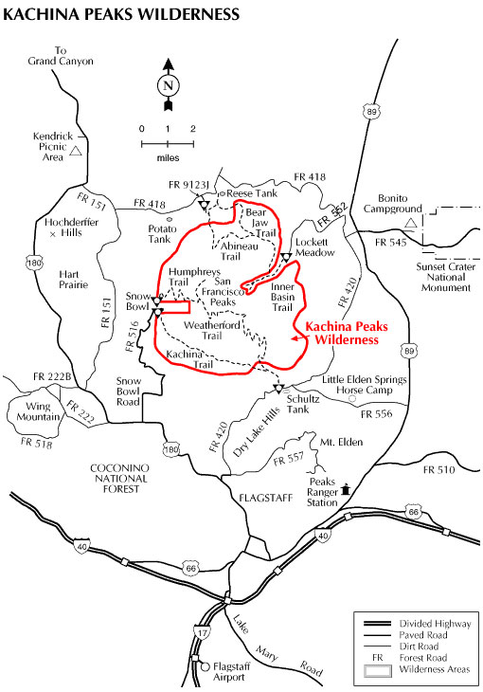

The Coconino National Forest sits within the largest contiguous ponderosa pine forest in North America. The forest contains all or parts of ten wilderness areas, designated under the Wilderness Act of 1964. The Peaks are located within the Flagstaff District, formerly called the Peaks District. The small ski run developed years ago on the edge of Hart Prairie in the San Francisco Peaks continued to grow. In 1984, when the Kachina Wilderness was designated under the Wilderness Act of 1964, the ski operation had pushed into the wilderness borders like a sort of lozenge. In the southern portion of the Coconino, Mormon Lake represents the largest natural lake in the state of Arizona and several other natural lakes dot the top of Anderson Mesa. On the southwest side of the mesa, Upper Lake Mary and Lower Lake Mary were constructed in the early 1900s as reservoirs for water. Wildfire heightens the concerns of surrounding communities. The lack of significant rainfall in early summer and spring, along with the higher temperatures and winds that are part of the unique cluster of climatic conditions that surround this mountain on the Colorado Plateau, led to high fire danger that was amplified by climate change.

The 1970’s brought a vision of the San Francisco Peaks as an opportunity for economic development. This initiated a controversy that has lasted more than 40 years. Summit Properties, owned by a Texas land development corporation called the Post Company, articulated a grandiose vision after they gained the special use permit. Working off the Snowbowl permitted area and using an additional 350 acre parcel of private land in the Hart Prairie area of the San Francisco Peaks, Summit purchased the Arizona Snowbowl ski area concession with the full intention of implementing greatly expanded facilities into the private lands that sat within the Forest Service lands at Hart Prairie. The Coconino County Planning and Zoning Commission rezoned the area in 1970. The development was to include 300 acres of hotel accommodations, condominiums, swimming pools, golf courses, trout ponds, tennis courts, and riding stables and a four million dollar resort/residential project. A vision of “Arizona’s Aspen” was unleashed, mimicking the high-end Colorado ski community.

The “Save the Peaks” movement birthed an opposing vision. The Sierra Club, the Hopi and Navajo Nations and local groups protested the impacts on their religious and environmental rights. The Forest Service held a series of public meetings. Opposition mounted to the “Aspen” development and the Planning and Zoning Commission refused a new zoning request from Summit Properties that would have approved the full Hart Prairie expansion in January 1972. (Richard and Jean Wilson Collection 1995, Cline Library, Special Collections and Archives Department, NAU. #NAU.ms.73 p.2 Historical notes). Professors from Northern Arizona University in Flagstaff commented. John Duncklee, one of those professors, wrote a long response to the studies and environmental statement that the Forest Service was working on at the time. He pointed out the lack of study and data gathering, the fragile arid environment, porous volcanic soils and the impacts of road building, the variable stability of the slopes, the extreme fire hazard in the area around Hart Prairie in the vicinity of thee Snowbowl, the importance of the San Francisco Peaks as a laboratory for scientific research, limitations of water provision with a growing population in Flagstaff: his research findings showed that 49 of the natural habitats in the Hart Prairie area were identified as slow to recover from disturbance. (Duncklee 1-11 archive.library.nau.edu/cdm4item_viewer.php?CISOROOT=/cpa&CISOPIR=611238&CISOBOX=1&REC=2 Cline Library Special Collections and Archives Man-Land Relationships on the SF Peaks: A Preliminary Report by John Duncklee 1971. John Duncklee Collection http://www.azarchivesonline.org/xtf/view?docld=ead.nau/duncklee_john.xmlk). Duncklee continued to participate in the dialogue. On May 19, 1972, he attempted to frame the conflicting dialogue as he wrote to the Forest Service that “the greatest economic potential of the San Francisco Peaks is the natural beauty, relatively free of human interventions….motel owners, ski operators, loggers and sub dividers will disagree.” (Duncklee, letter)CISCOROOT=cpa&CISOPIR=459337EE=9 ) In 1973 Richard and Jean Wilson, local landowners who wanted to preserve the natural qualities of the Peaks, filed suit against the County Board of Supervisor, the Planning and Zoning Commission and Summit Properties. They sued to repeal an earlier 1970 rezoning of Hart Prairie, and were in turn sued by Summit Properties. Summit Properties added the USFS, the Museum of Northern Arizona and even the Tuba City School Districts to their list of as co-defendants. Professors from Northern Arizona University in Flagstaff commented.

A mediator appeared in the form of the Coconino Citizens Association. They worked toward a balanced solution by developing the idea of purchasing the privately-owned Hart Prairie acreage at market value. A land trade with the Forest Service was suggested. Finally the Forest Service was able to move to purchase the property. The Forest Service appraisal appeared six months later, slow and low, according to the corporation. Negotiations continued until 1977, when a deal was struck and expected funds were generated by the Land and Water Conservation Fund Act. The deal was closed in January of 1978. These early years of battle resulted in modified proposals. The grand vision of connecting a great ski resort on public land with a full scale recreational village, with housing and economic centers stretching into private land was put aside.

But this was not the end of it. By 1978, the Arizona Snowbowl’s new owners sought expansion again. Northland Recreation claimed a growing interest in skiing and sought approval for proposed developments under its existing use permit. The protests began again with all the usual suspects--the environmental organizations, the Hopi and Navajo Tribes, and many local residents versus other local residents, the corporation, investors and those who stood to benefit. Again, the Forest Service held public meetings and solicited input. The expansion included a development plan designed to increase capacity from 552 to 2,835 skiers. The Forest Service added some modifications, limited the expansion to the existing area of the permit and labeled the approved plans a compromise between the requests of Northland and the Navajos and Hopis. Initially, the decision was halted and reviewed within the Forest Service and the expansion was limited to basic maintenance and the addition of a paved road. But political levels intervened in Washington: a fuller expansion of the permitted area and mechanical improvements was approved by Forest Service Chief Max Peterson. And just as soon, everyone was back in court with another suit filed by the Navajo and Hopi nations, the Wilsons and The Navajo Medicine Man Association. Rulings decreed that the plaintiffs had not met their burden of proof. Further review was denied. The new all-weather road increased the development potential of the Snowbowl. However the grand vision of connecting a great ski resort on public land with a full scale recreational village, with housing and economic centers stretching into private land was put aside. Having won enough to make it dollerable with a profitable sale, Northland got permission to have its Forest Service use permits transferred to Fairfield Snow Bowl, Incorporated in 1983.
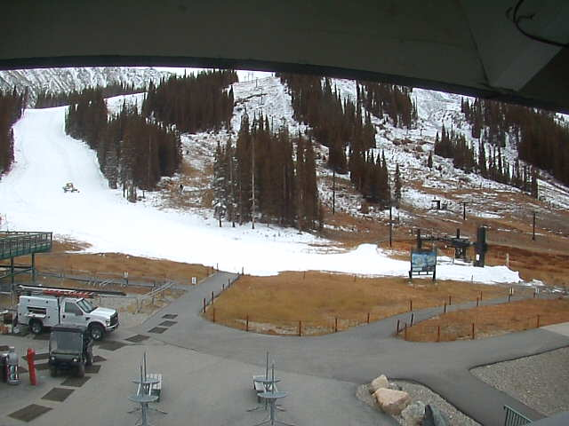

One might think the story ended there. But this was not the end. Faced with long-term drought and extremely variable ski seasons due to the lack of snow connected to a long-term pattern of climate change, the Arizona Snowbowl Resort Limited Partnership began to explore the use of artificial snow. In peak years, the Arizona Snowbowl might see over 150,000 skiers and 450 inches of snow. During years of low precipitation, the numbers can drop to less than 3,000 skiers and less than 90 inches of snow. (LawJour for Social Justice ASU March 1, 2011. In the 2001-2002, the Snowbowl opened for only four days. http://ljsj.wordpress.com2011/03page2/)

Artificial snow was proposed as the cure-all. But where would they get the water? The Peaks had no water source. Flagstaff was already facing limitations to its growth and development plans due to lack of water. Then why not use wastewater? The company proposed the purchase of wastewater from the city of Flagstaff. Quietly, without public process, the Arizona Department of Environmental Quality approved the use. This would be a win-win for the city and the Snowbowl, right? The Snowbowl paid no taxes to the city because it was outside the limits. So, here at last, was some revenue coming back to the city from the Snowbowl from the sale. Wastewater could be pumped through pipes up to the ski area and a reservoir could be constructed to hold it. Later, it could be pumped to fan guns that would spray it over more than 200 approved acres.
The Navajo and Hopi, now joined by other tribes, had a different reaction. Here was an idea a thousand times worse than any of the previous ideas. What could be worse than transforming the physical and spiritual ecosystem of a holy mountain by clearcutting a substantial area of its forests, digging gigantic trenches up its side and pumping millions of gallons of wastewater up its flanks to make fluffy snow for the luxurious ski vacations of urban dwellers? They were back in court by 2006.

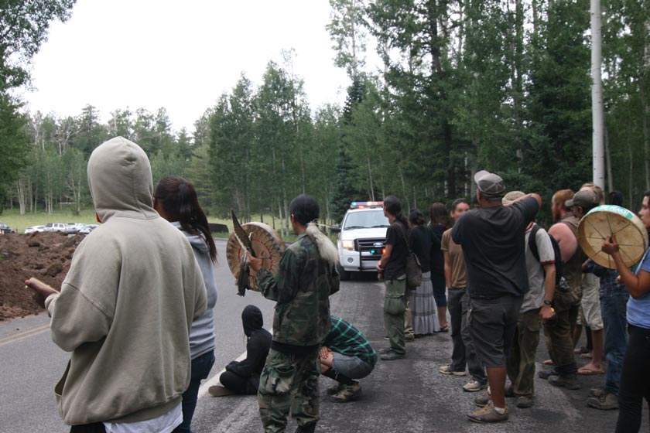
Now skilled in media and Internet-capable, young Indian people and interested activists around the world began to fill cyberspace with information to educate the internet world on their views. Led by Klee Benally, Jr, a talented Navajo videographer and media artist, they hit cyberspace like a blizzard. Numerous sites appeared, along with twitters and blogs and zines dealing with the Snowbowl issue to fill the cyberclouds. The Save the Peaks Coalition Benally led linked tribal members with activists and environmental groups here and abroad. You have only to Google a cluster of key terms like Arizona Snowbowl and San Francisco Peaks, and their dominance of the cyberwaves will appear. This cyber- information campaign effectively promoted the organization of marches, prayer meetings and protests. Their stories even appeared in skiing publications like the Mountain Journal. They were balancing the generally negative information in the local press. Brenda Norrell, who writes for the Native American press, drew a parallel between the local news and the slanted press during the civil rights movement: “The news coverage in the Arizona Daily Sun on the Snowbowl issue, and those defending the sacred San Francisco Peaks, is reminiscent of the news before the Civil Rights era, before Rosa Parks sat down on that bus and before the march to Selma. It stings of racism.” (norrell.blogspot)

Tribal governments passed resolutions against the development and sued again and again. New laws and policies seemed to recognize tribal religious rights. The newer Religious Freedom Restoration Act of 1993 seemed to hold promise. After all, it said the government can’t place a substantial burden on a native religious practice unless it meets a compelling government need. Clinton had announced Executive Order 13007 for the protection of and access to sacred sites, and President Bush also issued an order. President Obama began his administration with a meeting of tribal leaders to hear their concerns. They sent a clear message about consultation and about the developments at the San Francisco Peaks. Still, the prevailing winds in the courts had not changed. Though they lost in federal court in Arizona, the Tribes appealed to the 9th Circuit Court of Appeals in San Francisco and appeared to have a win, with two or three judges siding with them. But legal maneuvers forced an enbanc decision by additional members of the appellate court. The en banc court could not see how the wastewater snow “substantially burdened” the free exercise of religion and they reversed the original decision of the 9th Circuit’s three judge panel... Portions of the majority ruling by Justice Cario Bea seemed disengaged from pertinent facts: Giving one religious sect a veto over the use of public park land would deprive of the right to use what is, by definition, land that belongs to everyone.” (http://www.azcentral.com/arizonarepublic/news/articls/2009/06/09/20090609snowbowl 07/11/2011)

But these were not parklands; they were in a national forest. Even if they were parklands, such a huge multi-million dollar development in a sensitive alpine area would controvert the mission of the National Park Service to “preserve unimpaired” while providing for public use and enjoyment. But these were national forest lands, and though differing in mission, current environmental laws and legislation limiting certain uses in certain spaces would apply to them as well as to the National Parks. And some argued that the ski development was only for those who could afford more expensive recreation, while it limited opportunities for other kinds of popular recreation by chopping up the land base and re-purposing general parking for other recreationists. Adjoining lands had already been designated as wilderness. The land use Judge Bea reviewed was only for recreational skiing: she missed the fact that skiing was not the dominant outdoor recreation use of these public lands. In fact, the ski expansion had negative effects on other users who formed that vast majority of forest users enjoying the Peaks for hiking, picnicking, biking, photography and a myriad of other uses. The Justice also seemed unaware that the Farm Bill of 2008 gave the Forest Service the power of closure for American Indian religious practices: they could limit public access when required by Tribes to perform ceremonies. They also gained the power to hold sensitive information about sacred sites secure from public access and unaffected by public information laws. The judge took the majority opinion view that access was the only key to religious freedom. The court would entertain no modifications to the proposal this time.

Legal scholars interested in social justice cried foul: “In practice though, these laws have done nothing to stand in the way of allowing Phoenicians to ski on frozen fecal matter, literally urinating on the spiritual beliefs held by indigenous people for centuries. (LJSJ, ASU p.2) Even the Wall Street Journal picked up the irony with an article entitled: “Tribes find Phony Flakes Disrespectful like Bombing a Church.” (Miriam Jordan, gaduginews.blogspot.com/2010/08 save-peaks-wall-street-journal-navajo.html 3.23.11) The plaintiffs made a run at the Supreme Court, but their pleas were refused in June 2009 and so was their case. The Tribes would have to turn to the second point of their case---the public health dangers posed by the Snowbowl’s wastewater snow project that would pipe up 180 million gallons of treated sewage water every year and then release it on the Peaks.

Courts that could not comprehend tribal religious needs and legal maneuvers continued to stymie any resolution acceptable to the Tribes. Still, there were the promises made by the Obama administration. The Navajo Nation Council passed a resolution on Earth Day April 22, 2009 calling or the President to step up and protect sacred places. USDA, the hierarchical parent of the Forest Service, became involved. They hatched a new idea----what if the federal government paid for potable water for the artificial snow? Surely this would be less offensive to the Tribes. They didn’t think to engage in meaningful consultation with the Tribes. In 2010, Flagstaff City Manager Kevin Burke revealed a plan, negotiated with the USDA, to use Flagstaff drinking water instead of the sewage water.

The new USDA proposal quickly fell on its own sword. Tribes were not consulted: it was still an insufficient modification for the Tribes and they publicly rejected it. Further, Arizona’s political delegations were largely against it. Senator McCain spoke out against this waste of 11 million dollars of federal money that would be paid to the Resort to subsidize the increased costs of using potable water in these difficult economic times. Arizona’s political elite had long weighed in on the side of the Snowbowl. Former Secretary of the Interior Babbitt, once steward of the trust responsibility to Tribes, was hired as a Snowbowl consultant to help them push their project through the federal hoops. Legal maneuvers and political pressure worked well in the past, and the Arizona Snowbowl Resort continued on that path. Initially the proposal for potable water was considered by the city of Flagstaff, but a citizen uprising pounded the nails in its coffin. The community was too water-wise to sell off their potable water supply for the pleasure of a limited number of snow recreationists or the benefit of a corporation. The real payoff to the citizens of Flagstaff was small. Although short-term construction jobs could appear in the early stages, only low-paying seasonal jobs were likely to emerge from recreation corporations. And the Snowbowl was located on federal land and would never pay city taxes.

The political winds changed with a new administration in Washington. The Obama administration made promises to the Tribes; Obama spoke of the need to protect sacred sites. Secretary of Agriculture Vilsack ordered the Forest Service to hold off on the permit in June 2009. Tacking in a different direction, the Secretary ordered a review of the Forest Service’s sacred sites policy. In July of 2010, the Forest Supervisor wrote a letter giving clearance to the Resort informing them that they had immediate permission to proceed with their proposal using wastewater or potable water and added further modifications to their benefits. Things had changed since the eighties. Internal reviews did not lead to decisions. Orders from the top changed the decisions when the political winds blew. The value of professional expertise was now challenged by the political levels of agencies, creating instability and reducing flexibility. Another suit was filed, holding up implementation of the permit.

The Snowbowl Resort was so anxious to get the pipeline in that they accused the local Forest Service of delaying the process after the Supreme Court rejected the request to hear the case. The Coconino National Forest was moving ahead, but it had hoped to further settlement talks between the Tribes and the Resort to achieve better implementation. Even under difficult circumstances, the ground level was hoping to improve project implementation and they looked for any acceptable modifications. Tribal representatives were invited to planning sessions and could comment on the layout of pipes and other features of the proposal.

Despite these efforts for incremental improvement, political pressure from Arizona’s congressional delegation and elected officials put things on a fast track. A few months after the letter authorizing the Snowbowl to begin work, the Secretary of Agriculture opened up a new review of sacred sites policy that seemed to challenge the entire permitting process on the Peaks. Was it just a “we’ll do better in the future,” or was he engaging real change and a new look at the Peaks controversy?

A year later in 2010, a national program of listening sessions on sacred sites policy began, led by top officials of the Forest Service. Consultants included the Environmental Conflict Negotiation component of the Udall Institute at the University of Arizona who began the work along with tribal liaisons from both the Forest Service and the USDA began the work. Due to the previous experiences of Tribes, they could view these “listening sessions” as a limp response. But this time the level of accountability was higher. The sessions took on a more serious tone with the presence of a court reporter, due dates and advanced planning in place, and the eventual production of a draft document that outlined significant changes in the current sacred sites policy. Still open to comments in draft form through October 2011, it would cast a shadow backward on the permit decision even in its draft form. But would this mean anything for the Tribes?
It was time for another fatal irony. As the listening sessions were progressing, and the Tribes and their partners continued to pursue its legal battle in a lawsuit around public health hazards after losing on the religious issue, U.S. District Judge Mary Murguia denied the injunction requested by the Save the Peaks Coalition and nine plaintiffs in their new lawsuit to stop the clearcutting and construction of the pipelines to carry the effluent water up to the Peaks. On April 1, 2011, the Ninth Circuit Court of Appeals followed her lead by denying a motion by the Save the Peaks Coalition to stop the Snowbowl Resort from cutting down approximately 30,000 trees. The Resort would not wait have to wait for the legal process to be completed any longer. Interviewed by Indian Country Today just days before the Ninth Circuit wrote its opinion, the Resort’s general manager said “We have the permits and authorization …And we will proceed once the ski season is over.” (Berry, Carol, March 28, 2011, ICT, http://indiancountrytodaymedianetwork.com/2011/03/san-francisco-peaks-on-schedule for artificial-snow-from-water 6/28/2011) Initiating millions of dollars of construction costs would help tip the balance. Who would want to stop a business that just made a big investment from expanding in these economic times? Some wondered if the Resort wasn’t preparing for a sale again, now at a much higher price because it could claim that it was now a stable business, seemingly free from the vicissitudes of the extreme weather variations and extremely short ski seasons from the shadow of climate change.

On May 24, 2011, a massive industrial-scale construction project began trenching and blasting along the road to the Snowbowl to install the 14.8 mile wastewater pipeline. Trees crashed to the ground as clearcutting began. The Save the Peaks Coalition and other activists organized a full scale attempt to stop the project, chaining them to heavy equipment. Arrests and complaints followed. Though delayed, the project went ahead. Hopi Radio KUYI provided this report from the Coconino County Sheriff’s Office on June 16, 2011: “Summit Firefighters cut the chains and locking devices off of each protestor. As one juvenile was being freed she began to pass out and was immediately
accessed by medics….Five adults and one juvenile were arrested and transported…”
(http:intercontinentalcry.org/protest-halts-snowbowl-destruction-on-san-francisco-
peaks/ 8/28/11)

Delays and closures for hikers and summer recreationists stretched over at least five months. Hikers, picnickers and general recreationists, though they were the dominant users of the area, didn’t make money for the resort like skiers.

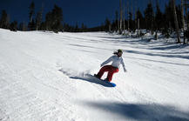

The Arizona Republic provided a reasonably balanced review of the existing conditions:

The coalition of Native Americans and the environmentalists, including the
Sierra Club that took Snowbowl’s landlord, the U.S. Forest Service, to federal
court in 2006, vowed to take other action including congressional action or a direct
appeal to President Obama. But Eric Borowsky, the majority owner of Snowbowl,
countered, “We’ll just deal with everything they come up with. (http://www.azcentral.com/arizonarepublic/news/articles/2009/06/09/20090609snowbow. 07/11/2011)
A central point of information, indigenousaction.org kept news of the protest going. A 58 page blogspot gave voice to the protestors:

Keith Barney, Navajo, 22, arrested said, ‘With my involvement in physically
attaching myself to an excavator I put my own health at risk in order to speak
and act on behalf of all those who cannot speak for themselves: the birds, the
plants, our Holy people and those yet unborn….this is a continuation of years
of resistance, prayers, and legal battles… (http://bsnorrell.blogspot.com/2011/06/
photos-san-francisco-peaks-lock-down.htm. 6/28/11)

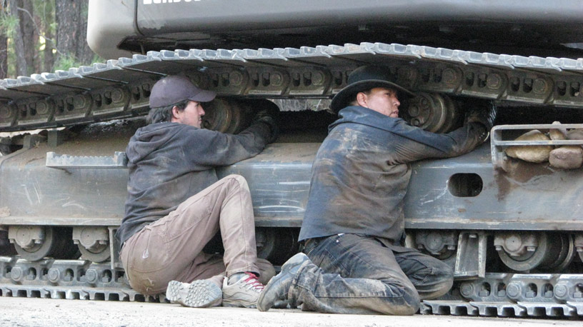

After the arrests, activists maintained encampments to observe the continuing construction. They watched the creation of a gash six feet wide and six feet wide and six feet deep to lay the pipes. Also on the construction agenda was a reservoir, new runs and lifts, additional parking that would make parking for hikers less convenient, the aforementioned 14.8 mile pipeline, clearcutting 74 acres of rare alpine habitat that is home to threatened species, a 12 million dollar snowmaking system, and a conveyor-belt style people movers on the beginner slopes. Meanwhile, environmental activists posted the news and looked beyond the San Francisco Peaks to other points of desecration:
As we take action, we look to the East and see Bear Butte being desecrated.
Mt. Taylor facing uranium mining; to the South, Mt Graham desecrated, South
Mountain threatened, the US/Mexico border severing Indigenous communities
from sacred places; to the West, inspiring resistance at Sogorea Te, Moanan
Keys facing desecration; to the North, Mt Tenabo, Grand Canyon, Black MeSa
and so many more…our homelands and our culture under assault.
( 2011 http://climate-connections.org/2011/06/16/protest-halts-snowbowl-destruction-on-san-francisco-peak s/ 6/8/11) Posted by Ahni (2011) Protect the Peaks-stop destruction and desecration now.” Retrieved 6/28/11 from: http://intercontinentalcry.org/protest-halts-snowbowl-destruction-on-san-francisco-peaks/

The only place where silence reigned was the federal courts. The Tribes had lost again.
NATURAL SCIENCE AND THE PEAKS

The sections below describe how various disciplines understand the Peaks. Western science relies on measurement and the scientific method. Even within the scientific perspective, different conclusions emerged. Research scientists and the bearers of traditional ecological knowledge agreed on one point: this was a delicate system that could easily be disrupted. The corporate analysis arrives at a different conclusion.

The Meteorological Mountain Magnet

Meteorologists describe an exciting and dynamic climate system at work in the Southwest. It is both dynamic and delicate: it could spin into unpredictable cycles by changing any element. The San Francisco Peaks are the epitome of this system: their location, altitude and storm-attracting qualities affect large areas around them. Spectacular thunderstorms, winter snows, monsoons, flash floods and lightening punctuate these arid and semi-arid areas with diverse climate conditions. Temperatures warmer than other parts of the United State hold sway for most of the year. Blue skies, followed by enchanting sunsets are the norm. Here climate, through its interaction with water resources, creates remarkably diverse ecosystems. Climbing through mountains like the San Francisco Peaks, you ascend into distinct climates and experience diverse kinds of weather. Altitude is everything here. For every 1000 feet of elevation you gain as you climb, you experience the same effect as if you travelled five degrees of latitude (300 miles) north: for every 1,000 feet of elevation, temperatures usually cool 4-5 degrees (Woodmency, 2001). This makes every elevation on the mountain important and each reflects its particular type of ecological diversity. Our understanding of this varied, delicate, and even freakish climate system in the Southwest is limited: only 100 years of climate records exist.

The drier climates of the Southwest are relatively new. Paleontologists say the Pleistocene, the period 1.8 million years to 12,000 years ago, was much wetter. As the great Northern ice sheets melted, the climate became more arid. Now, cycles of weather, air and ocean currents shape the weatherscape and the waterscape. These oscillations follow the natural temperature cycles on the surface of the Pacific Ocean and have global effects. We do know that above- or below-normal precipitation frequently occurs and is said to be connected to El Nino and La Nina when temperatures in the equatorial Pacific Ocean are warmer than normal during December, or when those temperatures are cooler than normal. These oscillations can produce extreme temperature variability. Climate change effects further disrupt even these somewhat erratic weather patterns. Low rainfall in spring and early summer combined with high winds make the Peaks and much of the Southwest particularly fire prone. Changing the system by adding large amounts of artificial snow would have unknown effects.

Topography is key to understanding the significance of the San Francisco Peaks. It is a global story of storms, winds, and jet streams. Westerlies blow the majority of storms to the north of the Southwest region, which sits on their southernmost end. Pacific storms dump most of the moisture on the Sierra Nevada, and drying air passes over the lee side of the mountains in a rain shadow. From there on, through the Great Basin and the Southwest, significant precipitation drops when the air encounters a mountain range. The position of the San Francisco Peaks at the western side of the Southwest makes it a primary attractor of rain from the Pacific system. The Peaks have their own rain shadow on the lee side, while the windward side attracts more moisture.
(illustration..need to scan )

The Peaks help trap the cooler night air in the valley below, providing moisture through morning fog. The dew point, the temperature to which air must cool for dew to form, is reached when mountains and high mesas trap the night air, and plants receive moisture even without rain.

The San Francisco Peaks are in a semi-arid zone: at elevations of over 3,500 feet, they experience below-freezing temperatures, ice and snow and 10 to 20 inches of annual rainfall. Rising higher, the snowfall in the alpine regions of the Peaks is vital to the forests and to the valleys below where less precipitation falls. This snow melt supports the ecosystems below the mountains and provides more moisture to lands on the windward side. In Navajo culture, they are connected with the male, or hard, rains. These can occur on the Peaks but are rare in the drier regions below. They bring moisture and recharge to the system. In the summer, the Peaks bring more rain. Their higher reach brings them into contact with cloud formations at mid and higher elevations. Thunderstorms occur five times more frequently over mountains than they do over valleys. (Woodmency, 2001). Fed by the North American Monsoon flow coming up from the South, the convergence over the interior of Mexico is drawn northward over the Southwest (Woodmency, 2001). Because mountains generally have more cloud cover and more forest canopy, they maintain cooler temperatures than the lands below. The dew point, the temperature to which air must cool for dew to form, is reached when mountains and high mesas trap the night air, and plants receive moisture even without rain.
Illustration: thunderstorm formation tba have to scan

Hydrology

The Peaks sit on top of an aquifer that forms a vast underground lake. The Dakota-Glen Canyon and the Coconino-deChelly aquifers cut a wide swath north to south in the Colorado Plateau. In this arid land, replenishing the aquifer is an inefficient process. Though snow and rainfall are limited they flow into the hydrological cycle in ways that are predictable and essential to life. (Sadler, 2007). Precipitation plays a major role, though it is itself naturally unpredictable. Mountains receive twice the amount of moisture as surrounding deserts. During the hard rains of summer, moisture quickly runs off and may even evaporate before it flows into streams. Winter snows may melt slowly enough to recharge the aquifers, but if higher temperatures prevail, they may evaporate or run off like the summer rains. Four factors influence how much moisture remains in the hydrological system: soil type, plant cover, sunshine and wind. (Sadler, 2007). The Peaks have wide temperature fluctuations, so the heat they absorb during the day may be released into the dry air at night resulting in more evaporation. Areas near the Peaks benefit from the moisture they attract in summer monsoons, snow and later, snowmelt, because this precipitation moves down in the hydrological cycle to create lakes and recharge the aquifer. Disruptions in this process, like changes in timing, the aftermath of forest fires, or prolonged drought can have devastating effects on lower elevations. El Nino and La Nina can both increase the variability of temperature and precipitation. In looking at long-term climate trends, drought appears to be more common and current climatic conditions begin to stress the Southwest and areas across the globe with increasing severity, (Sadler, 2007).

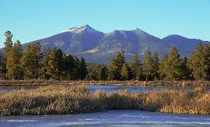

The climate system on the Peaks produces a hydrological bounty both delicate and diverse. Springs and seeps that dot the region provide vital water resources for plants, wildlife and traditional agriculture. Water dissolves, percolates, evaporates and returns as dew, and winds its way to the surface from the aquifer below. Seeps and springs are indicators of the health of the aquifer: their disappearance has direct impacts on the ecosystem. The condition of springs, critical to biodiversity, is in crisis: “More than 90% of the springs in the Southwest have been dewatered or are ecologically impaired because of groundwater pumping, development, or modifications for livestock or potable water use.” (Stevens, 2007)
Streams form when the water does not evaporate or seep into the ground. Streams at higher elevations are typically more pure: they pick up sediments, salts and minerals later as the flow and cut through the terrain below. The pristine, cooler waters of the higher elevations provide habitat for species of fish, insects and animals that require those conditions.

Large amounts of water can be withdrawn from the aquifer using the pump technology developed in the 1940s. When discharge exceeds recharge, the water resource becomes depleted. Drought conditions, increasing populations and use for developments in the Southwest can slow recharge. Yet groundwater can be less dependable than surface water due to three factors: 1) groundwater quantity and movement can be difficult to gauge 2) regulation of groundwater permits and usage may be poor 3) coordinated management between surface and groundwater may not exist. In addition, large withdrawals without recharge can cause groundwater to shift in the aquifer system. It might not be found where it was found before. With the growth of Flagstaff in this arid environment, the balance between withdrawals and recharge was lost. The area was expected to run out of water resources by 2050 despite the vast underground aquifer. A great amount of water rests in the older deeper alluvium that has limited permeability: this water is generally inaccessible below the depths of about 1,000 feet. (Logan, 2002).

In any case, taking increasing amounts of water without coordinating withdrawals with recharge can result in problems. The city of Flagstaff developed around the springs along the mountain’s inner basin. Later, Lake Mary Reservoir was developed and today most of the city’s water comes from Lake Mary and Woody Mountain well fields (Hyde, 2002). The wells are all ready 2000 feet deep. Though sufficient recharge exists to extrapolate a healthy aquifer into the future, the city would have to go deeper and deeper if the current rate of discharge continues. And that could be prohibitively expensive. In the Southwest, the older alluvium can have low permeability with a prevalence of “consolidated rock” and can be generally inaccessible below depths of 1000 feet. (Logan, p.19) Flagstaff is already pumping water at significant expense.

Water for the City of Flagstaff is expected to become a serious problem by 2050.
Today, there is a general reliance on technological expertise in the management and the exploitation of the water resource (Logan p.8) Meanwhile, in the ancestral memory and cultural heritage of the Indian cultures of the Southwest is knowledge of the crash of the Hohokam water systems that forever changed the future of that civilization. (Ishii, 2011) Traditional ecological knowledge suggests that disrupting the natural systems endanger future access to water.

Biology

Even a small amount of water, a temporary rill down the mountainside, a waterhole in the rock or the smallest of springs acts as a vital resource for plants and wildlife in the Southwest. From the biological perspective, water is life and life is water as we study how biological factors and human behavior interact with the environment. Larry Stevens, an evolutionary biologist, points out two processes that strongly affect life and biodiversity across the gradient of habitat zones:
1) The disturbance regime…the periodic, sometimes catastrophic episodes of
flooding, drought, fire and rock fall that regulate the stability of the ecosystem
and which life forms are sustainable and when they can reproduce and grow
2) Productivity influences the growth rates of individuals and populations, as
well as their trophic level, or position within the food chain: it also affects their
ability and speed of recovery. It is a function of slope angle, aspect (slope
direction), elevation, soil type and other factors modified by the size isolation
and proximity for dispersal corridors of the habitat. (Stevens, 2007 p. 52)

Remarkable ecosystems, biological surprises, and unique species of insects, amphibians and reptiles characterize the Southwest. They are often fragile, some left over from the Pleistocene and others still adapting to the relatively new arid environment. Their sustainability is questioned today by the massive human interventions in the water supply to support human demand and recreation. Vulnerability to certain factors and life cycle requirements of each species also affects their ability to sustain life. In this delicate environment, endemic species are especially threatened by changes in the water system, chemicals in the water and by the introduction of alien species: all of these factors are enhanced by climate change. Amphibians like frogs are particularly sensitive. Better education and management and improved studies of what habitats are threatened are a prescription for a more sustainable future for these diverse life forms. (Stevens, 2007)
The rare alpine Southwest was refugia that is increasingly important for animals migrating from hotter, drier climates. Wildlife migrations due to climate change were being documented in many areas: animals like the pika in Yosemite were moving up to higher elevations all over the world. (Science, 2011)

WHO SPEAKS FOR THE PEAKS?

Many voices proclaimed their unique vision for the Peaks. Each claimed that they held evidence that had ultimate credibility. The Tribes claimed their rights based on native religion and the spiritual dimension of the Peaks. Their evidence was based on lifeways that were thousands of years old. Their detractors attempted to confine religion to smaller, specific sites and structures, avoiding the systemic and inclusive nature of tribal religion and traditional ecological knowledge. Scientists described their understanding of the Peaks and analyzed the impacts of development on weather systems, hydrology, water quality, and biological resources using Western scientific method. They were countered by those who implemented bureaucratic rules that excluded large bodies of scientific research. Agencies like the Forest Service attempted to implement a planning process under the National Environmental Policy Act, but some of the policies and laws they were required to use were unclear and ill-suited to the analysis of this situation. The entrance of full-blown corporations provided entry into the world of politics. Ultimately, political pressures could derail nearly any process or expert opinion. How was one to evaluate the credibility of evidence from any of the voices?

Native Religions and the Spiritual World of the Peaks

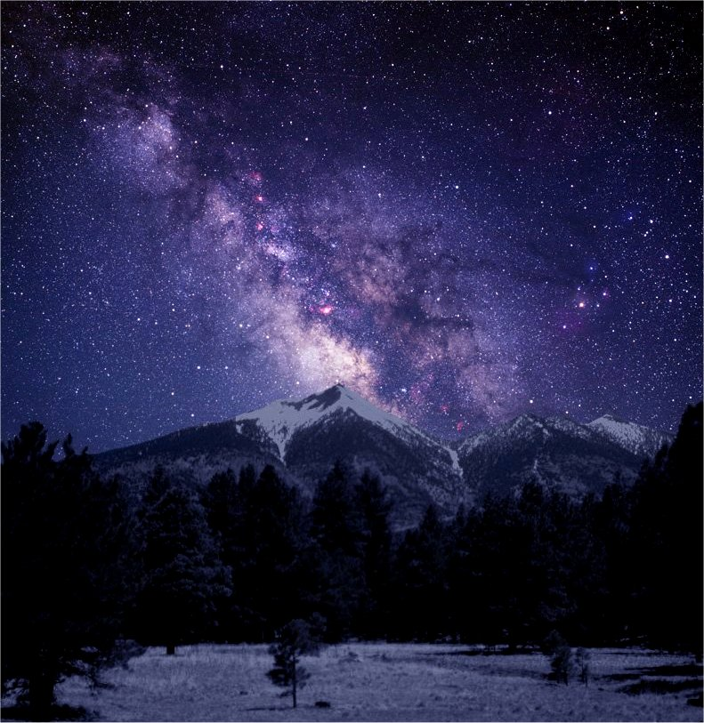

Before the battle for the Peaks began, few realized how integral they were to the religion and spiritual practice of 13 Arizona Tribes and possibly others. The relation of humans to their environment produced a different understanding of the human-nature in indigenous thought. Rather than the control of nature, a cooperative and democratic balance was sought:

You are but a small part of the puzzle in this great mystery. You are no greater
than the clouds, no greater than the little ant crawling here. No less than either one.
Everything is balance. Everything is the way it should be. And to disturb one to
remove one is to send ripples out, both in the physical and the spiritual. And it
comes back to you in some form. It is a very powerful vision I grew up with daily.
My whole world was my horizon. Nothing else existed beyond that. My world
is what nurtured me. And my whole prayer echoed from one valley to the other
and back again. (Shonto Begay p.64)
In this short explanation, Shonto Begay related the integration of the physical and spiritual in the Navajo world view. It is a dynamic vision where what you do comes back to you. It is energized by prayer that can move out great distances. Certain features, like mountains, form sacred spaces and reverberate with prayer. The four sacred mountains, of which the San Francisco Peaks is one, carry deep meaning for the Navajo:
They sent words or news or something like that to these sacred
mountains. Whatever is happening out here on these sacred mountains, there is a
medicine man that uses prayers. And then the winds send the message to these
four main sacred mountains. This is how we always say we hate to have these
mountains destroyed. Because it talks like us in their way. Just like the trees
when the wind, the breezes and you could hear the sounds of it. And even the
grasses and whatever herbs there are, they are talking to each other by whispering,
or they might be praying. Or they might be singing. That is the song that we
hear. If they are destroyed we can’t use any medicine out of there. (Roberta
Blackgoat 65)
The mountains are sacred points in a spiritually energized world where everything is connected. The relationship to the physical world is intimately tied to the spiritual world and to health:

Everything here between the earth, the sun, the moon is all related. It is all
related to ceremonies, or it is all in the creation stories. Before humans, before
we were made, there were only deities, spirits that were in this here world. They
were part of being healthy. For us they are part of Nature that we have to use to
get knowledge to take care of ourselves, our family, our relatives, and maybe
for our society….In our culture we have the benefit of having it in our creation
stories. And we can relate back to it to help us be better people, to help us acquire
the knowledge to function and have respect for ourselves and everything else…..
and the spiritual knowledge that I gain makes me feel very happy and makes me feel
good, and makes me be aware of more of Nature. The air, the mountains, the waters
and the plants. This is their prayer. (Herman Atine 65)
Prayers are sent directly out to the mountains and the mountains are represented by beauty. The Peaks are represented by abalone shell:
When we say prayers, we send it off to the mountains, four directions. And we
do have Sacred Mountains, within which we call the Holy Land Dinetah. It is
magic because prayers, chants, observing certain ways of life, of living with the
earth are observed….Everything is a cycle…Things happen and happen again…And
to destroy something without thinking, plowing a huge piece of land…you have this
great disturbance. (Shonto Begay 66)
Besides forming points on the four horizons, the four sacred peaks have a special connection to their religious understanding of the gift of language:

So in our offerings, in our prayers, we always start out with the beautiful language.
From here on, may it always be beautiful. And that’s why you name the four
mountains, the four directional mountains, because that’s where we acquired
the language. And they’re placed in the mountains. That why we go to these
mountains and we make offerings to them on a yearly basis, to continue that.
…..And our west mountain is Dook’o’ooslid, and when you say Dook’o’ooslid,
you say, ‘From the tip of the Peak of San Francisco, may you always have this
beam of light to light where I’m going, whether it be day or night. May that
beam always be bright for me so that I know my path, where I’m headed.
(Shonto Begay p.68)
In Apache belief, the mountains are home to the Gans, sacred beings who bring health and harmony to the world. Similar to the Navajo practice, prayers are sent out to the mountains. Hearing of the disturbance at the San Francisco Peaks, Raymond R, a cultural leader at White Mountain Apache spoke “My prayers will be weaker now.” Apaches are among many tribes who have shrines on the San Francisco Peaks and visit them frequently.

The San Francisco Peaks, their Nuva’tukau’obi (the place of snow on the very top), are just as central to the Hopis: “The Peaks are connected to weather events and thus to the water system. They are a calendar for solstices, seasonal times to visit shrines, movements of sun, moon and stars. They are landmarks to gauge planting seasons, ceremonial dates, and characteristics of animals.” (Ishii, 2011)

They hold deep spiritual meaning in these cycles, as Hopis rise to the Peaks as kachinas when they depart from earth and return to the people as rain:

There is a cycle of life and a cycle of water: we die to become kachinas and
return back as rain. We are in the cycle of water and weather itself. We are
intermediaries between the physical and spiritual worlds where it becomes rain.
…..Fir boughs are used by the Hopi Kachinas because the firs live higher and
they need water: clouds live on the boughs of these trees. By using the fir boughs in
ceremonies, prayers will return to the Kachinas on the peaks. They return as rain….
Developments like the Snowbowl on public lands are big threats. The whole
system needs to be protected: purity is important for spiritual and natural cycles.
Some say that reclaimed water is more pure than the snow you that you could eat
now. Not so. Reclaimed water is associated with death: because you can’t see
real or spiritual pollution doesn’t mean it doesn’t exist. Plants and animals don’t
have the choice: bad water affects them. Who speaks for them? What about the
food chain? (Ishii, 2011)
Cultural Practices
Tribes conducted many different cultural practices on the Peaks. They were willing to share information on some of them, particularly on the gathering of medicinal plants. Lomayumtewa Ishii discussed the Hopi cultural practice of gathering herbs on the San Francisco Peaks in an interview:
Medicinal herbs are gathered and used: the mountain is like a pharmacy. Plants
are adapted to the natural weather and water system that provides pure water at
specific times and quantities. Religious uses of plants are important like gathering
…. for the kiva: need for pure and unpolluted sources of material.
Impure water can have a bearing on spiritual practice. The ….artificial snow-making
practice created a threat with or without reclaimed water: may have long-term effects
on natural systems. Threats to spiritual practice exist: one cannot assume the threat is
the same to all Tribes, since they have different practices. Threats to health are
undocumented from reclaimed water: it is widely agreed that estrogens such as those
found in reclaimed water feminize fish. This could throw off the balance of male
and female. (Ishii, 7/7/11)

The Hualapai weighed in with comments from Rex Tilousi, a leader of the Havasupai Tribe: “This mountain is where life began. It created us. Native Americans journey to the peaks to collect herbs for traditional healing and worship deities they believe swell there….” (http://gaduginews.blogspot.com/2010/08/wave-the-peaks-wall-street-journal-navajo.html 3.23.11)
Natural Science and the Peaks

Arguments supporting different visions for the future of the Peaks were founded on different kinds of understandings of its systems and its very essence. This section includes descriptions of how various disciplines understand the Peaks. Western science relied on measurement and the scientific method. Even within the scientific perspective, conclusions varied. The full blown impacts of climate change overlaying patterns that were centuries old were difficult to analyze. Definitive answers were often lacking. Agency science relied heavily on specific, highly localized science that fit into government categories. Research scientists often took a more holistic and broader view of the evidence. Agencies might differ in their approach and findings on the same project, depending on the type of expertise that was available. Research scientists and the bearers of traditional ecological knowledge agreed on one point: this was a delicate system that could easily be disrupted.

Investment, Corporations and the Evolution of Recreation Economics
Skiing began on the Peaks outgrew the original vision of creating a convenient area for local skiers managed by the Forest Service when it became a large-scale corporate development. Corporate expansion commodified the alpine resources of the Peaks. By the 1970’s all the real issues around expansion of a commercial skiing operation in a high- value natural area were on the table. The sparkling vision of an “Arizona Aspen” painted a picture where high end recreation met second homes, condominiums and luxury businesses filled the landscape. New development proposals popped up every few years, because going bigger and controlling the amount of snow improved the bottom line. A small ski run with limited potential became a Snowbowl and finally a Resort. Were they just gilding up a pig in a poke? Were they creating a project “too big to fail” out of a failing enterprise, and then putting it on the market? Was it really a “compelling interest” of a government agency to subsidize development experiments for a seemingly unsustainable business?

The current owner, Ed Bornowski, claimed he offered to sell it to the Tribes at the height of the controversy. But at what price? It seemed as if the Snowbowl was always for sale and that it changed hands every time an advantage was gained from the government that allowed some type of expansion and subsidy. The Snowbowl had limited viability due to great swings in natural snowfall that left them with seasons of only a few weeks for period of several years. In the face of climate change, the future was even more uncertain. It was sustainable only with government subsidies like environmental analysis and protection, management, road maintenance and other expensive services---and even the money to buy millions of gallons of potable water if needed.

A corporation exists to make money for its shareholders. Investors in multi-million dollar expansions want recompense. These developments raised questions about the nature of a private concession run by a corporation pressing for expansion on public lands where other sets of values were present. As the corporations owning the Snowbowl grew in power and legal and political clout, would the uses of public lands tilt towards them instead of the majority of recreational users, tribal members conducting religious and cultural practices, conservationists, scientists and universities who also used and benefitted from public lands and who held different values for those lands?

Not all economic analysis is based on corporate capitalism. Today, the Snowbowl may be for sale again. One can consider what might be possible if a green corporation or coalition of nonprofits and Tribes took over the Snowbowl. Some university economists have alleged that the “Aspen” Snowbowl Resort vision will provide little or no real economic benefit to Flagstaff. Could a different vision, based on green economics, provide a new perspective and new sustainable economic development project? A coalition called “Save the Snow” (save the snow.org) now calls for such an alternative.

THE FOREST SERVICE, THE NATIONAL ENVIRONMENTAL POLICY ACT, SCIENCE AND THE LAW: All the king’s horses and all the king’s men

Politics and Administration

Political pressure and lack of clear policy direction to accommodate tribal religious needs made the job of mediating conflicting interests particularly difficult for the Forest Service. The polarization of different and conflicting interests made it even harder. Both sides of the controversy accused them of delay and of working against their interest. Indeed, the multiple use agency felt pressure from all sides in this puddle of fractionalized interests. Jamie Pinkham, a Nez Perce leader in natural resources, whose wide experience in tribal affairs, intergovernmental relations and environmental organizations is well-known, framed the problem:

There is so much fractionalization in this country with the different interests.
Freedom has been a great thing for this country. But in essence, freedom has
left us a little bit vulnerable. Freedom has been built on a variety of heritages.
The mining heritage. The farming heritage. The timber heritage. But also we have
religious and ethnic heritages, including the Indian people. And freedom has allowed
this to happen. But the vulnerability of that is that with this, some heritages have been
built at the expense of another. Some are held more politically sacred. So we have
these conflicts that arise and the division within our communities. The thing we need
to focus on is that we have only one Mother Earth, and that is the earth on which we
prove ourselves to our Creator. And we need to reconcile these human differences
that exist between us. (Pinkham, Jamie, Loeffler, p. 44-45)

With power seated at the top of the USDA, the involvement of the Secretary of Agriculture could side-track efforts from within the Forest Service. Among the agencies, the Forest Service has been considered the last to remain professional at its highest internal levels. With increased involvement at the agency’s political level, professional decision-making, consensus-building and flexible problem-solving could be derailed. Under the Bush administration, the Justice Department and the Department of Agriculture fought vigorously for the 2005 proposal to make artificial snow from effluent wastewater. (iam, 2011). The Obama administration followed, making a show of respect for tribal sovereignty and sacred sites, but lacking effective consultation or a clear path to achieve more balanced goals. So far, no different result came of new efforts.

Administrative Governance and NEPA
The Forest Service administers the National Environmental Policy Act of 1972 (NEPA). It was designed to bring about better decision making and create opportunities for public involvement in agency decisions about proposals that impacted natural resources and concerned human communities. A major proposal like the ski bowl expansion required a full Environmental Impact Statement (EIS) called for by NEPA. In complex cases like this, it results in a massive study of all the laws and impacts of the proposal, with interdisciplinary scientific studies, accompanied by a full public process. (USDA Forest Service, EIS, 2005) However, in the case of Snowbowl expansion proposals, science and policy were uncomfortable bedfellows and the process failed to bring about the desired effect of a defensible decision...

Freedom to Practice Native Religion?

Despite all the studies and adherence to procedural rules, two issues were blurred in the NEPA processes for the recent Snowbowl proposals. The first was how to determine what placed a burden on the free exercise of religion by Tribes. What troubled the Regional Forester in 1980 became even more confused as they fished for some kind of standard to apply. In the end, the EIS of 2005 failed to adequately deal with this legally charged issue. This failure probably led the further muddling of this issue in the court case, reducing it to an issue of access alone---a finding that hardly met the test of logic. If one had access to a holy place, and the place had been defiled with pollution or inappropriate behavior, it would hardly be acceptable to say one had the free exercise of religion. The Native press provided many apt illustrations based on the use of treated wastewater from Flagstaff’s sewers. The Council on Environmental Quality gives agencies like the Forest Service specific instructions on how to implement Environmental Impact Statements. But they offered no real guidance on this complex area of sacred sites and religious use. The Forest Service was on its own to try to find a way to interpret complicated questions about religious rights and sacred sites.

- 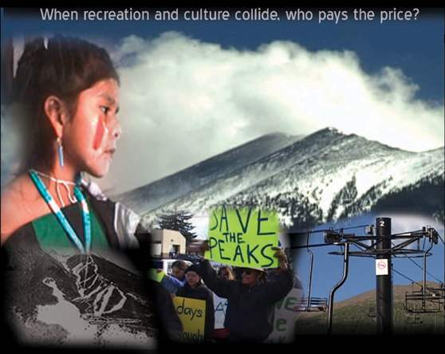

One possible reason the NEPA process missed important targets was because it relied on the analysis of an anthropologist who determined that there was no burden on the religious practices of Tribes. But could she speak for the requirements of native religion? All the while, Tribes were passing resolutions, protesting, and sending letters explaining why a significant burden on their religious practices occurred from the Snowbowl proposal. Who speaks for native religion? If one wanted an expert opinion on the practice of Christianity, wouldn’t one ask a pastor or priest? Many of the federal laws analyzed in the NEPA process required consultation with native religious practitioners and elders as well as tribal governments. True, it might be harder to locate native religious practitioners. But in the Southwest it wasn’t that hard. The Hopi Tribe had an established priesthood and kiva leaders and there was an association of Navajo Medicine People. Many of these people participated in the NEPA process and submitted written materials. Yet in this NEPA process, a sole anthropologist determined that there was no significant impact on native religions and the associated cultural practices.

In testimony by the defendants, Dr. Judith Popper, the Regional Archaeologist for the Southwestern Region of the Forest Service, agreed that the tribes view the Peaks as “(a) as a home of spiritual beings; (b) a place where significant mythological events occurred; (c) a place where spirits of the dead went to be changed into bringers of rain; (d) a personification of gods and goddesses; (e) an area where important societies originated; and (f) as source of life.” However, she concluded in her testimony that “although practitioners sincerely felt that the Forest Service decision would impact their beliefs and exercise of religion, the impacts did not amount to a substantial burden.”
The activism regarding the Peaks culminated in several areas of concern that made the opposing groups converge: power relations. Indigenous history in this country is a history of power relations and the Peaks incident is no different. Current research among indigenous groups is focused on the colonization and the resultant study centered on post-colonialism, or the recognition by indigenous people that foreign power structures have resulted in the current state of Native America. The discussions are focused on how power is achieved and maintained to perpetuate a dominant, societal way of life that continues to exploit indigenous lifeways and lands. Part of this dialogue surrounds documents that perpetuate this dominance, and the Environmental Impact Statement provided by the United States Forest Service is one of those documents.
The Environmental Impact Statement produced by the USDA Forest Service contains much information from people who were given voice as authoritative experts that create a pretense of truth. By the same token, indigenous knowledge of the peaks should be given the same credence with great pretense of authority when discussing the significance of the peaks in different contexts: the media, in written documents, and in discussions with non-indigenous entities such as the City of Flagstaff, the U. S. Forest Service and the United States Federal Government. This pretense of authority is an important issue because authority and authenticity is not a type or degree of knowledge and truth, but it is a relationship to what is known and who can represent peoples’ rights. Therefore, indigenous authority needs to be acknowledged and there needs to be a shift in discussions about the peaks to one of discursive power relationships, and how a process can be developed to actively engage WITH native sensibilities where this case becomes one of respect, not one of process. (Ishii, 2011)
How will federal and state government reconcile these power struggles with indigenous sensibilities and beliefs at stake? On the local level, many groups and individuals took these issues to task. However, there is growing global and international awareness of these types of power struggles. The Peaks incident has taken on international awareness and this awareness has also played, directly and indirectly, into the future vision for the peaks.

Whose Science Rules? Impacts to Human Health and the Ecosystem

Second only to the native freedom of religion claim was the problem that the EIS did not analyze the impacts of using sewage effluent for the production of artificial snow, particularly on children who might be likely to swallow or have other close interactions with the artificial snow. Concerns swirled around the use of wastewater. The Save the Peaks Coalition pointed out significant flaws and holes in the Environmental Impact Statement on this issue. The first was the failure to analyze the potential health impacts on the wastewater snow on children. Children were the most likely to ingest and make prolonged contact with the artificial snow. This would be the first time that the artificial snow was to be made of 100% wastewater. Although the wastewater was treated, it still contained particulate fecal matter and many other untreated contaminants. Newspapers reported what the EIS did not:
The Arizona Department of Environmental Quality regulations allow A+ class
treated sewer water to contain fecal matter in three out of seven daily samples….
Moreover, studies done by Dr. Catherine Propper, Professor of Biological
Sciences at Northern Arizona University on this same treated sewer water
have concluded that the waste water contains pharmaceuticals, hormones,
endocrine disruptors, industrial pollutants like pesticides and herbicides,
and narcotics. David Norns, PhD, an integrative physiology professor at
the University of Colorado in Boulder, found that pharmaceutical ethinylestradiol
made it through the Boulder Wastewater Treatment Plan and into Boulder
Creek and reported that native male fish in Boulder Creek decreased in
numbers with respect to females… (Save the Peaks, 2010, p. 8-9)

The Clean Water Act was passed some time ago: it did not require the analysis for newer pharmaceuticals and chemicals from industrial processes. The U.S. Geological Survey and Northern Arizona University completed a reconnaissance study that confirmed the presence of organic wastewater compounds including pharmaceutical, industrial and household compounds in treated effluence from the City of Flagstaff and three municipal wells. (Propper, 2006). Of great concern were endocrine disrupting compounds (EDCs) because of their known impacts on the normal endocrine function of wildlife affecting survivorship, health and reproduction of exposed organisms: ‘outcomes of exposure range from overt toxicity and increased mortality to impacts on development of reproductive organs and behavior.” (Quandrud and Popper, 2010)

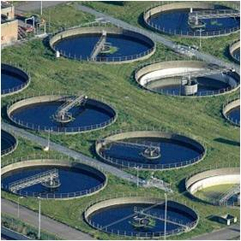
Flagstaff Sewage Treatment Plant

On a broader scale, few studies addressed the complex ecosystem consequences of exposure to wastewater effluent (Quandrud and Popper, 2010) and little is available on the impacts to humans, particularly children. Did the lack of specific science mean that potential impacts should be ignored? Many scientists would argue that the “cautionary principle” should be in play. This principle suggests that proposals that pose significant risks to human health might best be avoided until better information becomes available.

However, the agency’s analysis of science relied heavily on specific, highly localized peer-reviewed science that fits into government categories and speaks to specific proposals. And that kind of science was not available. Studies on the impacts of EDCs were just emerging, though they were coming in from all over the globe. Research scientists often took a more holistic and broader view of the evidence, evaluating studies of similar impacts from around the globe. Studies specific to Flagstaff’s water were just completed, without time for peer review. The NEPA analysis skipped the impacts of EDCs in the EIS for just these reasons and ignored the scientific work done at Northern Arizona University, the US Geological Survey and many other studies that were available to them in literature reviews that were presented during the process.

Agencies might differ in their approach and findings on the same project, depending on the type of expertise that was available. Most of them used contractors to complete the document, but oversight and responsibility remained with the agency. The Snowbowl EIS did not incorporate the studies done for the US Geological Survey, an agency with significant expertise in geology and hydrology, nor did their scientists analyze the EDC problem. Studies from other places and studies that were not peer-reviewed were left out of the EIS. Many of these studies dealt with new questions about endocrine disruptors and new types of chemicals found in wastewater from cosmetics and medications. Science takes time: many times scientists were still testing and preparing reports and articles about new risks.

The question at hand was whether an agency should take a risk, when current available information suggested that strong potential for negative outcomes existed, or should they wait for a more definitive basis for making a decision. Much was made of the idea that the expansion would impact only 1% of the mountain. No analysis of edge impacts of the development to surrounding high value ecological and wilderness areas came up nor were the impacts that spread out as the water from artificial snow melt flowed through the ecosystem considered. No thorough analysis of the impacts to Flagstaff’s long-term water supply appeared.

On the other hand, research scientists in specialized agencies and universities and the bearers of traditional ecological knowledge took another tack: the Peaks were an integral component in a delicate system that could easily be disrupted with the potential to have negative consequences to human health and ecosystem well-being. The decision to leave out studies from elsewhere or those that were not peer-reviewed created an EIS blind to emerging information. Science takes time: many times scientists were still testing and preparing reports and articles on new types of chemicals found in wastewater from cosmetic and medications.

Water Supply

The third issue was water supply and that was not being discussed. While the Department of Agriculture was offering to pay for reclaimed recycled (potable) water from the city to avoid the problems of chemicals and fecal matter in the effluent water, the City of Flagstaff was approaching a critical lack of water itself. In another ironic twist, the city was seeking to invest hundreds of millions of dollars in a pipeline that stretched across Hopi land to a ranch east of Flagstaff to access a new water source. (Cyndy Cole, 2010)

Peak Legal: The Problem of Legal Protection for Native Religions

A problem arises in the law when a religious definition includes everything and where it is cultural. The cultural focus can be pervasive encompassing “What it means to be a Navajo.” These broader perspectives differ from the Western way of organizing the world where religion has specific meaning and is embedded in structured, defined institutions. Many things of a spiritual and cultural nature for American Indians are not measurable in this way. Native spiritual beliefs and practices are religious-like in some ways and not in others (vision quest, blessings, special relationship to springs, bodies of water, animals). Still, is it possible to separate ritual practices and the spiritual tie leading to the need to access certain geological features and bodies of water unimpaired as sacred sites as distinct from the aspects that permeate the routine of everyday life? What is the religious or cultural right of access with regard to springs, clean cool water, and natural snow? Many of these questions remain unanswered.

This point was illustrated in 1980, when the Northland Corporation requested an internal administrative review of the Forest Service’s local decision to limit some of their expansion proposals as required by USDA regulations and policies. This was the initial step on the road to filing a lawsuit. The review has a direct and honest tone that suggests it was written free of political pressure from within or without. The forest official is clear: he does not understand Indian religious claims and he is quick to recognize the muddling in the legal advice he sought. This administrative review, completed by the Regional Forester in Albuquerque presaged many of the legal and policy questions that would plague the courts and future Forest Service managers:

I am presented with a dilemma. Between the possible violation of the First
Amendment rights to exercise one’s religion without restriction, the structure
against the establishment of religions by Governmental action, the
impingement of private property rights, and the proprietary rights of the
Government in its own land, there seems to be an unresolvable conflict.
Certainly in this case, the conflicts are apparent. These competing legal claims
may each have a sound basis? Legal advice on the matter is not conclusive as
to which points of view have the better merits. Indian religious claims dealing
with a whole mountain are new and untested. The Indian Religious Freedom
Act is also new and untested. Against this background, it has proven impossible
to decide this appeal on legal grounds. Perhaps the best that one can hope for is
to achieve a balancing act between competing Constitutional issues. Thus, it is
possible that the expansion approved by the Forest Supervisor may go too far
and would result in a tilt toward development and infringement of the religion.
Removal of the improvements would certainly tilt the other way. Strict status
quo would not be in the interest of public safety and would, in the long run,
amount to removal as obsolescence sets in. There is another consideration that
has weighed very heavily in my deliberations. The Snow Bowl, while it has
been there for many years and is one of very few ski areas in Arizona, is not an
outstanding winter sports area when measured against national standards, nor
can it ever be made into one? At the same time, there is an increasing demand
in Arizona for downhill skiing. It is obvious however, that no amount of
development would make the Snow Bowl into a topnotch area……Thus, the
following decision is based on nonreligious considerations. Decision: The
Forest Supervisor’s decision to authorize expansion of the Snow Bowl winter
sports area is hereby modified to provide only for repair and replacement of
existing facilities as required by obsolescence, public safety and deterioration.
(Hassel, 1980 ) archive.library.nau.edu/cdm4/itemviewer.php?CISOROOT=/cpa&CISO PTR=6374… 6/28/11).
The Regional Forester also authorized paving of the road to the Snow Bowl. But his attempt at balance did not prevail. The Chief of the Forest Service over-rode his attempt at balance and approved the full expansion proposal.

Compelling Interest

Cases have consistently upheld the ideas that the state can attach the idea of a compelling states interest to a specific project such as building a road or ski basin for economic development purposes and that the state’s ability to make control lands under its supervision is essential. Centrality and compelling interest are two concepts have been used to override the protection of American Indian religious practices. (Deloria, 2011) (2)
In the case of the Peaks, the question arises about compelling interest. Does the government really have a compelling interest to subsidize a marginal business that has an unlikely future on public lands over the interests of the majority of users, among them those hoping to exercise their rights to freedom of religion?

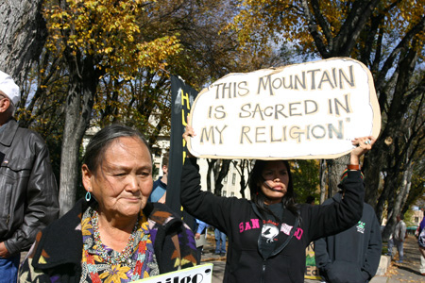

Another area of law that establishes the legitimacy and sincerity of practice is the instance of conscientious objectors. The determination is based on belief and some information: it does not have to be attached to a specific church or institution. This resonates with information from an interview with Dr. Lomayumtewa Ishii at Northern Arizona University in July 2011: he explained that a release of information about Hopi prophesies and Hopi religion occurred in the 1970’s as the basis for some Hopis to obtain the status of conscientious objectors. (Ishii, 2011) Sam Deloria commented on areas of the law and reactions from Tribes and tribal members that are instructive of the legal difficulties involved.
The practical analysis of the sincerity test is more difficult when it comes to
religious rights, practices and uses. Do you deny access or other rights to Tribes?
and tribal members that are recognized by a state, but not by the federal government?
Do you deny “new agers”? The Navajo Nataali (Medicinemen’s) Association
objected to categorization as a religion: “We are not a religion. We represent a way
of life and beliefs about ourselves and the universe. For them, the Western definition
is too specific. (Deloria, 2011)

(2) Sam Deloria, founder of the summer institutes in Indian Law at UNM, contributing faculty to the Tribal Governance MPA at The Evergreen State College and long-term commentator on legal issues for Native Nations, is currently Director of the American Indian Graduate Center.

Deloria offers an avenue for resolution at the interface of agency regulation and law:
To solve the problem, you dismantle the idea from the policy end and then
from the spiritual end to get to answers. You have to speak in ways that the
system can accommodate---in terms that can be put into a set of regulations.
The idea of the conceptual uniqueness of American Indian religions gets you
nothing. This must be worked through at the interface. The problem at the
San Francisco Peaks is that we have not been able to explain what it is we
want in terms that the court can understand, like centrality and standards.
(Deloria, 2011)

Legal scholars and agency analysts are looking for the interface. It is possible that the Forest Service’s sacred sit policy review process or the domestic implementation of the UN declaration on the rights of Indigenous Peoples may be places where light shines on the interface where standards and guidelines can at last be developed.

Centrality

The current test is built around the idea of centrality: that a practice or place is so essential, that removal of access or denying a practice would result in extinction of a religion or a practice. A new standard and test of centrality is needed. More must be done beyond testifying to general sacredness. The idea of integrity, of an “unimpaired condition,” leads to the idea that “infringement can be understood as a forced or undesired change in the practice of a religion.” (Walker. Deward, Jr. 1991 in Weaver, pp. 226-7) This position is more amenable to fact finding.

In the post-American Indian Religious Freedom Act period after several court cases were lost, Congress attempted to address the problem by passing the Religious Freedom Restoration Act of 1993. It redefined the concept of a burden on religious freedom as it had been decided by the courts under the First Amendment from a “complete inability to practice religion in any location. The burden was now to be based on an analysis of undue impact based on a case by case factual assessment of substantial impact: a substantial burden on religion must be overcome by an identified compelling government interest. (Hutt, 2009) This new definition left agencies considerable discretion to pursue new avenues to find a way to protect American Indian practices and beliefs. Unfortunately, it left a trail of confusing court decisions. The Ninth Circuit Court weighed the facts like a trial court, rather than addressing the narrow legal issue before them to which it could apply facts. The Ninth Circuit accepts a Traditional Cultural Properties (TCP) designation for Indian religious and cultural sites only when there is a non-Indian basis for site significance, while the Tenth Circuit accepts Native American TCP designation based on cultural use. (Hutt, 2009) The result of two federal appeals courts with two different methods of handling these cases is muddling. Under these circumstances, land managers lack clear guidance. The Supreme Court could clear this conflict up, but so far has not shown the inclination to do so.

The cautionary principle seems to fit cultural issue. Agencies can improve the situation by reviewing their policies in line with current interpretations and executive orders to create internal policies and guidance for managers. Additional training and guidance for managers, NEPA teams and local line officers and decision-makers is clearly needed.

Bureaucracies knew how to protect Western style religions. They had a rule- making structure to protect them based on the hierarchical and institutional nature of Western religion. If you wanted to use a National Park Service site, you could validate the use as religious with a note from the bishop. That made accommodation legitimate. For example, the ruins of the mission church at Pecos National Historic Park are used for a feast day mass. National Park Service areas can be used for legitimate religious purposes as long as they don’t bar the use of other visitors. Public lands frequently accommodate summer religious camps and the Forest Service gained authority for full closures for native religious purposes in 2008. Clinton’s memorandum described strictly delimited spatial considerations in defining sacred sites. By the time the Forest Service was finishing up its policy review of sacred sites, it was clear that the Clinton definition did not work in practice because the idea of strictly delimited spatial considerations conflicted with indigenous religious use. Agencies can improve the situation by reviewing their policies in line with current interpretations and executive orders to create internal policies and guidance and develop additional training and guidance for managers, NEPA teams, local line officers and decision-makers. Agencies could begin by improving the situation by reviewing their policies in line with current interpretations and executive orders to create internal policies and guidance for managers.

Reframing Alternatives for the San Francisco Peaks

Moving beyond the schisms between politics and administration, differences in culture and religion, and disjuncts between science, policy and law, participants are challenged to look for the interdisciplinary keys to unlock alternatives and potential resolution of this 40 year long controversy.
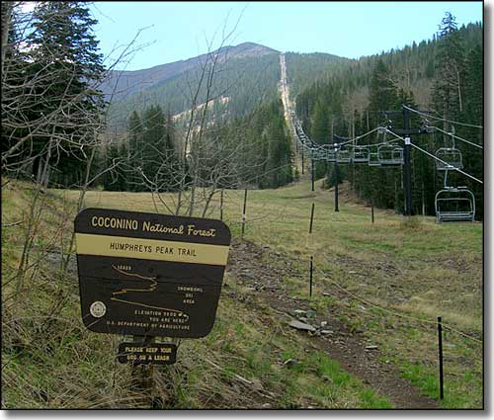

ALTERNATIVES FOR THE SAN FRANCISCO PEAKS

Interdisciplinary and Local Solutions

More than forty years of conflict and multiple federal lawsuits brought no lasting solutions in the battle for the Peaks. At the end of the day, after all the failed legal arguments to protect American Indian religious freedom, the Hopis hit upon a new tactic. They combined their religious issues with issues around water quality and environmental degradation. They noted the inability to restrict contact with the waste-water based snow, the effects of artificial snow-melt, economic loss for the San Francisco Peaks community, and damages to wilderness values in the Kachina wilderness and nearby trails enjoyed by hikers due to overspray from the snow-making machines. The Hopi’s suit took issue with Flagstaff’s contract to sell sewage effluent to the Snowbowl as a violation of several Arizona laws governing the use of reclaimed wastewater. State laws require control of runoff and overspray and restrictions on limitations of human contact that cannot be met.

The suit shifted the issue back to the state and local arena with allegations that the city’s contract to sell water violates Arizona environmental laws because it will result in unreasonable environmental degradation, further depletion of drinking water resources, infringe on public and indigenous uses of the area, expose humans and wildlife to chemicals including endocrine disruptors, and that the economic benefits will be wiped out by the cost of environmental degradation. (forgottennavajopeople.org 2011)

The suit specifically alleges that overspray from snowmaking will affect the adjacent Kachina Wilderness, designated under the Wilderness Act of 1964. Hopi Tribal Chairman Leroy Shingoitewa stressed the importance of the case to the Hopi Tribe,
The health and safety of the Hopi people is indistinguishable from the health and
safety of the environment—protection of the environment on the San Francisco
Peaks is central to the Tribe’s existence. The use of reclaimed sewage on the San
Francisco Peaks as planned by the City of Flagstaff and Snowbowl will have a
negative impact on the Hopi Tribe’s frequent and vital uses of the Peaks.
(Hopi Tribe, 2011, p.2)

Was this the unifying thread that would solve the Regional Forester’s dilemma, so clearly stated back in 1980? Was it really all about the water all along? Could joining the protection of Hopi religion to the protection of water against environmental degradation build a stronger coalition that could claim to be a true representation of the public interest? Would the water protect the mountain and open the door to new alternatives more appropriate given the problems of drought and a future of climate change? Had the Hopis struck a note of resolution by articulating a Hopi cultural right to water that corresponded to environmental rights and expectations of the public?

International Alternatives
Frustrated with all of the domestic process, some looked to the international court of appeals. Walter Echohawk discussed the potential for the UN Declaration on the Rights of Indigenous Peoples (UNDRIP), recently signed by the United States, to turn the tide. (Echohawk, 2011) The cyber activists saw specific articles that suggested a change was in order (bsnorrel.blogspot) and attorneys who worked in federal Indian law saw potential implications. Sam Deloria suggested that the San Francisco Peaks might be the first test of UNDRIP. After all, it was designed to protect the freedom of indigenous people and “prohibit discrimination against indigenous peoples and promote their full and effective participation in all matters that concern them and their right to maintain distinctiveness and pursue their own visions of social and economic development.….and the “protection of human rights and fundamental freedoms for all.” (www.un.org/apps/news/storyasp?News/D=23794) As such it offered clear guidelines and principles for supporting indigenous religious freedom. (www.un.odg/socdev/unpf;ii/documents/DRIPS_en.pdf) At last, the main principles from which to draw the missing standards were set. A dynamic process that sets international norms was in place.

The Senate Committee on Indian Affairs held a hearing on the implications of UNDRIP for domestic policy. The actual impacts of UNDRIP were poorly understood. It has been viewed as aspirational but it also has ties to other treaties, conventions and international agreements that deal with human rights. The focus is on standards and practices. The question is….could the implementation of this declaration at last clarify “all that is holy” for the Tribes in a way that would guide the courts?

Other Alternatives

If complexity breeds diversity, other alternatives are still to be created. Interdisciplinary combinations and coalitions and cooperation between different levels of government might bring results.

REFERENCES

Posted by Ahni 2011 “Protect the peaks-stop destruction and desecration now.” Retrieved 6.8.11 from:
http://climate-connections.org/2011/06/16/protest-halts-snowbowl-destruction-on-san-francisco-peaks/ 6/8/11)
Retrieved 6/28/11 from:
http://intercontinentalcry.org/protest-halts-snowbowl-destruction-on-san-francisco-peaks/

Benally, Klee, (2009) Navajo nation calls on Obama to protect sacred sites April 24, 2009. Downloaded 7 11 11from: http://indigenousaction.org/navajo-nation-council-calls-on-obama-to-protect-sacred

Berry, Carol, March 28, 2011, ICT. San Francisco peaks on schedule for artificial snow from wasterwater: initiating millions of dollars of construction costs would help tip the balance” Retrieved 6 28 11 from: http://indiancountrytodaymedianetwork.com/2011/03/san-francisco-peaks-on-schedule for artificial-snow-from-waste-water

Climate Connections, “Protest halts snowbowl destruction on san francisco peaks.” Retrieved 6 8 11 from:
(http://climate-connections.org/2011/06/16/protest-halts-snowbowl-destruction-on
-san-francisco-peaks/

Cole, Cyndy (2010) “Snow-making gets green light,” Arizona Daily Sun, July 3, 2010. Retrieved from: http://azdailysun.com/news/local/article_9c2ebb3e-e02e-51b9-86e2-84704e0f932e.html

Duncklee, John, Collection number: NAU.MS.355 Cline Library, Northern Arizona Uni versity, Man-Land Relationships on the San Francisco Peaks: A Preliminary Report.
pp. 1-11 (fragility: p. 9).v Downloaded 8 26 2011 from:
(Duncklee 1-11 archive.library.nau.edu/cdm4item_viewer.php?CISOROOT=/cpa&CISOPIR=611238&CISOBOX=1&REC=2)

Cline Library Special Collections and Archives Man-Land Relationships on the SF Peaks: A Preliminary Report by John Duncklee 1971. John Duncklee Collection http://www.azarchivesonline.org/xtf/view?docld=ead.nau/duncklee_john.xml). Duncklee continued to.

Duncklee, John, Collection number: NAU.MS.355 Cline Library, Northern Arizona University, Letter from Daily Sun Publisher and Editor Cline to Bruce Ledbetter of the Post Company July 1, 1971. archive.library.nau.edu/cdm4/item_viewer.php?CISOROOT=/cpa&CISOPIR=611238&CISOBOX=1&REC=2

Duncklee, John May 9, 1972 Letter from Duncklee to the Forest Service. Critique of environmental statement. Archive.library.nau.edu/CISCOROOT=/epa&CISCOPTR459337REC=9

Deloria, P. Sam, August 2011, personal interview

Echohawk, Larry, Plenary speaker, George Wright Society, March 7, 2011, New Orleans.

Heade, Kevin, (2011) A slippery slope: why snowbowl’s sewage-snow should be stopped
Law Journal for Social Justice at Arizona State University March 1, 2011. Downloaded 6/28/11 from: http://ljsj.wordpress.com/2011/03/p.2

Hopi Tribe, (2011) “Hopi file lawsuit over recycled wastewater on San Francisco Peaks,”
Censored News: Indigenous Peoples and Human Rights,” Aug 22, 2011. Downloaded 8 31 11 from:
(http://forgottennavajopeople.org/blog/?p=2016

Hassel, H. J. (1/69) Regional forester’s decision on request for administrative review of forest supervisor’s decision to expand srizona snowbowl skiing facilities coconino national forest. Downloaded 6 28 11 from:
archive.library.nau.edu/cdm4/item viewer.php?CISOROOT=/cpa&CISO PTR=6374 6/28/11).

Hutt, Sherry, (2009) “The Evolution of Federal Agency Authority to Manage Native American Cultural Sites, Proceedings of the George Wright Society, Volume 26, #1.

Hyde, Pamela, (2007) “Watering the people: a recent history of water use on the Colorado plateau” Plateau, v. 4, n.1, pp. 126-47.

Iam, (2011) “Court Denies Injunction to Halt Snowbowl Development,” indemedia, March 31, 2011.

Ishii, Lomayumtewa, July 2011, personal interview.

Johnson, Miriam (2010) “Save the Peaks, Wall Street Journal Retrieved 3/23/11 from: (http://gaduginews.blogspot.com/2010/08/save-the-peaks-wall-street-journal-navajo.html 3.23.11)
KUYI, Hopi Radio 6 16 11. Retrieved 8 28 11 from:
http:intercontinentalcry.org/protest-halts-snowbowl-destruction-on-san-francisco-
peaks

Law Journal For Social Justice http://ljsj.wordpress.com2011/03page2/)

Loeffler, Jack (2008) “Healing the west: voices of culture and habitat” Santa Fe, Museum of New Mexico Press.
Herman Atine p. 65
Roberta Blackgoat p. 65
Shonto Begay
Shonto Begay p. 64, 66, 68

Logan, Michael F. (2002) The Lessening Stream: An Environmental History of the Santa Cruz River, Tucson, The University of Arizona Press

Ortiz, Simon (2002) Out There Somewhere” Tucson, University of Arizona Press, p.89

Sadler, Christa, (2007) “A thirsting land: water and the colorado plateau” Plateau, v. 4, n.1, pp. 12-25.

Stevens, Larry (2007) “Water and biodiversity on the colorado plateau” Plateau, v. 4, n.1, pp. 48-55.

Save the Peaks Coalition (2010) “District court rules for USFS in save the peaks case,” 12 1 2010, p.8-9. Chem in fish Retrieved 6 28 11 from:
http://www.south-of-flagstaff-arizona.com/flagstaff-skiingn-snow-making.htm.

USDA Forest Service (2005) Final environmental impact statement for Arizona Snowbowl facilities improvements proposal, Coconino National Forest, Coconino County, Arizona/lead agency, USDA Forest Service: responsible official, Nora B. Rasure, Albuquerque N.M.: United States Department of Agriculture, Forest Service, Southwestern Region.

Weaver, Jace, ed (1998) Native american religious identity: unforgotten gods,
(Walker. Deward, Jr. 1991 in Weaver, pp. 226-7 )

Woodmency, Jim (2001) “Weather in the southwest,” Tucson, Southwest Parks and Monuments Association.

Richard and Jean Wilson Collection, Collection number: NAU.MS.73 Cline Library, Northern Arizona University. Historical Notes p. 3. Downloaded 8 26 11 from:
https://gate2.evergreen.edu/exchange/StumpffL/Inbox/samversion, EML/Richard%20and

(http://forgottennavajopeople.org/blog/?p=2016 8/31/2011)

(http://www.south-of-flagstaff-arizona.com
/Flagstaff-skiing-snow-making.html

CDC Wonder (1993) Update: Hantavirus Pulmonary Syndrome -- United States. Publication date 10/29/1993. Downloaded 9 5 10 from: http://wonder.cdc.gov/wonder/prevguid/m0030705/m0030705.asp

Ignore this section..just using for format

Davies, W. (2001) Healing ways: Navajo health care in the twentieth century. Albuquerque: University of New Mexico Press.

Bales, F. (1994) Hantavirus and the media: Double jeopardy for Native Americans: American Indian Culture and Research Journal, v. 18:3, pp 251-263

Brugge, D. & Missaghian, M. (2006) Protecting the Navajo people through tribal regulation of research. Science and Engineering Ethics, v.12:3, pp.491-507

Clay, C. A., et al (2009) Contact heterogeneity in deer mice: implications for Sin Nombre virus transmission Proceedings of Royal Society: Biological Sciences v. 276:1660, pp 1305-1312 Downloaded 9/05/10 from: http://rspb.royalsocietypublishing.org/content/276/1660/1305.abstract

Davies, W. (2001) Healing ways: Navajo health care in the twentieth century. Albuquerque: University of New Mexico Press.

Denetclaw, W. F. (1994) Is “south-west mystery disease” caused by hantavirus? Lancet, v. 343:8888, pp. 53-54.

Donovan, B (2008) Year of fear: Medicine men knew cause of Hantavirus. (Gallup) Independent. May 17-18. Downloaded 9 5 10 from: http://www.gallupindependent.com/2008/may/051708hantavirus.html

Glaberson, W. (2001) National briefing. Southwest: New Mexico. $2.1 million award in hantavirus case. New York Times June 13. Downloaded 9/6/10 from: http://www.nytimes.com/2001/06/13/us/national-briefing-southwest-new-mexico-2.1-million-award-in-hantavirus-case.html

Glass, G. E., et al, (2002) Using remotely sensed data to identify areas at risk for Hantavirus Pulmonary Syndrome. Emerging Infectious Diseases, v.6:3. Downloaded 9/5/10 from: http://www.cdc.gov/ncidod/eid/vol6no3/glass.htm

Jacobs G.H., Williams G.A., Fenwick J.A (2004) Influence of cone pigment coexpression on spectral sensitivity and color vision in the mouse. Vision Research 44:14 pp. 1615-1622

Norrell, B. (1994) Navajo reluctant 'guinea pigs' in Hantavirus drug study. Indian Country Today. May 11.

Rothman, E (1998) Hantavirus: Bountiful season brings deadly harvest. Harvard Medical School: Web Weekly, June 19, 2006. Downloaded 9 5 10 from: http://webweekly.hms.harvard.edu/archive/2006/0619/student_scene.html

Scott, M. (2002) Hantavirus risk maps NASA. Earth Observatory Downloaded 9/5/10 from: http://earthobservatory.nasa.gov/Features/Hanta/

Simpson, S. Q., et al (1995) Social impacts of respiratory infections. Chest Official publication of the American College of Chest Physicians. v. 108:2 Supplement, pp. 63S – 69S. Downloaded 9 5 10 from http://chestjournal.chestpubs.org/content/108/2_Supplement/63S.full.pdf

Trahant, M. (2005) Broadcast news: The absence of nature storytellers. Nieman Reports, Nieman Foundation for Journalists at Harvard. Fall. Downloaded 9/8/10 from: http://www.nieman.harvard.edu/reportsitem.aspx?id=100625

Valenti, J. M (2005) Rodent wars and cultural battles: Reporting Hantavirus. McGraw Hill: Media Ethics: Issues and Cases: Case Studies. Downloaded 9 5 10 from: http://highered.mcgraw-hill.com/sites/007288259x/student_view0/case_studies.html

Wrobel, S. (1995) Serendipity, science, and a new hantavirus. The FASEB Journal: Breakthroughs in Biosciences v. 9. pp 1247-1254. Downloaded 9/6/01 from: http://www.fasebj.org/cgi/reprint/9/13/1247.pdf

Zeitz, P.S., et al (1997) Assessment of occupational risk for hantavirus infection in Arizona and New Mexico. Journal of Occupational and Environmental Medicine: v. 39:5, pp. 463-467

APPENDIX A SCIENCE

Studies on wastewater were coming up with similar results in other areas of the country and all over the world. Endocrine disruptors and estrogen, found in creams, cosmetics and medications that mixed with wastewater, were affecting fish and wildlife all over the world. However, all the scientific studies that were presented by external scientists were rejected in the EIS because they were not yet “peer reviewed” or not local to the specific area of the proposal. The scientists argued that science takes time and that in matters of unknown impacts to human health and delicate ecosystems, the cautionary principle is preferred. Tests and peer review can take several years. And many scientists would look at similar studies done in other areas as supportive of a hypothesis. Even the untested areas gave pause. Antibiotics had been found in the water too, and under the bright mountain sun, some like triclosan and triclocarban could break down into dreaded dioxin. Steroids, pharmaceuticals, cosmetics, and caffeine were also found in wastewater. The reclaimed water is not tested for any of these nor does the Environmental Protection Agency have authority to set levels for such chemicals because they were left out of the Clean Water Act. Yet some of these substances have the capacity of not only altering our personal physiology, but that of generations to come.

Compelling questions arise around water and climate change in this case that were left out of the policy processes on the San Francisco Peaks. And yet, it seemed that science might be a unifying factor in developing alternatives. One set of scientific questions revolves around climate, hydrology and questions about recharging the aquifer and conserving drinking water. Was it prudent to remove the wastewater from its current function of recharging the aquifer and passing through another natural system of purification as it seeped back into the ground. Another set of questions arises around contaminants found in wastewater. If the cautionary principle was applied in this instance of potential negative effects to human and ecosystem health, what would a vision of the San Francisco Peaks look like? Finally, if all the findings were assessed in the context of possible amplification due to climate change, what would alternatives look like when issues were broadened to include the increasing instance of devastating wildfires in Arizona.

