

Master of Public Administration

2700 Evergreen Parkway NW

Olympia, Washington 98505

July 18, 2011

Dear 2012 MPA Tribal Cohort,

Hi everyone. We trust you are having an enjoyable and productive summer wherever you may be. This letter is being sent to you to provide initial information that you may find useful to hit the ground running, so to speak, when we reassemble as a cohort in the fall. Included in this letter is a booklist of required readings, and information related to the Moodle site, from which, as is explained in more detail below, will be the primary vehicle for communications between faculty and students. This course will provide opportunities for you to engage in both individual and group projects concerning analytical research techniques. More information related to group and individual projects are addressed below. As faculty, we anticipate this to be an exciting year, one full of challenges and opportunities for you to develop the skills necessary to conduct meaningful, scientifically sound, and ethically based research on subjects of interest to you and your respective communities.

John and Cheryl are the teaching team for Fall 2nd Year Core. We are, in brief:

**Cheryl Simrell King** has taught research and statistics for almost 25 years (12 years at Evergreen). Coauthor of *Transformative Public Service: Portraits of Theory in Practice* (2005, M.E. Sharpe) *Government is Us: Public Administration in an Anti-Government Era* (1998, Sage Publications) and Editor of *Government is Us, 2.0* (2011, M.E. Sharpe), she writes and practices in the areas of democratizing and transforming public administration, accountability, sustainability and the relationships amongst and between citizens and their governments. Her current public service work focuses on transformational sustainability in local governments and assisting local government officials in designing and implementing citizen engagement endeavors.

**John David Gates** is enrolled member of the Cheyenne River Sioux Tribe. His primary areas of professional expertise lie in the areas of federal Indian law and policy and international indigenous human rights. John received his undergraduate degree from the University of New Mexico, and his law degree from the University Of Iowa College Of Law. John served as prosecutor for the Cheyenne River Sioux Tribe and served on the bench as Judge Pro Tem for the Laguna Pueblo, located in New Mexico. He taught courses in Native American Studies (NAS) at the University of New Mexico from 1997/2004, where he also worked collaboratively with the faculty to establish a bachelor degree program in NAS. While employed under legal contracts with several tribes in New Mexico, John taught courses in cultural studies at Central New Mexico Community College in Albuquerque. In 2004/05, John was awarded a J. William Fulbright Senior Scholar fellowship to teach courses in federal Indian law and international indigenous human rights at the University Of Bonn, Germany. He currently serves as an expert witness on matters related to Native Hawai’ian sovereignty and self-determination.

Linda and Alan will be stepping in for Winter (Analytical Techniques II) and Spring quarters (Capstone).

A preview of Fall quarter follows:

* The **book list is appended to the end of this message**, in the order they are used in the program. In addition, articles and other readings will be assigned – we’ll post these in a timely manner. We’ve made every effort to keep the cost of books down and to achieve a balance of “nuts and bolts,” recent research and critical perspectives. We placed an order through bookstore – books are available there in late August. A word of warning: the White (*Taking Language Seriously*) and Smith (*Decolonizing Methodologies*) texts are going to be your densest reads.
* We will use **Moodle as our central organizing place** for our work together. Everything from us (including the syllabus) will be posted on the Moodle page. We’ll communicate to you primarily through Moodle and email. You will post all your assignments on our Moodle page. We’ll let you know when the page is up and running.
* The **syllabus** will not be ready until the first week of class. We have finalized the schedule for the first weekend of class. It is appended at the end of this message.
* A bit of information on **assignments:** the primary goal for both quarters of ATPS is to give you direct experience with applied primary research. You will, soup to nuts, design and implement a research project that informs a public, policy, organizational or social/cultural question or challenge. In other words, it’s real. We will work on defining and narrowing research questions, designing instruments to collect qualitative and quantitative data, ensure the privacy and safety of research participants, collect and analyze data and reporting your findings. These projects will be done in groups of three people; only under exceptional circumstances will we approve a larger or smaller group, or an individual project. Some assignments will be project based (and done in groups); other assignments are individual assignments (and done individually).
* Therefore, start thinking about **potential project ideas** and be prepared to talk about your ideas the first weekend (and submit a short, two-three paragraph description of your idea). Generally speaking, you may begin to consider your project idea by looking broadly at an issue. For instance, “I would like to examine what effect climate change may have on existing salmon populations in the Pacific Northwest.” From this general question, your research inquiries may proceed under two research methodologies, i.e. analytical research and impact analysis. These categories are not exclusive of each other, however. Analytical research leans heavily toward the accumulation of qualitative and quantitative data using the scientific method to support or challenge, as the case may be, an existing topic or situation. Impact analysis focuses more heavily on examining what impacts a tribal policy, considered or adopted, may have on health, education, social welfare, or the political integrity of the tribe. Impact analysis would most certainly consider whether the proposed or adopted policy is in compliance with existing relevant tribal, federal and state laws and regulations. Both methodologies integrate the use, accumulation, and interpretation of data; however impact analysis requires additional inquiry into the appropriate legal authorities. When considering impacts, you are encouraged to think broadly. If your subject concerns human impacts you may wish to consider impacts on communities, families, the environment, intergovernmental relationships, cultural and spiritual impacts, if any, etc. It also may be helpful to review the following general subject matter areas extracted from norms, or elements, related to self-determination from an international perspective. Professor Anaya describes these areas to be; nondiscrimination, cultural integrity, lands and natural resources, social welfare and development, and self-government.
* **Human Subjects Review/Institutional Review Boards**. This subject will be taken up in more depth the first weekend of class; however a preliminary word of caution is in order. If your research is to include collecting data from people affiliated with a tribe, including interviews, personal, health or medical information obtained or access sought, you are strongly urged to contact the tribe with which you want to work and determine what protocols it has established regarding conducting this research within its jurisdiction. Policies, laws, ordinances, tribal executive orders, regulations, or protocols may exist which would prevent you from obtaining the necessary consent and approval from the appropriate committee, review board, or individual empowered to issue approval of your project. It is entirely possible that the timeline you might be confronted with in order to get approval from a tribe would eliminate your project idea from being completed this academic year. Indeed, this subject might be an interesting research topic in itself. For instance, what impacts on tribal governments, communities and tribal citizens might arise when existing protocols are onerous or excessively burdensome? What steps might be taken to both ensure the rights and interests of tribes and tribal citizens are protected, while at the same time creating an environment where meaningful and useful research may be conducted where review protocols truly benefit the subjects of that research. This subject itself might be well of particular interest and value, i.e. if you were to conduct a survey looking at a representative sample of tribes’ research protocols existing today, what might one discover from such research?
* For the second weekend of class, you’ll be required to submit a **literature review**. This is an individual assignment. We’ll talk more about it the first week of class but it’s also important to start thinking about it early. Basically, you’ll use scholarly/peer reviewed source material to situate a research question in the literature. This topic can be of any area of interest to you or it may be the topic of your group project.

That’s about all for now. As we already indicated, the full syllabus won’t be available until the first week of class. We don’t think we will be bothering you any further this summer. However, if you have any questions or concerns, feel free to email us.

In closing, we welcome back into the fold, Erin Genia, who reassumes her duties as Assistant Director of the MPA Tribal Cohort on July 18th. We look forward to seeing each of you soon.

Enjoy your summer.

Sincerely,

Your Faculty Team

**Book List:**

* **W. Lawrence Neuman (2005)** *Social Research Methods: Qualitative and Quantitative Approaches, (6th Edition);* **ISBN-13:** 978-0205457939*;* Allyn & Bacon (~$25 – using both Fall and Winter Quarters). Chapters will be assigned from this textbook to supplement other reading, most weeks.

[go here to Amazon.com](http://www.amazon.com/Social-Research-Methods-Qualitative-Quantitative/dp/0205457932/ref=sr_1_2?s=books&ie=UTF8&qid=1308580324&sr=1-2)

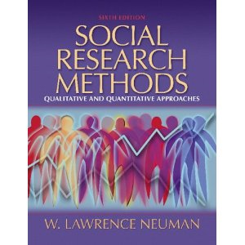

* White, Jay. (2002). *Taking Language Seriously: The Narrative Foundations of Public Administration Research*. Georgetown University Press. ISBN: 978-0878408788. (~$25)

[go here to Amazon.com](http://www.amazon.com/Taking-Language-Seriously-Foundations-Administration/dp/0878408789/ref=sr_1_1?s=books&ie=UTF8&qid=1307389694&sr=1-1)

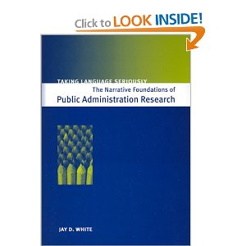

* Linda Tuhiwai Smith (1999). *Decolonizing Methodologies: Research and Indigenous Peoples.* (~$25). ISBN-13: 978-1856496247. Zed Books.

[go here to Amazon.com](http://www.amazon.com/Decolonizing-Methodologies-Research-Indigenous-Peoples/dp/1856496244)

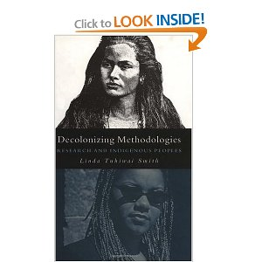

* Diane Ravitch (2010). *The Death and Life of the Great American School System.* ISBN-13**:** 978-0465014910. Basic Books (~$16)

[go here to Amazon.com](http://www.amazon.com/Death-Great-American-School-System/dp/0465014917)



* Wilson, Shawn (2009). *Research is Ceremony: Indigenous Research Methods.* ISBN-13: 978-1552662816. (~$15)

[go here to Amazon.com](http://www.amazon.com/gp/product/1552662810/ref=pd_lpo_k2_dp_sr_3?pf_rd_p=486539851&pf_rd_s=lpo-top-stripe-1&pf_rd_t=201&pf_rd_i=1856496244&pf_rd_m=ATVPDKIKX0DER&pf_rd_r=07VR1J8KSDKDF8RH90R4)

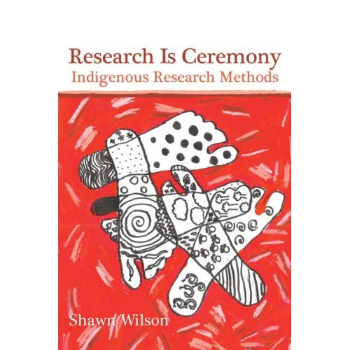

**Schedule (first weekend):**

|  |  |  |  |
| --- | --- | --- | --- |
| **WEEKEND** | **TOPIC/ACTIVITIES** | **READINGS** | **DUE** |
| **Weekend 1**  **Sept 30-Oct 2** | ***Introduction to Research***   * Introduction to course * What is research? (csk) * How to do literature reviews (csk) * Ethics of Research (jdg) * Human Subjects Review (jdg) * Methodology Overview (csk) * Indigenous Research (jdg)   Film: “Day after Trinity”  Groups – meeting time | White (all)  Smith (all)  Kuhn reading: [go here](http://stripe.colorado.edu/~yulsman/paradigms.pdf)  Newman, Chapters 1-5 | **Project Overview/Abstract Idea for Research – Individual**  **Project Overview/Abstract Idea for Research – Group** |