**Discussion**

**Learning Style and Learning Environment**

Mary Ellen Hillaire and many American Indian academics of her era had identified a major issue within the Academy – since the beginning, academics have viewed Native people and cultures as something less than, as objects and subjects to study. This is still an issue in academia today, with many academics and departments holding on to historical, and usually inaccurate, views of Native communities. Mary Hillaire, Vine Deloria Jr, Joe Dela Cruz, Mary Nelson, Linda Moon Stumpff, Alan Parker, and more challenged the overwhelming odds of the academy to create a place that was not only safe to learn in, but also elevated the knowledge and experiences of Native people. Academics and colleges today still challenge the credentials of Native people even if they are speaking about their own Tribe. There is a prescribed notion that, unless you have been through the academic process to learn research tools it is not possible to know something, let alone be objective – especially if you are working within your own community. Vine Deloria Jr. and other American Indian scholars directly challenge this view.

*“[I] didn’t want to be someone else’s example anymore, didn’t want to be placed in a fish bowl learning mode so others can witness how [I]…react” *Tribal student*

An undertone across many of the comments and interviews was the “Tribal specific” – Tribal specific cohort (Tribal students or students working for Tribes), Tribal specific curriculum (based on Tribal issues and using Tribal case studies or books), and Tribal educators (faculty, staff, and guest lecturers with lots of Tribal experience and knowledge). Much of this can be tied with usual experiences of students being a minority member in class, faced with situations that are not all that similar to the general population or whose view may be directly oppositional to the mainstream view. The United States government has often used imminent domain for the betterment of the greater good to the disadvantage of Tribal groups (seen as the “few” who loose out for that greater good). Even in many American Indian Studies classes, the majority will be non-Tribal students and the professor is just as likely to be non-Tribal. Mary Hillaire shared her vision with The Evergreen State College to develop a learning community and view on campus that has ultimately contributed to the growth and success of Native programs across the campus.

*“Not a place to study Native Americans, but where Native Americans can study”*

~ Mary Ellen Hillaire

**Recommendations for The Evergreen State College’s MPA Tribal Governance Concentration**

The feedback from the surveys of leaders and students, as well as the key informant interviews with staff, leaders, and students of the program led us to the following recommendations. The new faculty hired for the program must be Native or have an extensive knowledge and working relationship with the Tribes. A local and broader knowledge of Indian Country is ideal as most of the students are from the State of Washington Tribes, however there is a growing number of students from Tribes outside of the State of Washington and Tribes interact with each other on a regular basis.

The new faculty will need to continue to grow and polish the curriculum, keeping it timely and innovative so that the program continues to be at the top of the field of Tribal administration. If possible, a greater number of guest speakers should be included in the curriculum, and the use of Alumni in this function may be a great place to start. The establishment of an Alumni group specific to the MPA Tribal Concentration is imperative. Continued strategic planning sessions with Tribal leaders for the programs’ future is even more important for the sustainability of the program.

*“I would like to have there be some communication with tribal government leaders and staff who could suggest topics or ideas for development…”*

~ Student

**“***I am thankful to The Evergreen State College for taking a chance on the MPA-Tribal cohort and allowing it to gain a hold on the campus. Additionally, without the Tribe’s direct contributions to this program, it would not have been possible; that should never be overlooked as well as the tribal support for their students to attend the program. Any and all opportunities that can be open to tribal students so they can reach their educational, professional and personal goals is important and invaluable. As a student in the inaugural graduating class, I found opportunities to suggest changes or have my learning be self-directed through the projects that were required and am thankful for those learning and teaching experiences”.*

*~Jennifer Scott, Quinault*

*MPA-Tribal Concentration 2004*

**Conclusion**

The Evergreen State College’s MPA Tribal Governance Concentration continues to be a unique program in this country. It is clear that the program is leading the field of Administration for Tribes. The current structure of the program has worked, as seen in the placement of alumni in positions at the top of their fields. The program has over 70 graduates not including the class of 2012. The Tribal curriculum will need to continue to grow and adapt as the needs of Indian Country change. This will be particularly true as their relationships with Local, State, and Federal Governments, as well as Foreign Nations, change. The program was established with Tribal input and has Tribal needs. The establishment of this program offers TESC a unique opportunity for continued relations and support with the Tribes of the State of Washington. The current State support of the program speaks volumes to the importance of the program to the State and Local governments when even in a budget crisis like the State is currently in, the program continues to receive its funding.

*“…It’s a living thing to earn your master’s degree in Tribal governance. It’s a practical degree; it’s something you want to go out and use, and you want to use these skills. It’s not something that just stays in your mind, theoretical; it’s more than just existing in the scholarly realm. It’s taking our values of what we’ve learned and applying that knowledge to help our people.”*

*~Erin Genia, Lakota*

*MPA-Tribal Concentration 2010*

**Acknowledgments**

There were many who made this work possible, and we thank all who helped in the design, coordination, and collection of the survey, historical information, and the analysis. We would like to acknowledge The Evergreen State College, its Faculty and Staff, particularly those of the Master in Public Administration program and Archives department. Our heartfelt thanks to our family, friends, and peers, especially the MPA Tribal Concentration class of 2012. We dedicate this work to the Tribes of the State of Washington, The Evergreen State College, and the Master in Public Administration’s Tribal Governance Concentration program.

**Thank You:**

Evergreen Faculty and Staff

Linda Moon Stumpff

Alan Parker

Erin Genia

Cheryl King

Barbara Smith

Randy Stilson

Jennifer Scott

John McCoy

Tribal Leaders in Washington

Alumni of the MPA program

Current MPA students

Tribes in Washington State

Our Family, Friends, and Peers

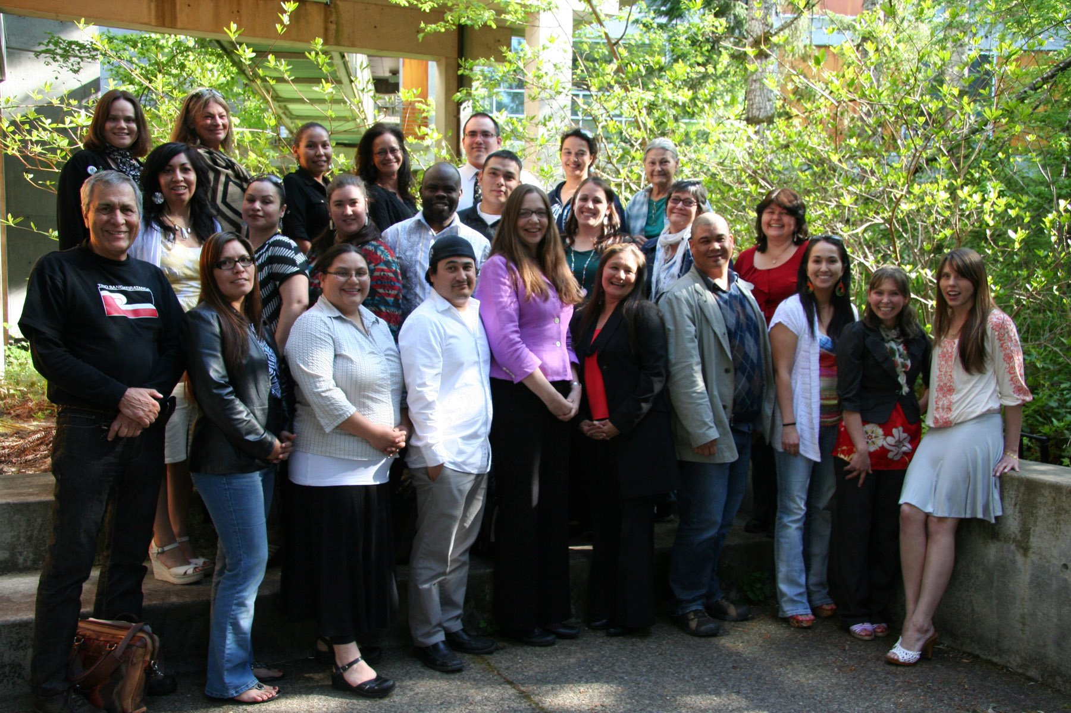

**MPA – Tribal Governance Concentration Class of 2012 & MPA-T Faculty and Staff**

**Top Row:** Erin Genia (Lakota, 2010; staff), Linda Moon Stumpff (San Carlos Apache, Faculty), Kim Benally-Hood (Navajo), Puanani Nihoa (Native Hawaiian), Jeffrey Wall (Nisqually), Olivia Hart (Cherokee), Sarah Nightbear (Columbia River People/Cree/Red River Metis)

**Middle Row:** April McGill (Yuki Tribe Northern CA), Margo Rana (Palau), Kendra Aguilar (Soboba Band of Luiseno Southern CA), Shonda Ocanda (Democratic Republic of Congo), Travis Brockie (Lummi), Kelly Sullivan-Baze (Port Gamble S’Klallam), Mary Bahr (Cree), Tracy James (Swinomish).

**Bottom Row:** Alan Parker (Chippewa/Cree, Faculty), Marie Natrall (Squamish/Northern Tutchone, 2012), Jenny Serpa (Quechua), Adam Osbekoff (Aleut), Debi McNutt, Lorna Edge-Onsel (Lower Elwah), Daniel Felizardo (Filipino), Stephanie Williams (Lummi), Sarina Corpuz (Filipino), Lillian Hendrickson.