July 30, 2026

Zachary R Pullin
524 W Brita Ave
Spokane, WA 99208

Dear Zachary,

I regret to inform you that your offer of admission to the Master of Public Administration – Tribal Governance concentration has been withdrawn. This decision is based upon new information we received from one of your recommenders which calls your integrity into question. Unfortunately, your subsequent response is unsatisfactory, as it did not adequately address the seriousness of the situation, or outline steps towards reconciliation. The MPA program must uphold high standards of student conduct, and therefore cannot offer you a seat in the cohort at this time.

Sincerely,
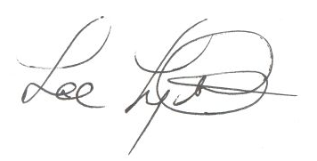
Lee Lyttle.
Director, MPA Program & Member of the Faculty
The Evergreen State College

