

**Enhancing Organizational Capacity to Infuse Teaching and Learning with 21st Century Solutions**

**Steven J. Hicks, MPA**

[**sjayhicks@gmail.com**](mailto:sjayhicks@gmail.com)

**www.edu21stcentury.org**



*Abstract*

*A lot has been written about the implementation of technology to improve classroom practices and learning outcomes, however far less has been written about how technology can improve organizational practices of education organizations. Despite the importance of education in a society, educational organizations are incredibly reactionary organizations; they react to the changing world rather than contributing to the changes. Educational organizations must continually enhance their organizational capacity to become proactive and holistic public managers. This paper provides some solid strategies for using technology to make educational systems more networked and proactive while securing strong return on technology investments by incorporating teach voice into policy formation, developing stronger investment allocation frameworks, viewing students are contributors, and developing strong virtual communities of practice.*

Steven J. Hicks, MPA

[sjayhicks@gmail.com](mailto:sjayhicks@gmail.com)

www.edu21stcentury.org

Public education is an anomaly in public governance. Teachers are rarely thought of as bureaucrats, yet they are public employees tasked with carrying out the government’s policies and providing a service to taxpayers. Education is arguably the most significant governmental agency due to its broad impact on civic engagement, health care, and the nation’s economy. Due to its significance to society and politicians, education policy frequently changes far faster than its impact can be seen. Changes in an education system can take years or even decades to measure. This makes education policy extremely reactive to its environment rather than proactively shaping it. Teachers and school administrators are unique because they engage every day with the same citizens for years. Over these years, teachers develop a much broader understanding of their community than other bureaucrats but educators tend to be separated from the actual act of governing or shaping education policy. Strategies to enhance education as an organization will / should include the use of technology to incorporate teacher voice into policy formation and to effectively increase organizational capacity to become less reactive and more proactive.

Teaching an individual isn’t a challenge to a professional teacher. Centuries of practice and cutting-edge research into neuroscience tells us a great deal about the teaching and learning process; children learn best with experiential learning, story-telling, employing the Socratic method and other inquiry-based approaches. The Great Challenge for all educational institutions around the world is not figuring out how to effectively teach, it is scaling these approaches up to a higher level; a classroom of 20 students, a school, or an entire national education system. The greater the scale, the more challenging consistently implementing these effective pedagogical approaches becomes. To manage things *at scale* requires bureaucracy and organization and how well an organization continually increases organizational capacity (capabilities, knowledge, and resources organizations need in order to be effective) will, over time, determine its success at achieving its goals.

Government organizations, including educational departments, typically are organized with hierarchical tendencies. They have a centralized, vertical structure where funding and policies are set at a higher level, while the implementation and day-to-day routine is dictated by “ground level” bureaucrats. This command structure tends to work for many public agencies. However, in most countries teachers have a level of professionalism greater than a “ground level” bureaucrat in other governmental organizations; teachers have gone through training which has made them experts at, essentially, implementing government policy for 20-30 students in a classroom. A few will expand their expertise to administering an entire school and virtually none will ever gain the capacity to effectively form policy at the national level.

At the higher level one of two things almost always occur: high level bureaucratic positions are filled by former educators who lack skills to manage an organization at this level or they are filled by professionals who *do* have the skills to manage high level administration, but lack the “ground level” knowledge of implementing policies in the classroom. This fissure in organizational capacity is detrimental to education given the length of time it takes to see return on investments in education. To overcome this problem educational organizations, above all, need to adopt an alternative to the vertical, centralized organizational structure.

Technology, by nature, is decentralized and evolves communication. It enables hierarchies to transform into networks where all stakeholders are able to contribute to the best of their ability and where the small contributions of many can directly and significantly impact the whole. This results in an organization which is far more successfully proactive; instead of waiting to see if whatever policy was devised “at the top” works out before it must be amended (or, more often than not, totally abandoned). Additionally, there is a growing body of research on how technology transforms classroom practices and learning outcomes, but far less attention is paid on how technology can inform education policy decisions and organizational capacity; these strategies are generally applied to the private sector (successful companies are proactive companies) and rarely government organizations.

It is unrealistic to expect widespread restructuring of Ministries of Education and, while reinventing training programs and restructuring promotion schemes may contribute, technology holds the key to making a more immediate impact on organizational capacity. There are several realistic alternatives to the top down educational organizations which at the national or institutional level can, through the effective use of technology, improve organizational capacity and communication structure.

## Incorporating Teacher Voice into Policy through Technology

The simplest and easiest way to begin utilizing teacher’s voice in policy formation is electronic surveying. There are numerous digital tools which can be used for free or for a low price which would enable administrators to quickly gather information from a wide range of educators across a country. All that is required is that the teacher have an email address and internet access. Many of these services will do simple analysis of the answers which relieves the burden of doing statistics for bureaucrats.

Questions framed as “Do you think…” or “Would you like…” as well as Likert Scales which allow teachers to place value on a variety of options can provide an excellent source of needs analysis of the teachers. The data helps policy-makers understand the immediate concerns of teachers beyond metadata like test scores. Furthermore, it can expose the effects of previous policies far quicker than other methods of data collection and allow for course correction to take place. This works infinitely better than waiting for the weaknesses of policy to be exposed through public outcry. Involving teachers in the beginning not only validates new policy, it increases the success rate of polices once they are enacted.

Simple surveying is the most basic form of teacher engagement. It can even be expanded to include a more pragmatic function: teacher personal development. While a basic survey may be short and act as simple communication device, surveying can also be designed to “give back” something to the teacher which they can use to develop themselves in a personal capacity. This is achieved by analysing the survey results in a way which encourages reflection and gives guidance to teachers on where to go to learn new skills which are personally relevant.

An example of this type of survey is a technology use/knowledge matrix. Teachers are asked to rate their classroom use of a variety of technologies and, separately, their knowledge in using the same technologies. The results of these answers are then placed on a matrix of “high use- high knowledge”, “high use-low knowledge”, “low use- high knowledge”, and “low use-low knowledge”.

The result of this type of survey to higher-level bureaucrats is an immediate insight into what technology is actually being used in the class as well as where formal professional development programs can best be targeted. Additionally, it allows Ministries to see if the technology investment is being frequently used or if professional development investments have been effective. If the results are negative in this regard, the data can be used to course correct.

For example, imagine significant investment has been made in a Learning Management System (LMS); its use may be initially high (which can been seen by analysing the internal LMS data) but knowledge may be low (only immediately understood via surveys). Survey results like this demonstrate to the Ministry that teachers are merely going through the process because they’ve been told they must do so or because they recognize use of the application is expected, however, their buy-in will eventually slow and the LMS will fall into disuse since teachers don’t fully understand how to use the application.

The result of a knowledge/use survey to the teacher can also have immediate impact. Teachers obviously understand their own use and knowledge on some level, but it often helps to have this information given back to them visually and properly contextualized. To them, this survey becomes a reflective exercise which can be transformed, with proper incentive and guidance from policy-makers, into self-development.

For example, if a teacher sees they have a high-knowledge and high-use on a particular device there is no action needed. Likewise, if they have low-knowledge and low-use, the particular technology would be considered a low priority for them. If a teacher has a high-use, but low-knowledge it means they often use the device but have little more than a basic understanding of how to operate it. A good example of this situation is a teacher who uses a digital whiteboard only as a digital projector, without understanding the full range of approaches it allows. In this case, providing the teachers with guidance in the form of tutorials and videos on the features can help them utilize the devices more efficiently.

Lastly, a teacher with high knowledge but low use may be surprised to learn how they can apply these skills in the classroom. For example, a teacher may be very proficient in using video editing or digital photography in their personal lives but are unaware of how to apply that to classroom use. Providing these teachers with tutorials on how to apply something they are very knowledgably about into an academic setting will enhance both learning outcomes and technology infusion in the classroom.

Surveying teachers can also help with the deployment of new technologies and initiatives. Educational technology projects often fail to achieve optimal results because the wrong groups have been targeted for intervention. When participants or recipients are selected to receive new hardware or technology they often are selected on the basis of traditional methods such as geographical location, seniority, underprivileged, have not received something for a long time, personal, political, etc. At best these methods are random and at worst the groups *least likely* to be able to implement programs successfully are selected. Instead, survey results can enhance the effectiveness of deployment by using the Technology Adoption Curve.

The technology adoption curve was outlined by Dr. Everett M. Rogers in his book *The Diffusion of Innovations*. This model demonstrated that different types of people embrace technological innovation at different rates. This axiom has proven accurate in the vast majority of academic studies utilizing it and has been engrained in the culture of marketing and product development for decades, especially in communications and technology driven industries; however, it has yet to be frequently applied to technology diffusion in education.

The technology adoption curve classifies individuals as being a member of five cohorts: innovators, early adopters, early majority of adopters, late majority of adopters, and laggards who will never fully embrace technology. Each of these categories has definitive traits/characteristics that can be measured in teachers, administrators, and students. New interventions can target willing, “early adopters” who are far more likely to embrace 21st Century teaching; these teachers will emerge as organizational leaders when it comes to ICT use in the organization. This may already happen on an ad-hoc basis, but using a formal process will empower decision-makers to formulate more effective policy and programs which cross the barrier of success known as the “Technology Chasm”.

The “Technology Chasm” is a term developed by industry to describe the risk that technology faces when it is inadequately diffused throughout the ecosystem. This means that often innovations are used by the earliest adopters but an ineffective plan for diffusion is implemented; think about 3D televisions or 8 track-tape machines as examples of failed diffusion in marketing. In this case the technology exists, but is never becomes ubiquitous; it falls down the “technology chasm”.

One of the key lessons in technology diffusion is to start with the groups most likely to be receptive, so that the programs can prove successful. If they are successful then there is a good chance that the early majority and the late majority will adopt them. But if the initial group cannot perform the project will die with their failure even if it was a good idea because they were unable to implement it.

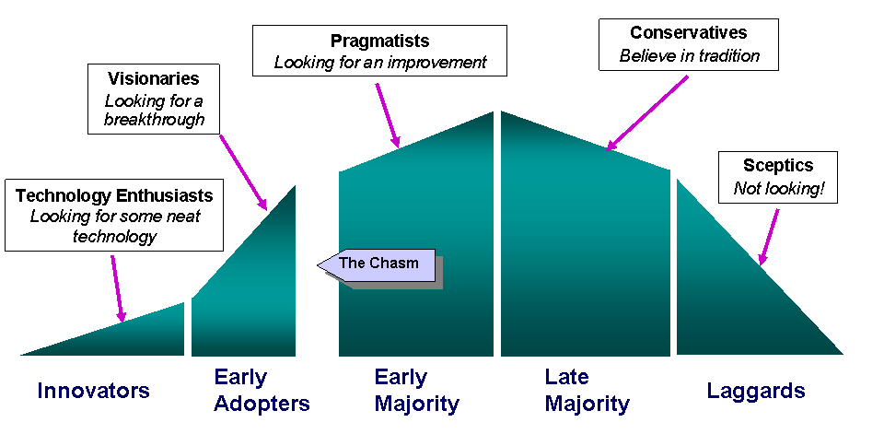

As mentioned, the principle of the technology adoption curve is often not used in technology education development. The end user is generally considered to be a “given” and the development approach is unfocused ensuring the defeat of the initiative and a waste of valuable resources by inevitably and unwillingly targeting “Late Adapters” and “Laggards”. The prevalent attitude in technology education development is that teachers will embrace technology either because they *should* or because *they have to*. Research shows both of these assumptions are incorrect, therefore, a more systematic approach should be considered.

By using the Technology Adoption Curve, decision-makers can decide whether to introduce new concepts to teachers (e.g. blended learning) or to delve deeper into existing initiatives where teachers are most comfortable (e.g. using email in teaching). This approach ensures a better chance of success by targeting the appropriate groups at the appropriate time. After a programs initial success with the innovators and early adopters then the focus would move on to transferring this success to the early majority then the late majority. Initial target group is of paramount importance as is the sequence of implementation and can only be deduced by effective engagement with the teachers themselves.

All the mentioned strategies mentioned here undeniably require varying levels of complexity. It is also undeniable that using technology to increase communication with teachers provides immediate feedback and guidance which jointly helps form effective and good policy. Ground level support and more accurate data ensures a higher degree of success when implementing the policies and bureaucratic decisions are legitimized.

## Strategies for Technology Investment Allocation

Effective surveying leads directly into effective allocation of technology investments. As mentioned, surveying can provide a needs analysis on what stakeholders want and need in the classroom. This method is far more validating and effective than simply relying on educations trends and information from technology venders. *Appropriate* technology must be deployed, not mimicking the policies or direction other countries or institutions are taking.

When technology is deployed without information gathered from a proper needs assessment survey, tremendous money is wasted. Educational organizations are filled with countless stories of failed technology initiatives which were conceptualized in a top down approach. Poor lab design, ineffective professional development, and the massive failure of programs such as “One Laptop per Child” initiatives happen with alarming frequency. The results are often downplayed and the consensus verdict is that educational institutions are stumbling forward trying to figure out “what works” in a rapidly changing environment. Often, teachers themselves are blamed for the lack of success. The reality is often proper data wasn’t gathered, teacher’s voice wasn’t taken into account, and policy makers merely tried to copy another’s perceived success or followed the advice of a vendor.

The truth is that the effectiveness of many technology solutions is still very much unknown, so focusing funding and procurement on technology which has a higher chance of success is of far greater value than being modern or cutting-edge. Beyond engaging teachers, developing a simple framework of procurement principles can ensure a higher likelihood of return on investment and can even validate procurement decisions from accusations of impropriety.

The 3i Framework in an effective lens through which one can look at ICT investments: Infrastructure, Info-structure, and Info-culture. They can be briefly described as:

* **Infrastructure:** Facilities and ICT hardware investments
* **Info-structure**: ICT software, systems development, platform, & content investments
* **Info-culture:** Organization capacity building (i.e. benchmarking, professional development, data acquisition, pedagogical practices).

Info-culture is the *least* addressed element of development because it is the most conceptual, requires more planning and implementation time, and because the majority of venders don’t address this area. However, it is crucial to success of the other two investments; not focusing on info-culture raises the possibility of failure in any initiative.

The 3i Framework itself is simple. It provides a way of looking at budgets which maximize the return on ICT investment. Generally, a budget should work from the principle of 60-20-20. That is to say, 60% of budget should be spent on procuring hardware (i.e. the computers), 20% on digital content, and 20% on professional development and benchmarking activities. Too often, when this framework isn’t considered, initiatives fail. A good example are the many initiatives which seek to give teachers more hardware, but omit a range of software to use on the hardware, don’t provide professional development on how to use the hardware, and never revisit the issue again to resolve problems; this is why so much hardware is gathering dust in schools around the world.

In the 3i Framework, the funding process starts at the smallest level- the info-culture. Funding the professional development and investing in benchmarking activities should happen *before* large scale infrastructure investment. In other words, teachers should be learning *how* to effectively utilize the principles of technology infusion into the classroom and profiled before significant resources are wasted. This can be used as an incentive to reward teachers who reskill themselves with technology they’ve already demonstrated they know how to use.

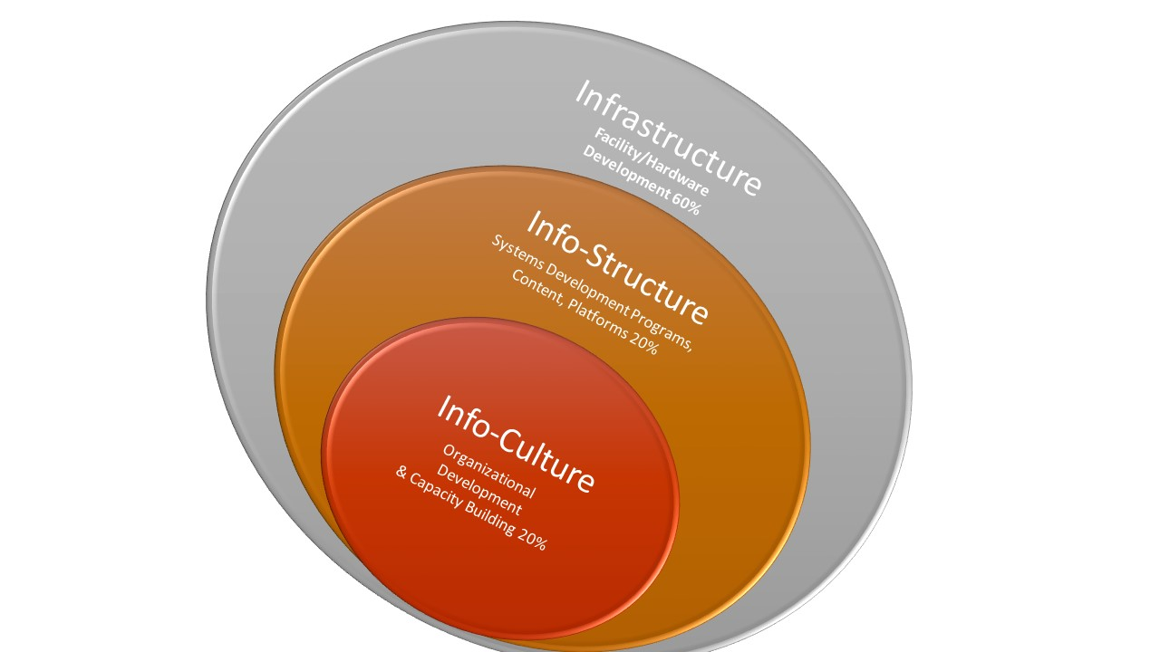Only then should info-structure and infrastructure investments be considered. Planning on the types of content and platforms to be used will influence the types of infrastructure needed. For example, is a high speed internet connection necessary if school policy prohibits the use of internet in schools, if teachers are unskilled at using web resources in teaching, or if digital content is offline? Are tablets a worthwhile investment if students will be creating a lot of digital projects using video and audio or are PCs impractical because students will be using virtual instrumentations in their science classes? Significant return on ICT investment can be achieved by using the 3i Framework and reversing the intuitive, traditional way of investment allocation.

## Students as Stakeholders

It is impossible to look at capacity building without accounting for the full range of stakeholders in an organization. Students comprise roughly 90% of the stakeholders in a school, yet are given the least voice in how the system is designed now and in the future. Not only are students stakeholders, but they are valuable human capital which can contribute to the overall success of the organization. No organization would be considered effective if they neglected 90% of its human capital.

Students are not cruelly omitted from contributing to the organization; they are typically thought of as the “product” of education rather than an active contributor. Conceptualizing students as “products” is directly tied to the traditional vertical, hierarchical organizational structure in education. This organizational structure is analogous to the classic vertical organization: the factory. The policy-makers mimic the functions of managers and owners, the teachers are the employees, and the students are objects being produced. It has been shown how engaging teachers as active participants can yield positive results and the same can be said for re-conceptualizing the student from a “product” to a participant.

Again, the easiest way to engage students is by digitally surveying them. It is true that students’ understanding of the complexities inherent in managing a system is limited; they simply lack the experience to see the nuances need to make accurate decisions. However, two things students can be counted on to provide are: what kind of learning works for them and what new technologies are emerging.

Studies which do look at student voice have found that (American) students overwhelmingly prefer group work and project-based activities. They rated, for example, lectures as the least effective way for them to learn new information. These kinds of insights might change depending on local culture, age of the students involved, or previous learning experiences. Nonetheless, data highlighting student preferences provides useful insight into the learning process and can enhancing future planning. Young people also like to be included and feel significant; including their voice in this way enhances their relationship with learning on the whole and can potentially lead into more engagement with curriculum.

The second valuable area students can directly contribute to organizational capacity regards emerging technology. It is no secret young people have a higher degree of proficiency with technology than most adults. It isn’t accurate to generalize and say *all* students have a natural understanding of technology, but as a general rule young people have an enthusiasm for learning new technologies absent in many adults. This enthusiasm can be leveraged to enhance the organization’s capacity to infuse technology in a number of ways.

One issue organizations have when they bring in new technology is the maintenance and upgrading of the technology. Students, under the supervision of an adult, can be leveraged to provide this maintenance. While the idea of student maintenance of technology may sound imaginative, there are several organizations which have years of experience at implementing exactly this type of program. Generation YES ([www.genyes.org](http://www.genyes.org)) and MOUSE ([www.mouse.org](http://www.mouse.org)) are both non-profits which have developed vast materials and experience at using students as tech support in the school. Additionally, some hardware providers will allow students, under supervision, to fix their equipment without voiding the warranty.

Student Tech support programs are a great way to capitalize on an underused computer club or even as a class unto itself. If the program is part of a class, students can progress towards one of the many industry certifications available and get valuable hands-on practice at fixing technology in “the real world”. Students will learn trouble-shooting, how to organize work tasks, and leadership skills all at a reduced cost to the organization than employing more IT support staff or replacing broken technology.

Students who are not interested in working with their hands can still be valuable contributors to an organization’s ICT initiatives. Professional development (PD) is an expensive and logistically difficult, time consuming task. It is also one of the most important to ensure technology investment is fully being utilized by teachers. An organization can make professional development cheaper and meet the local needs much easier by employing students to do routine professional development on-site for teachers.

Student-led professional development can be bundled together with curriculum to teach students public speaking, organizational skills, and technology skills. Students who do professional development for teachers become the “go to” member of the organization for that particular technology. This type of professional development works very well because the personal relationship between teacher and student makes the learning more holistic and immediate compared to inviting a stranger to lecture a group or teachers or sending teachers off-site to learn a new technology. In this case, PD can happen with several teachers or one-on-one and needn’t take up significant time.

There is a lot of talk in education circles about “Teacher generated content”. Teacher generated content implies that teachers will generate content and then disseminate it to a wider-body of teachers. The logic is content will be more localized to curriculum than products on the market and also be cheaper to produce. While in line with the ideas expressed in this paper, the reason teacher generated content won’t work is because it is far too time consuming and teachers often lack the technical skills to make quality content.

The last possibility for better engaging students in technology initiatives is by having them become content creators. This approach works very well for artistic minded students or students who like to create something new. Students who don’t have the technical skills have the free time and inclination to develop those skills. In fact, many students are learning these skills either in school or in their free time as a hobby. One only has to look at Youtube to see how many more videos are posted by kids than teachers.

While many students already have to capacity produce content, they don’t have the subject-area knowledge. The teacher’s role in this process is to provide notes and the parameters for the content before leaving the construction process to the student. As with any design process, there is a degree of back-and-forth between teachers and students which only bolsters the student’s ability to communicate with adults in a professional setting. Schools who have succeeded in student-generated content programs typically imbed the content-creation process into a project-based learning activity where the end product is used by a larger community as a learning object.

It should be acknowledged that many people will never be able to see students as valid participants in their own education. Some people will never be able to change their mind-set of seeing students as the outcome of education rather than an input. However, for an organization to be fully effective, student engagement needs to be considered. Logic dictates that by sheer volume of students at least some of them have greater to offer education systems beyond being passive recipients of knowledge. The entire organization is missing out if these contributions are not given any opportunities to emerge.

## Communities of Applied Practice

The last suggestion for adopting a more fully networked approach towards enhancing organizational capacity in education is by developing a community of applied practice. Communities of practice (CoP) aren’t entirely a new idea in organizations, but they should be taken to another level than is often the case. Communities of Practice should be engagement tools between policy-makers and practitioners at the “lower” level. They should also be applied to classroom practice and act as a facilitating device to turn ideas into action.

There are many examples of technology which can be appropriated to CoPs and, in fact, many CoPs already exist on these sites. Facebook, Edmodo, and even LinkedIn are all good starting places for educators and policy-makers to explore communities of practice. However, making a unique, localize, and government sanctioned CoP will yield the best results for achieving organizational capacity; the other options are great for individuals and even work at an institutional level, but are difficult to manage all the things a large organization would desire.

A Community of Practice is a simple place where an organization’s participants are able to share experiences, best practices, ideas, and innovations. It is also an often overlooked element of professional development; development is not only about training, but also about sharing and comparing. At its most basic a CoP is a place where teachers can engage one another about what is working and not working for them. Bringing the management of the CoP under the purview of policy-makers augments the breadth of engagement and creates an essential tool for the networked organization.

The CoP becomes a place where results of the teacher and student surveys can be displayed. This is important because it demonstrates policy-makers are listening to the teachers. It also allows the policy-makers a venue to explain recent policy decisions and events. This is very significant because it personalizes the news. Without employing this method, teachers are often left reading the details of new polices or new directions the organization is taking in the media along with regular citizens. Including this type of news in a closed community where communication regularly takes place can feel far more inclusive.

Additionally, the CoP can include an online marketplace with items approved by the Ministry. For example, online classes which are validated by the Ministry, educational apps or software in the local language. These items more than likely exist, but their effectiveness is diminished when teachers must take time to actually track down the items themselves and are unsure how the product fits with local curriculum.

This function of a CoP also provides a greater degree of autonomy for practitioners. It is far easier to provide multiple options for teachers using a CoP rather than the traditional “one size fits all” approach many ministries use. For example, as opposed to buying one software package for the entire country, the ministry could buy three and disseminate them to teacher through the CoP; essentially letting the teachers “shop” for content from pre-approved selections. Teacher or student generated content can also be shared in this way.

Professional development become highly personalized using this strategy as well. Online courses and massive open online courses (MOOCs) are being more and more ubiquitous. Applying those concepts to the CoP ensures that teachers are getting recognized by participating in these courses as well as providing some regulation from the Ministry. The Ministry may select a variety of courses, or even a series of courses in a learning pathway, and have teachers participate in them at their leisure. Results can post to the teacher’s profile, which ensures the Ministry has an up to date account of what teachers are doing to continually develop and can reward teachers accordingly.

Universities can also be involved in the CoP. Not only can local universities provide online courses, but they can act as a valuable resource to share new research, best practices, or new programs to the rest of the CoP members. This relationship can evolve into more formal school-university partnerships which are increasingly more common. University and graduate students can find ample research opportunities using the CoP which can then be used as contributions to all participants.

There are many ways to design a CoP, but the important aspects are it remain inclusive of all parties (even students) and transparent. This strategy can act as a clearing house and meeting point for the organization. If an organization is successful in making the CoP active (not always an easy thing to accomplish) it will have completed one of the most important steps at fully utilizing its organizational capacity and becoming a proactive network.

## Conclusion

Few would argue education lies at the heart of a society. It is the single largest change agent developing countries can use to achieve their national goals. Education needs to be more than test scores and college entrance applications. These kinds of metadata is virtually useless without an authentic context provided at the ground level. Using a vertical organizational structure severely diminishes an organization’s ability to respond to changing realities. Furthermore, a vertical organization will find it incredibly hard to be as proactive as it needs to be to successfully meet national aspirations.

Using technology not only to enhance test scores or to keep curriculum current, but to enhance an organization’s ability to incorporate technology into organizational practices will increase proactivity and empower an organization to more successfully meet their goals. Technology planning means more than simply investing in current trends; it must begin with reflection and needs assessment. It follows through by using technology to better communicate with all stakeholders, and it concludes with continually adapting and modifying technology programs until they work rather than abandoning perceived failures. Adopting some of the strategies outlined in this paper can help an educational organization reinvent themselves into an effective and dynamic force who generates high return on their technology investments.