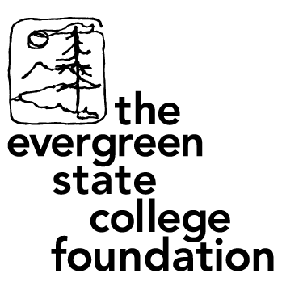

The Evergreen State College Foundation (EIN #) is raising funds to support the graduation expenses of Native students who are graduating from the Masters of Public Administration Tribal Cohort.

Native American students will be graduating from The Evergreen State College on Friday June 10, 2016 starting at 9:30 am. We will be honor to have you attend the commencement ceremony held on Red Square of the campus who will be graduating with a Master’s in Public Administration.

Each year the students and facility members are presented with Pendleton Blankets to recognize seven plus years of studies. This gift helps to recognize the Masters in Public Administration degree studies which has helped each student to enhance their abilities to understand, analyze and to manage an organizational environment more effectively and to promote positive enhancement of tribal, public, nonprofit, city, and federal sectors. These students will be soon entering careers as grant writers, personnel administers, policy analysts and managers of various departments in the area of health, education, natural resources and related fields within t.

Today we would be humbled and honored if your tribe towards pursuing adequate funding for the purchase of Pendleton Blankets of 40 Blankets at $150 each = $6,000.

The Evergreen State College Foundation is a 501 (c) (3) nonprofit organization, and gifts are tax deductible to the extent permitted by law. 100% of your gift supports The Evergreen State College; 95% directly support visionary opportunities made available and sustained to allow our progression in a culturally relevant and applied program attributes to elevating our abilities and expectations for ourselves and our communities.

Checks can be mailed to:

The Evergreen State College Foundation  
2700 Evergreen Parkway NW

Olympia, WA 98505

We would like acknowledge all the support and sacrifices that sustained our academic endeavors and launched this commencement in our educational journey. Moderations in time and space narrowly allow each student to perform a single display of their gratitude and appreciation during our Master of Public Administration graduation ceremony. Our efforts and abilities that would not be attainable without a broad scope of collective support necessitates the desire for gifting, even displayed on a limited scale of appreciation, is cultural and traditional practice that is acknowledged as an essential component to include in our commencement ceremonies. Financial inequality existing within our Tribal cohort and individual capacities to fulfill added financial burdens during and leading into the final steps of our academic journey places us into the position to humbly request for a donation from you and your organization.

orts programs.