July 23, 2014

Mary H. Harper STUDENT ID: A00253636

734 West Marcy

Montesano, WA 98563

Dear Mary,

Congratulations! I am pleased to inform you, upon recommendation of the MPA Admissions Committee, that you have been accepted into Evergreen’s Master of Public Administration – Tribal Governance Concentration for Fall 2014. We select our entering cohorts with considerable care, and this year’s pool of applicants was more competitive than ever before. You are part of a diverse, capable, and dedicated cohort of people selected to begin the program this year.  We hope you will join us.

To accept this offer of admission and reserve your space in the Fall 2014 cohort, **the college must receive a non-refundable $100.00 tuition deposit by Monday, April 28, 2014**. The tuition deposit billing form is enclosed. Once you have paid your deposit, please activate your “My Evergreen” account to ensure that you receive emails from us.

We are glad that you have registered for your Fall courses! I have you registered for the first Core session in *Context to Public Administration-Tribal* for six credits and you are registered for the second session in *Path to Sovereignty* for four credits for a total of ten credits for the Fall session. We are looking at a rigorous concentration with so many talented students entering into the cohort. If you have any questions, feel welcome to contact Puanani Nihoa, Assistant Director for MPA Tribal Governance Concentration, at [nihoap@evergreen.edu](mailto:nihoap@evergreen.edu).

**Re: Orientation**: please note that while Fall quarter classes begin on Monday, September 29, 2014, we typically start first year Core a bit earlier, with a weekend class meeting/orientation to the MPA program. We are in the planning stages now and will send more information to you in May.

**Once again, congratulations on your admission to the Master of Public Administration program!** We hope you will accept this offer and look forward to working with you.

Sincerely,

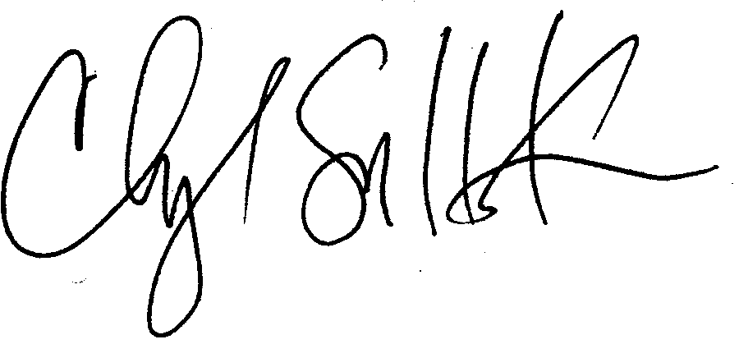

Cheryl Simrell King, PhD

Director, MPA Program & Member of the Faculty