April 4, 2014

Tonya J Greene STUDENT ID: A00264025

709 South Pine St

Port Angeles, WA 98363

Dear Tonya,

Congratulations! I am pleased to inform you, upon recommendation of the MPA Admissions Committee, that you have been accepted into Evergreen’s Master of Public Administration – Tribal Governance Concentration for Fall 2014. We select our entering cohorts with considerable care, and this year’s pool of applicants was more competitive than ever before. You are part of a diverse, capable, and dedicated cohort of people selected to begin the program this year.  We hope you will join us.

To accept this offer of admission and reserve your space in the Fall 2014 cohort, the college must receive a non-refundable $100.00 tuition deposit by Monday, April 28, 2014. The tuition deposit billing form is enclosed. Once you have paid your deposit, please activate your “My Evergreen” account to ensure that you receive emails from us.

If you \*cannot\* accept our offer of admission, please email Puanani as soon as possible at [nihoap@evergreen.edu](mailto:nihoap@evergreen.edu) so that we may inform students on our waiting list.

What follows is some important information about admission, financial aid and Fall quarter registration and course scheduling. If you have any questions, feel welcome to contact Puanani Nihoa, Student Support Assistant for MPA Tribal Governance, at [nihoap@evergreen.edu](mailto:nihoap@evergreen.edu).

Your admission to the MPA program requires that you complete an MPA-approved 4 credit introductory statistics course with a grade of “C” or better before you begin MPA coursework in Fall 2014. For a list of Evergreen and non-Evergreen courses that would satisfy the statistics requirement and other important information about the statistics prerequisite, go to the “statistics prerequisite guide” on the Admissions Requirements page of our website, at: <http://www.evergreen.edu/mpa/admissionsreq.htm>. After course completion, please submit an official transcript by September 15, 2014 to Jan Hays, MPA Office Assistant, at: MPA Program; Lab 1, Room 3019; Evergreen State College; 2700 Evergreen Parkway NW; Olympia, WA 98505. Your admission to the program will be withdrawn if we do not receive an official transcript documenting completion of the statistics prerequisite by September 15, 2014.

This offer of admission is dependent upon successful completion of any academic work currently in progress.

Re: financial aid: if you have \*not\* yet applied for financial aid and would like to apply: (1) Complete the FAFSA (Free Application for Federal Student Aid) to qualify for federal student loans; (2) Review MPA sponsored financial assistance opportunities and complete the 2014-15 MPA Financial Aid Awards Application Form by April 7, 2014. Information for both options is posted on our MPA Financial Aid page: <http://www.evergreen.edu/mpa/finaid.htm>. Please note that in order to qualify for any MPA aid with a \*need\* component, the FAFSA \*must\* have been submitted by the March 1, 2014 campus priority deadline. Applicants who have completed the 2014-15 MPA Financial Aid Application Form will be informed of MPA awards decisions via email \*before\* the April 28th MPA admission deposit deadline.

Fall 2014 course registration will begin Monday, May 19, 2014. After we receive your tuition deposit, registration instructions and information about Fall courses will be emailed to your Evergreen email address.

Re: Orientation: please note that while Fall quarter classes begin on Monday, September 29, 2014, we typically start first year Core a bit earlier, with a weekend class meeting/orientation to the MPA program. We are in the planning stages now and will send more information to you in May.

Once again, congratulations on your admission to the Master of Public Administration program! We hope you will accept this offer and look forward to working with you.

Sincerely,

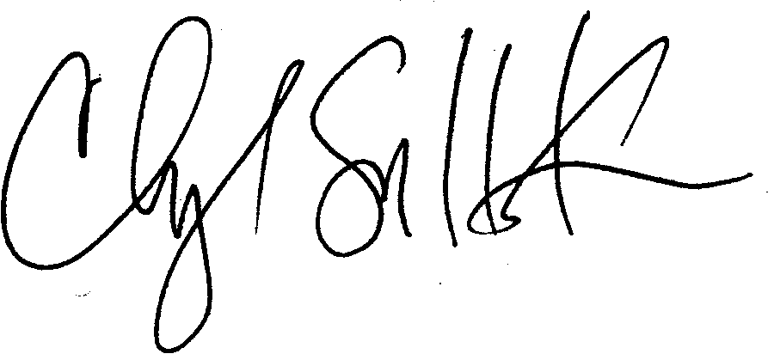

Cheryl Simrell King, PhD

Director, MPA Program & Member of the Faculty

The Evergreen State College