July 30, 2026

Lexie Jean Tom STUDENT ID: A08004226
2865 Kwina Rd
Bellingham, WA 98226

Dear Lexie,

I am pleased to inform you, upon recommendation of the MPA Admissions Committee, that you have been accepted into the Tribal Concentration of Evergreen’s Master of Public Administration program for Fall 2011.

If you wish to accept this offer of admission and reserve your space in the Fall 2011 inter-year cohort, the college must receive a non-refundable $100.00 deposit within 30 days from the date of this letter. The tuition deposit billing form is enclosed. If you cannot accept this offer of admission, please notify Erin Genia via email immediately geniae@evergreen.edu.

Congratulations on your admission to the Tribal Concentration of the Master of Public Administration program as an inter-year student. We select our entering cohorts with considerable care and admissions are quite competitive. You are part of a diverse, capable, and dedicated cohort of people selected to begin the program this year. We hope you accept this offer and look forward to working with you.

Sincerely,
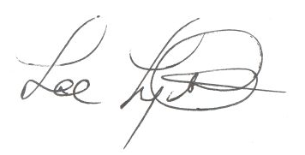
Lee Lyttle.
Director, MPA Program & Member of the Faculty
The Evergreen State College

