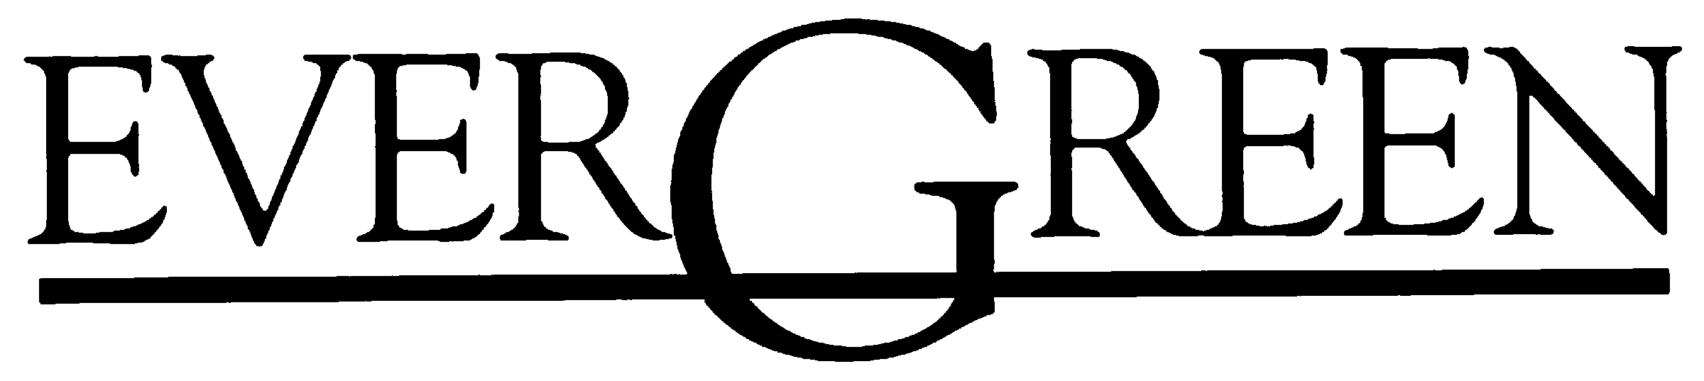
The Evergreen State College
Masters of Public Administration
Tribal Governance Concentration Program
2700 Evergreen Parkway NW
Olympia, Washington 98505

July 30, 2026

Yakama Nation Higher Education
Staff and Education Committee Members
P. O. Box 151
Toppenish, WA 98948

Re.: Graduate student Patrick Luke

Dear Yakama Nation Higher Education Committee,

This note is to inform you that Patrick Luke has been attending The Evergreen State College Master’s in Public Administration-Tribal Governance Concentration, this will be his second year in our concentration; he is in good standing in our cohort and preparing admirably to embark upon his last year of gregarious work.
The Tribal Governance Concentration is the only MPA program in the United States that is developed in coordination with local tribes to meet the needs of tribal communities. This year marks our 11th year anniversary. Our program provides an exemplary education on issues affecting American Indians, Alaska Natives, Native Hawaiians and international indigenous peoples. It includes leadership training, critical thinking and communication skills, opportunities for original research, public engagement, policy development and advocacy skills, alongside the knowledge needed to work effectively in Indian Country.
The MPA-Tribal Governance program was designed with working adults in mind. The classes are offered at the Olympia campus approximately every other weekend. The courses are scheduled in an intensive format on Friday afternoon, and all day Saturday and Sunday. In between the weekend classes, students are required to do online work. This allows students with full time jobs and family commitments to take part. It is also ideal for students who live throughout the region, as they can travel to Olympia for weekend class a reasonable number of times per quarter.
Here is an excerpt from Mr. Lukes’ instructor in the program who states the following from this student’s evaluation:

Patrick is a good student whose presence is an important value in this cohort. He is a student who others listen to given his experience and insights. Patrick’s critical thinking skills were evident in his written work and participation, when it occurs, in class and seminar. His writing is strong and generally addresses the assignments given. Patrick lends a contribution to the cohort in that his insight is highly valuable. He reads the required material and adds to the discussion. Patrick’s final project, though seemingly a work related already existing document, took on the very complex issue of natural resources management and examined many critical issues. His writing and research were thoughtful and examined the pertinent issues facing a tribe I their potential code creation. Patrick is a good student and valued member of the cohort.
—from Faculty member, Russell Lehman

If you have any questions, comments, and/or opinions please don’t hesitate to contact me at your convenience.

Puanani Nihoa, M.P.A.
MPA Tribal Concentration
Assistant Director-MPA Tribal
Governance Concentration Program
Lab I - Room 3020
Evergreen State College
2700 Evergreen Parkway NW
Olympia, Washington 98505
(360)867-6202
nihoap@evergreen.edu
http://www.evergreen.edu/mpa/tribal/

