**Decision Package**

**TESC MPA Curriculum Changes for AY 2021-2022**

**May 21, 2020**

**SUMMARY OF KEY CHANGES**

1. Core Cohorts: Learning lenses woven throughout all cohorts’ core courses = path to sovereignty, ethics, economics, methodological inquiry. Weekend Intensive Option = weekend cohort core course option available to all students at point of admission. Not concentration specific. Reduction in core program from 36 to 24 credits = Core courses will be offered as 4 credit hour courses rather than 6 credit hour courses. An additional course, Analytic Techniques for Public Service III, will run simultaneously with Capstone. Capstone is no longer a “core” course, but a distinct course offering. Analytical Techniques for Public Service becomes a year-long offering instead of only two quarters. The MPA program operated under this exact model from 2000 -2010.
2. Concentration requirement: MPA students will be required to complete at least one concentration of 12 credit credits, selecting from Tribal Governance, Public and Nonprofit Administration, and Public Policy. Each concentration will require students to complete 3 pre-determined courses.
3. Termination of statistics pre-requisite to admissions requirements

**BACKGROUND**

The Evergreen State College Master of Public Administration (MPA) program continuously gathers input on its curriculum from multiple sources, including annual summer institutes with key stakeholders, student, alumni, and employer surveys, external reviews, and regional meetings and conferences. Periodically, MPA program faculty and staff evaluate the MPA curriculum in light of this input to consider revisions that will better align the curriculum with the needs of public and nonprofit sector employers, students, and the community at large. The latest significant re-design of the MPA program was in 2010, which included the adoption of the 36 credit hour (6 credits per quarter) model for the MPA core curriculum. While this model has served the program well in several ways (such as improving the program’s 2-year graduation rate), other sources of feedback identify opportunities for improvement. Some of the key findings emerging from these reports include:

1. Declining overall student satisfaction with MPA program curriculum and instruction
2. Disconnect between the Tribal Governance concentration curriculum and the public administration needs of Washington tribal nations
3. Student frustration with absence of electives for students pursuing a Tribal Governance concentration
4. Siloing of students by cohort and concentration
5. Addressing high demand particular subject matter, including nonprofit management
6. Declining MPA program enrollment
7. High expected growth over the next decade in professional masters programs nationally
8. High demand for programs that support flexible course delivery and stackable credentials

After multiple years of reviewing and discussing layered considerations, in November 2019, the MPA faculty and staff began a series of curriculum re-design sessions facilitated by Michael Fraidenburg of the Thurston County Dispute Resolution Center. This process identified shared goals a re-designed curriculum should achieve. The possible goals voiced by faculty and staff included (in order of priority):

1. Improving student-centeredness
2. Promoting equity
3. Improving consistency in core curriculum across years
4. Streamlining concentrations
5. Addressing faculty CBA requirements
6. Improving curriculum and program planning
7. Strengthening community relationships
8. Improving recruitment and retention

Working collaboratively, MPA faculty and staff developed alternative ways of envisioning the MPA curriculum around these goals, reaching consensus on the changes in this decision package. We anticipate the following outcomes from adopting these changes:

1. Improved student-centeredness with a curriculum that increases flexibility and range of options for students to complete the program
2. Improved equity by removing barriers to entry for some students and through more equitable student experience across concentrations
3. Greater consistency in MPA core curriculum across years through adoption of four learning lenses that will define core learning objectives
4. Improved enrollment through a cohort system and curriculum that offers more convenience for a greater range of students, including improved part-time options and a weekend-intensive option

**DETAILED CHANGES TO MPA CURRICULUM AY 2021-2022**

**1) Termination of statistics pre-requisite to admissions requirements**

Beginning with the admissions cycle for Fall 2021, MPA applicants will no longer be required to complete a statistics course prior to beginning the MPA program.

This change promotes equity and eases entry for first-generation and students of color, who are less likely to have taken a statistics pre-requisite course and who have less means to pay for the course. Moreover, faculty report that it has had very little impact on student preparation for the second year core sequence. The revised curriculum model creates a year-long “Analytical Techniques for Public Service” offering instead of just two quarters. This will allow faculty the time to effectively build statistics into the core curriculum.

**2) MPA Learning Communities: Cohorts**

Beginning with the admissions cycle for Fall 2021, MPA applicants will select one of three core program learning community options when applying for the MPA program:

1. Olympia evenings --- Core courses held at Olympia campus on 1-2 weeknights each week of the quarter.
2. Tacoma evenings --- Core courses held at Tacoma site on 1-2 weeknights each week of the quarter.

3) Weekend intensive --- Core courses held at Olympia campus Friday-Sunday for 2-3 weekends each quarter.

MPA students will continue to take the core courses associated with his/her learning community, and may take concentration and elective courses at any location. Students may change core program learning community (cohorts), space permitting and will require Director approval.

**3) MPA Degree Requirements**

To earn the MPA, students must complete 60 credits (and may not attempt more than 76 credits), allocated in the following way:

**i) Core Program (28 credits)**

Students must complete the following core courses:

*1st Year Core (12 credits)*

Context of Public Administration (4 credits)

Doing Democratic Public Administration (4 credits)

Policy, Finance, and Budgeting for Public Administration (4 credits)

*2nd Year Core (12 credits)*

Analytical Techniques for Public Service I (4 credits)

Analytical Techniques for Public Service II (4 credits)

Analytical Techniques for Public Service III (4 credits)

*MPA Capstone (4 credits)*

**ii) Concentration (12 credits)**

Students must complete 12 credits in at least one of three concentrations[1]

1. Public and Nonprofit Administration
2. Public Policy
3. Tribal Governance

**iii) Electives (20 credits)**

Students must complete 20 credits in MPA elective courses or other approved TESC graduate courses. This may be accomplished in part through Individual Learning Contracts or Internships.

**4) Core Curriculum Learning Lenses**

The MPA core curriculum will be organized around 4 “learning lenses”. These lenses define approaches and methods that will be integrated across the core courses and that will remain constant across years. These four lenses are:

1. Tribal governance
2. Ethics
3. Economics

d. Methodological inquiry

**POSSIBLE IMPLICATIONS**

**1) Student Financial Aid**: One goal in this curriculum re-design is to ease the path towards earning an Evergreen MPA on a part-time basis. This is particularly appropriate given that many if not most of the students we serve are in-service (in full-time professional positions) and therefore may often be unable to pursue a graduate program full-time and at the same time have a fair chance to demonstrate their academic ability. This raises a question about the availability of financial aid for part-time students in the MPA program.

To address this, the curriculum workgroup consulted with Colby Morelli in Evergreen’s Financial Aid office about financial aid for part-time students. The minimum credit load for federal financial aid for graduate students is 4 credits per quarter, and 8 credits per quarter is the minimum for full-time status for federal financial aid purposes. We also consulted with Randy Kelley in Evergreen’s Veterans Services office. According to Randy, VA benefits cover in-state tuition and fees for veterans enrolled for any number of credits, and this benefit does not require that the veteran complete the program within a particular time frame. For the additional housing benefit from VA, a veteran graduate student must be enrolled as a full-time student (8 credits).

Tribal education benefits vary significantly from nation to nation, with many nations offering no support to graduate study and others offering benefits. We know anecdotally that some nations that offer benefits for graduate study require the student to maintain full-time status or more and/or to complete the degree within a particular time frame. Since we anticipate offering both 2 credit and 4 credit options to students, a student can develop a courseload in any increment of 2 credits, and could earn 10 credits with a courseload of 3 courses. All students, including those receiving benefits that are contingent on maintaining a particular course load, can receive advising for a schedule that will keep them in compliance with these requirements.

**2) Program Headcount and Average Annual Full-Time Equivalent (AAFTE) Enrollment:** The curriculum workgroup also explored the possible implications for MPA program headcount and Average Annual Full-Time Equivalent enrollment with a student body that is more heavily weighted to part-time. Discussion with Coral Garey in Evergreen’s Office for Institutional Research confirmed that Washington State defines a full-time equivalent in graduate program enrollment as one student enrolled for 10 credits. Hence, a part-time student at 6 credits would count as 0.6 FTE, and a student at 12 credits would count as 1.2 FTE. A greater proportion of part-time students would lower AAFTE in a given year. It would also be expected to increase program headcount (since part-time students stay in the program longer in order to complete their degree).

To analyze the changes in FTE and program headcount with an increasing percentage of part-time students, we simulated headcount and AAFTE under two scenarios: one in which 10% of MPA students complete the program part time (over 3 years) and the remainder complete the program full time (over 2 years); and the other in which 50% of entering MPA students complete the program part-time and the remainder complete the program full-time. The model assumes that we admit 75 new students per year on average and a 10% attrition rate per year (both are approximately true for the MPA program today).

Figure 1 illustrates the projected AAFTE for the MPA program over 12 years following implementation of a curriculum that results in 10% of students going part-time and 50% of students going part-time. Between Year 1 and Year 2, AAFTE enrollment drops significantly in a program that shifts to 50% part-time enrollment compared to a curriculum with 10% part-time enrollment. This occurs since part-time students individually contribute fewer FTEs in a given year to enrollment. Between Years 2 and 3, AAFTE enrollment under 50% part-time enrollment increases to approximate AAFTE enrollment under 10% part-time enrollment. This occurs because headcount of part-time students increases because these students remain in the program for 3 years rather than 2. Note that AAFTE under 50% part-time enrollment is expected to be slightly below that under 10% part-time because their longer time in the program makes part-time students more vulnerable to attrition.

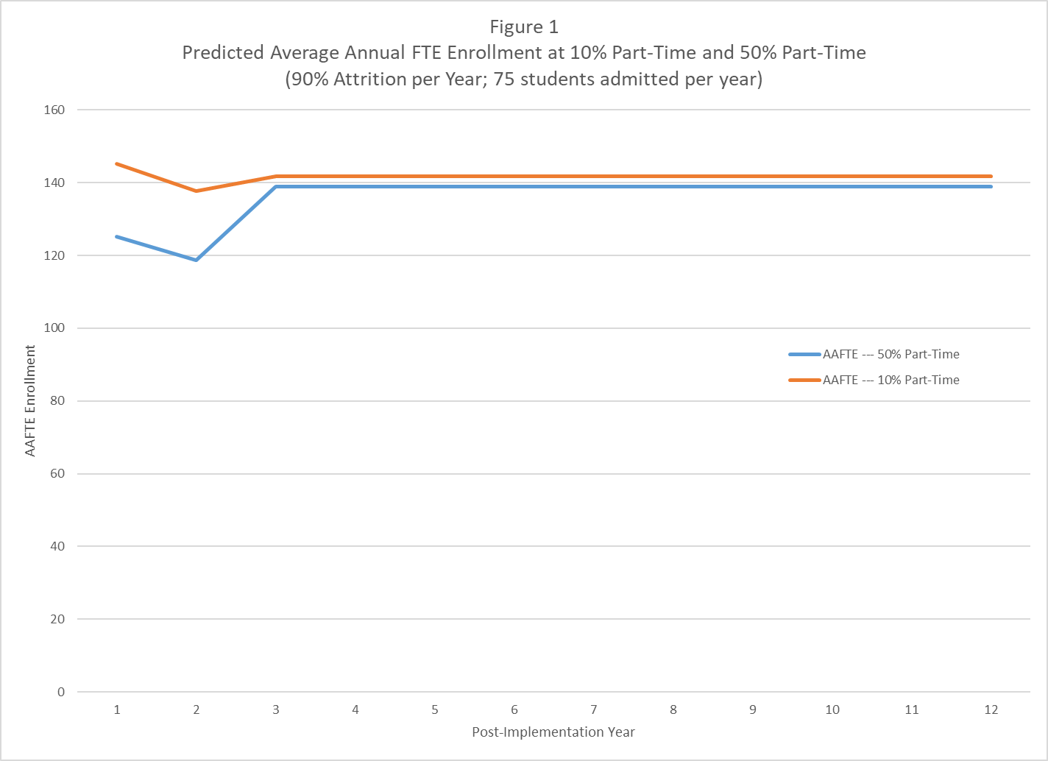

Figure 2 illustrates MPA program headcount (total number of full-time and part-time students) in a program with 10% part-time enrollment and 50% part-time enrollment. In Years 1 and 2, headcount declines under both scenarios equally from attrition. Between Years 2 and 3, headcount increases under both scenarios as part-time students who started in year 1 remain in the program through year 3. Hence the increase in headcount is greater in the program with 50% of entering students being part-time, and remains greater over the long-run.

These models indicate that we can expect a temporary dip in AAFTE in adopting a curriculum that results in more students pursuing the program part-time, but that over the long-run AAFTE will approximate that of a program where most students enter as full-time. A permanent difference exists owing to the extra year in the program from part-time students, which increases the risk of attrition from the program. Assuming the program’s annual attrition rate remains around 10% (as assumed here), this difference is small in comparison to the rest of the program. Hence only a small increase in enrollment resulting from students selecting the program because it is easier to pursue part-time is needed in order to cost-justify the change.

A further consideration of these curricular changes on AAFTE is how these changes may affect the proportion of MPA courses that MPA students choose to earn over summer. Summer courses are not considered in the AAFTE enrollment count. Changes that increase the average student’s propensity to take summer courses, then, may decrease AAFTE. Two factors under these changes may affect summer enrollment. First, if part-time students are more likely to take summer courses than full-time students, AAFTE would over the long-run be lower than it would be otherwise. Second, faculty workload change from 30 credits per year of teaching to 24 credits will reduce the number of elective courses over the academic year, but may increase the amount of ILCs and internships faculty need to sponsor. This may increase the number of summer courses students will take in order to complete the degree on time. Consequently, we should monitor changes in summer registration as we implement to determine whether adjustments should be made to compensate.

|  |  |
| --- | --- |
| **New MPA Curriculum (Beginning Fall 2021)** | **Old MPA Curriculum** |
| 60 credits total | 60 credits total |
| Core Curriculum 28 credits (6 courses + capstone—no longer part of “core”, 4 credits each) | Core Curriculum 36 credits (5 courses + capstone, 6 credits each) |
| Concentration required (12 credits , choice of Public Policy, Public and Nonprofit Administration, and Tribal Governance) | No concentration required  Two concentrations available:  --- Tribal Governance (20 credits)  --- Public Policy (8 credits) |
| 20 credits in electives for all students | 24 elective credits (no concentration)  16 elective credits (Public Policy)  4 elective credits (Tribal Governance) |
| Three cohort learning communities:  --- Olympia evening (any concentration)  --- Tacoma evening (any concentration)  --- Weekend Intensive (any concentration) | Three learning communities:  --- Olympia evening (PNAPP only)  --- Tacoma evening (PNAPP only)  --- Weekend Intensive (TG only) |
| No statistics pre-requisite | Statistics pre-requisite required for admission |
| Option to change core cohort learning community (space provided) | Core Cohort Learning community fixed |

**Appendix A: Sample Student Planning Worksheet**

# MPA Student Program Planning Worksheet

Name: Student Number: [Admissions: No prerequisites]

Cohort (select one): Olympia Weeknight Olympia Weekend Tacoma Weeknight

Begin Program Qtr/Year: Anticipated Graduation Qtr/Year:

# Graduation requirements

Internship required before graduation? Yes / No If yes, quarter completed:

**Core Required Courses** (28 credits total)

[learning lenses: path to sovereignty, ethics, economics, methodological inquiry]

**First Year Core** (12 credits)

Title Quarter Completed Credits

Critical Thought in Public, Tribal, & Non-profit Administration (Fall) 4

Public, Tribal, & Non-profit Administration in Action (Winter) 4

Finance & Budgets in Public, Tribal, & Non-profit Administration (Spring) 4

**Second Year Core** (12 credits)

Title Quarter Completed Credits

Analytical Techniques for Public Service I (Fall) 4

Analytical Techniques for Public Service II (Winter) 4

Analytical Techniques for Public Service III (Spring) 4

**Capstone** (4 credits) (Spring) 4

**Concentration Required Courses** (12 credits total per concentration):[2]

*students may enroll in more than one concentration

Title Quarter Completed Credits

# Tribal Governance Concentration

Tribal Management 4

Tribal Finance 4

Tribal Law 4

# Public and Non-Profit Administration Concentration

Public and Non-profit Management 4

Public and Non-profit Finance 4

Non-profit Theory and Practice 4

# Public Policy Concentration

Foundations of Public Policy 4

Public Law 4

Advanced Research Methods

*or* Feminist Approaches to Methods & Evaluation 4

**Electives (20 credits)**\*

Title Quarter Completed Credits

Total Electives: GRAND TOTAL:

Must complete *at least*60 credits Must not *attempt* more than 76 credits

* Electives include: MPA and MES courses; Individual Study/Contracts: Individual Learning Contracts and Internship Contracts (up to 12 credits total of any combination of Individual Study/Contracts); up to 12 credits of graduate coursework -- transferred from other accredited institutions (with approval of MPA Director) and/or taken at Evergreen prior to the Fall of admission

Elective courses are either 2 credit courses or 4 credit courses. Re: 2 credit elective courses: students may take a maximum of six (6) of the 2 credit MPA elective courses – a total of twelve (12) credits – toward their MPA degree.

**Students must complete a minimum of 40 credits by end of winter quarter before taking Capstone.

**Appendix B: Sample Full-Time Student Schedule (8-12 credits per quarter)**

**Year 1 (28 credits)**

Fall Quarter: 1st Year Core I (4 credits)

Concentration I (4 credits)

Elective (2 credits)

Winter Quarter: 1st Year Core II (4 credits)

Elective (4 credits)

Elective (2 credits)

Spring Quarter: 1st Year Core III (4 credits)

Concentration II (4 credits)

**Summer Year 1 (6 credits):** Elective (4 credits)

Elective (2 credits)

**Year 2 (26 credits)**

Fall Quarter: Analytical Techniques for Public Service I (4 credits)

Elective (4 credits)

Winter Quarter: Analytical Techniques for Public Service II (4 credits)

Concentration III (4 credits)

Elective (2 credits)

Spring Quarter: Analytic Techniques for Public Service III (4 credits)

Capstone (4 credits)

**Sample Part-Time Student Schedule (4-6 credits per quarter)**

**Year 1 (16 credits)**

Fall Quarter: 1st Year Core I (4 credits)

Elective (2 credits)

Winter Quarter: 1st Year Core II (4 credits)

Spring Quarter: 1st Year Core III (4 credits)

Elective (2 credits)

**Summer Year 1 (6 credits):** Elective (4 credits)

Elective (2 credits)

**Year 2 (16 credits)**

Fall Quarter: Analytical Techniques for Public Service I (4 credits)

Elective (2 credits)

Winter Quarter: Analytical Techniques for Public Service II (4 credits)

Elective (2 credits)

Spring Quarter: Analytic Techniques for Public Service (4 credits)

**Summer Year 2 (6 credits): Elective (4 credits)**

**Elective (2 credits)**

**Year 3 (16 credits)**

Fall Quarter: Concentration course (4 credits)

Winter Quarter: Concentration course (4 credits)

Spring Quarter: Concentration course (4 credits)

Capstone (4 credits)

Appendix 3: Sample Course Schedules Year 1 and Year 2[3]





1. Titles for the concentrations are placeholders, with permanent titles to be determined at a later date.
2. Titles for the concentrations and concentration courses are placeholders. Permanent titles to be determined at a later date.
3. Titles for concentrations and concentration courses are placeholders. Permanent titles to be determined at a later date.