***IMPORTANT: Links on the left was NOT reviewed Updated on 1/3/18; pn***

MPA Handbook Notes: *links* "*" indicates action needed

* *Academic Accommodations for Students with disabilities*/**ok**
* *Academic Advising*:

2nd paragraph: remove "First People's Advising" they do not advise graduate students

* *Academic Appeals*:

NEED to Discuss Info. Doesn’t offer an alternative solution; we need to include verbiage of what student can do for help

* *Academic Dishonesty*/***ok***
* *Academic Probation/****ok***
* *Academic Standing/****ok***
* *Access Services for Students with Disabilities/****Remove link****-already listed at 1st link*
* *Administration and Faculty Action Flow Chart/****ok***
* *Admissions*
  + Provisional Admission/***ok***
  + Conditional Admission/

1. ~~2~~~~nd~~ ~~paragraph:~~ **~~remove~~** ~~Ty Somerville and replace w/Anna Rhoads~~ DONE
2. Last sentence **remove:** Have transcripts sent to: Assistant MPA Director (see above); MPA Program; Evergreen State College; Mailstop: Lab 1; 2700 Evergreen Parkway NW; Olympia, WA; 98505/**Remove this entirely; REPLACE** w/ "All transcripts are sent to our 'Graduate Admissions Coordinator" (need to double check Amanda's correct title & address)
   * Internship Requirement/\***Changes Must be decided & approved by MPA faculty & dir.**

Suggestion: Students who are admitted without demonstrating completion of full-time work, for a year or more, with significant responsibility in public or nonprofit administration or in a public policy area **ADD:** or evidence of a year or more of administration volunteer work, will be required to complete an internship **before graduating from the program**. This internship is minimally **CHANGE:** to "two (2)" & **REMOVE** one (1) quarter credit hours and involves part-time work at (10 hours per week) with an agency or organization in the public or non-profit sector for one quarter. For more information about internships, see the “Internship” section of this handbook

* *Bad Weather Class Cancellation Policy/****ok* *AR Notes:** phone numbers need to be AP (360)866-600 not spaced with periods/AGREED
* *Capstone/****ok*** **\*AR Notes**: Capstone – typo “vThe Capstone” need to fix/AGREED
* *Concentration info and courses (for students admitted in Fall 2009 or later)* **REMOVE** *info. in parenthesis*

? Should we adjust the chart below so the ‘Electives’ is combined with “Concentration/Elective courses”?

### Public and Non-Profit Administration/*Discussion needed by MPA faculty & dir. to adjust info. Consideration whether concentration courses are included or adjust? *\*See snip-it ‘No concentration’*

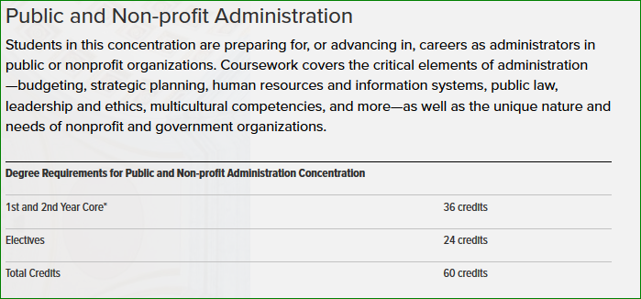

* Public Policy/\**same as above*-suggest that we clearly indicate what the ‘concentration courses’ are, for ex.:

1st and 2nd Year Core* /**ok** 36

Foundations of Public Policy/Concentration 4

Advanced Research Methods/Concentration 4

Elective 16

OR

1st and 2nd Year Core* 36

Concentration/Foundations of Public Policy 4

Concentration/Advanced Research Methods 4

Elective 16

OR

1st and 2nd Year Core * 36

Concentration courses:

Foundations of Public Policy 4

Advanced Research Methods 4

Elective 16

* Tribal Governance/Needs Edit: 4th sentence

Courses are taught in a intensive format, meeting 4 *Should be **5** weekend sessions each …(2 *Should be **3** sessions for core courses…)

**\*\*\*Need to Emphasize the Prerequisite Note:**

\***Pre-requisite Note:** Before students are allowed to register for first year core courses, they must …

*Thought:* TG cohort begins with a concentration course, so the **Note:** if anyone really takes a closer look at the statement would mean that students can attend their concentration without having to take their stats do we want to allow for that? Suggest that we amend the **Note:** to the following or veribage similar:

*\*\*\*****Suggested veribage:***

\***Pre-requisite Note:** Before students are allowed to register for Fall quarter they must complete an MPA-approved 4 credits ‘Introduction to Stattistics’ course, here’s a link: <http://www.evergreen.edu/mpa/statistics> or have communicated their plan to complete this requirement with their assistant director as soon as possible. Failure to comply to this requirement may led to either the program requesting the student be removed until the requirement has been satisfied.

* *Conflict Resolution/****Anna is Reviewing***
* *Contracts* 
  + 1st section/**ok** ?Why do we keep → (policy changed in July 2015: removed 4 credit graduate internship credit maximum) ?New students won’t know the difference?
  + Individual Learning Contracts
    - When a student’s academic program design cannot be satisfactorily…Graduate Individual Learning Contract *Add (ILC) right after ‘Contract’ below in bold we refer to ILC & INT but no mention beforehand
    - *Same paragraph* 3rd sentence: In most cases, due to limitations of faculty time, the burden of the academic design…*Change/Adjust language:

**\*\*\*Suggested verbiage:** Remove In most cases, due to limitation of faculty time, the burden of the academic design and undertaking is on the student

*Grievance (*note from Lori Johnson 01/02/2018*)*:

If resolution cannot be achieved as a result of the above, the grievance may be filed in accordance with the formal campus grievance procedures. For grievances against students, contact the Director of Student Conduct, Lori Johnson at 360-867-6296 or [studentconduct@evergreen.edu](mailto:studentconduct@evergreen.edu). For grievances against faculty or staff, contact Academic Dean [**Bill Ransom**](http://www.evergreen.edu/scripts/contact.php?sm=ransomb&sub=Email%20from%20the%20MPA%20Site&title=Contact%20Bill%20Ransom) at 360-867-6880.