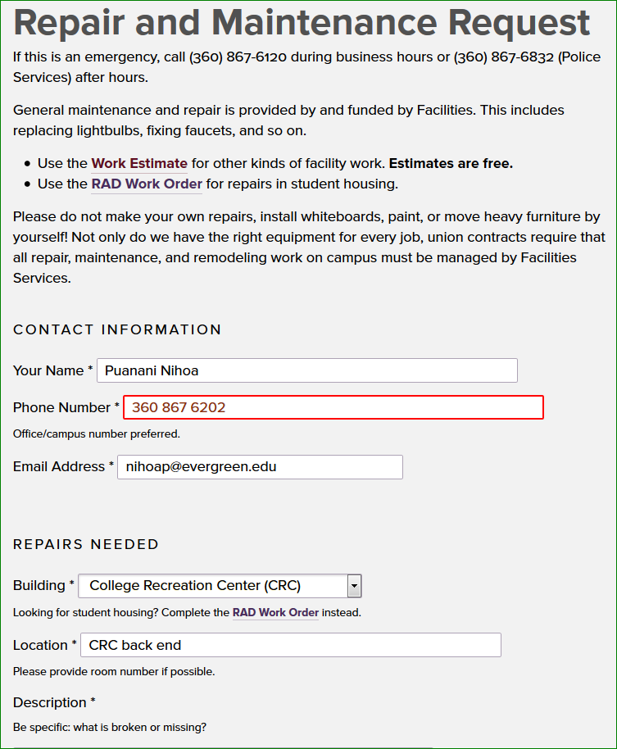

**Description:**

MPA has begun planning for our hooding ceremony. We request assistance for event set-up in the CRC back end. We will need 400 chairs total; 200 on each side separated with wide isles for special seating (theater seating style). We will need a stage 10' x 16' including stairs to access the stage, including podium at center. One additional table or two small table joined together to the far right side of the room for sound/media & staff.