

TO: Michael Zimmerman
FROM: MPA Program/Cheryl Simrell King
RE: MPA Enrollment and Resources
DATE: 2/25/2015

As evidenced in Figure 1 and 2 (attached), the MPA program has delivered consistent growth, performing beyond targets, since AY 05-06. We have successfully moved the program from one that was struggling to maintain enrollments and failing to meet target FTEs, to a program that consistently out performs targets.

Table 1 shows most the recent growth as measured by Fall headcount. It also indicates that estimated Fall headcount in 2015 will be very similar to Fall 2014 because 2014 growth rolls over into second year programs in 2015.

We have reached the limit of our growth. In fact, it could be argued that we have been beyond the capacity of our supporting environment for several years. Faculty and staff have outperformed expectations for years. People are reaching the end of their individual carrying capacity. This makes for a program that has very little resiliency.

In our AY2014-2015 review document, we used the metaphor of “perpetual whitewater” to describe program conditions. We rarely are floating on smooth water; we spend most of our time trying to keep the boats afloat in hazardous situations.

We couldn’t be more pleased that demand for our program exceeds supply. We are positively oriented toward growth – we welcome it, as indicated by our willingness to experiment with larger cohorts this year. We’d love to build new concentrations. However, while we don’t want to damage the demand situation, we have to slow down, catch our breath, and increase capacity and build resilience, before we can continue growing and expanding.

Following, we suggest:

- Returning to Fall, 2013 enrollment targets for the incoming cohorts long enough to build capacity and resiliency before considering any continued growth.
- Building capacity:
  - Hire a temporary Marketing/Communication position at .25 (job duties that were placed with Tribal Governance AD before we changed that job description).
  - Adjust the Director position to .75 administration and .25 teaching, to accommodate the growth in the job.
  - Hire at least two continuing faculty members, with expertise in the field, to increase our base from five to seven continuing faculty members. We need a minimum of seven continuing faculty members, with expertise in the field, to offer the program at Fall 2013 enrollment targets.
  - Allow enough time with sufficient faculty, and pre-2014 enrollment, to establish stability.
  - Suspend rotations through the AY2016-2017.
- We need to rethink growing, or sustaining the growth we achieved this academic year. Our experiences with this growth pilot lead us to believe that growth is not best accomplished through adding to existing cohorts. Most likely, it means adding a new cohort and/or concentration as well as other approaches.
FIGURE 1
MPA ANNUAL FTE

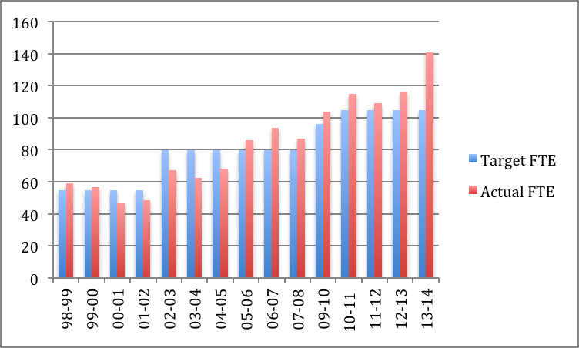
TABLE 1
RECENT FALL HEADCOUNT

 | Enrollment, Fall 2013  (Student/Faculty) | Enrollment, Fall 2014 (Student/Faculty) | Expected Enrollment, Fall 2015  (Student/Faculty)
First Year, PNAPP Cohort | 55 (18/1) | 64 (16/1) | 51 (17/1)
Second Year, PNAPP Cohort | 48 (16/1) | 51 (17/1) | 63 (16/1)
First/Second Year, TG Cohort | 20 (10/1) | 33 (16.5/1) | 30 (15/1)
Total (not counting students not enrolled in Core) | 123 | 148 | 144

