May 28, 2015

TO: Academic Deans
RE: Resource Faculty Appointment for Senator John McCoy

Deans,

I'm writing to request we appoint Senator John McCoy to a position as Resource Faculty Member, for the 2015-2016 academic year, affiliated with the MPA Program.

Senator McCoy is an elder of the Tulalip Tribe and team-taught several courses in the MPA-Tribal Governance concentration over the last two years. In addition, he has been affiliated with the MPA-Tribal Governance concentration as an involved community member and leader since it’s inception.

Senator McCoy represents the Everett, Marysville, and Tulalip communities and neighborhoods of Snohomish County. First elected to the House of Representatives in 2003, he was appointed to the Senate in November 2013. He retired from the U.S. Air Force in 1981, with extensive training in computer operations and programming. After almost two decades working in the public and private sectors he returned to the Tulalip community, was instrumental in leading the development of what is now the Quil Ceda Village Business Park, and served as General Manager of Quil Ceda Village from 2000 until his retirement in 2010.

John brings extensive experience in tribal governmental processes, intergovernmental relations, tribal administration, and tribal policy to his interactions with students. We hope to keep John in regular rotation as an adjunct in the first year Tribal Governance concentration courses, in particular the intergovernmental management course. In addition to what he brings to the classroom, we would like John to serve as a MPA Resource Faculty member as he provides unique resource support for our Tribal Governance students during their second year as they complete their research and Capstone projects.

Let me know if I can answer any questions or provide any additional information.

Best,
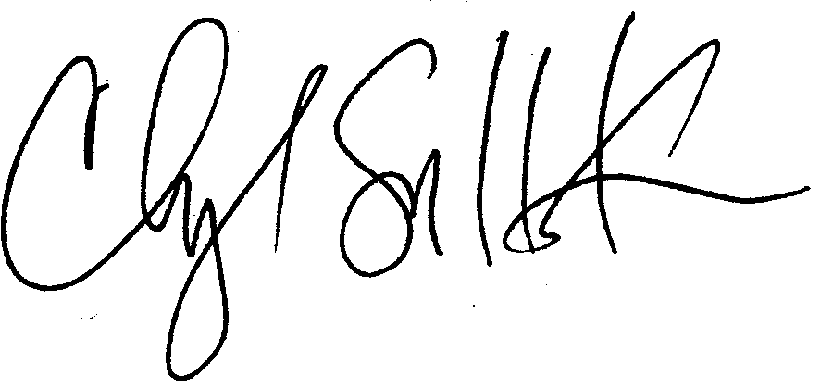
Cheryl Simrell King, PhD
MPA Program Director and Member of the Faculty

cc: Michael Zimmerman & Walter Niemiec

