dESIGN
fOR
pUBLIC
aDMINISTRATION

Short Course Overview
Intensive Weekend
April 13-15

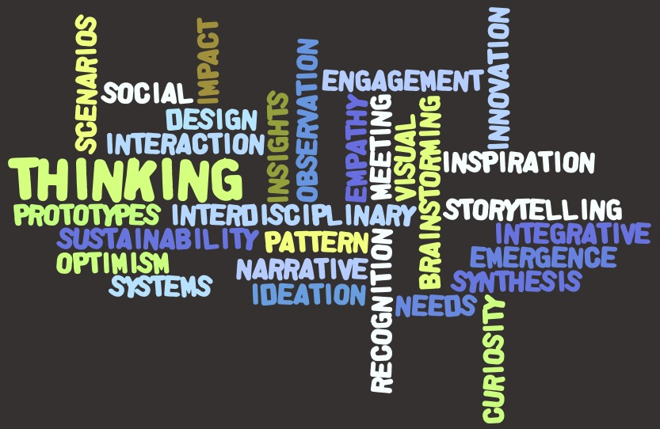
This short course examines the relatively new field of design thinking and it's application to public endeavors. This course overview gives you a glimpse at the course; a more detailed syllabus will be posted during Spring Break.

In the intensive weekend, we examine contemporary approaches to social and physical problems and challenges, often called "wicked problems," from a design thinking perspective. Design thinking uses design methodologies such as observation, prototyping, building and storytelling, and can be applied to a wide range of people and problems/challenges. It brings together people from different disciplines to effectively explore, in collaboration,human-centered ideas. It relies on our ability to be intuitive, to recognize patterns, to construct ideas that are emotionally meaningful as well as functional, and to express ourselves through means beyond words or symbols. While we'll study the theory of design thinking, the main focus of this short-course is on the application of design thinking in communities, using a case-study method. We will be looking at both design as a physical element to create/make/sustain communities as well as design as a method for social innovation and service delivery.
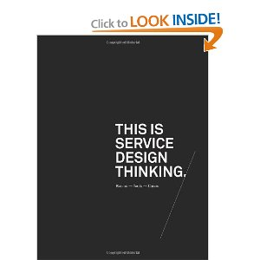
Our text is: This is Service Design Thinking. If you take the class, you'll need to read the entire book before our first Friday meeting.

Additional reading assignments will be posted on the Moodle page and will be available during Spring Break. Check out Tim Brown's, at the people at IDEO's ground-breaking work, for examples of possible additional readings.

The weekend will look something like this (all of these elements will be incorporated across the weekend - details forthcoming. The field trip will definitely be on Sunday):

- Friday - in class activities (lecture, film, workshop, guest speaker, seminar), course design project teams formed.
- Saturday - in class activities, guest speaker(s); seminar; "Ideal Design" sessions; design project team work.
- Sunday - Field Trip: Downtown Olympia: An Eye to Design.

The major assignment for the course is a team design project (applying design principles to a situation).

Questions? Contact Cheryl Simrell King (kingcs@evergreen.edu).

