**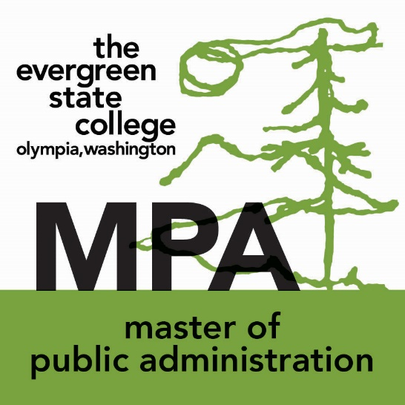****Water and Oil: Do They Mix?**

**A Community Conversation of How**

**Water and Oil Decisions Affect Economic Policy**

Public Symposium-Open to the Public

Hosted by the Masters of Public Administration (MPA) Program,

The Evergreen State College

**Location**

Saturday, May 6, 2017

Olympia Center

222 Columbia St. NW

Olympia, Washington, 98501

**Agenda**

9:00 am

Opening Remarks

**Eric S Trevan, PhD**, Member of the Faculty, The Evergreen State College

9:15am

Water Panel

**Joe Cushman**, Economic Development Director,

Nisqually Indian Tribe

**Nathaniel Jone**s, Mayor Pro Tem, City of Olympia

**Twylia Westling, MPA** Community Activist

10:30am

Break

10:45am

Oil Panel

**Malia Villegas, PhD**, Vice President of Corporate Affairs,

Afognak Native Corporation and Former Director,

Policy Research Center, National Congress of American Indians

**Larry Geri, DPA**, Member of the Faculty, The Evergreen State College

12:00pm

Closing Remarks

**Lachezar “Lucky” Anguelov, PhD**, Member of the Faculty, The Evergreen State College

MPA The Evergreen State College appreciates the generosity of the City of Olympia and the contribution of the Olympia Center