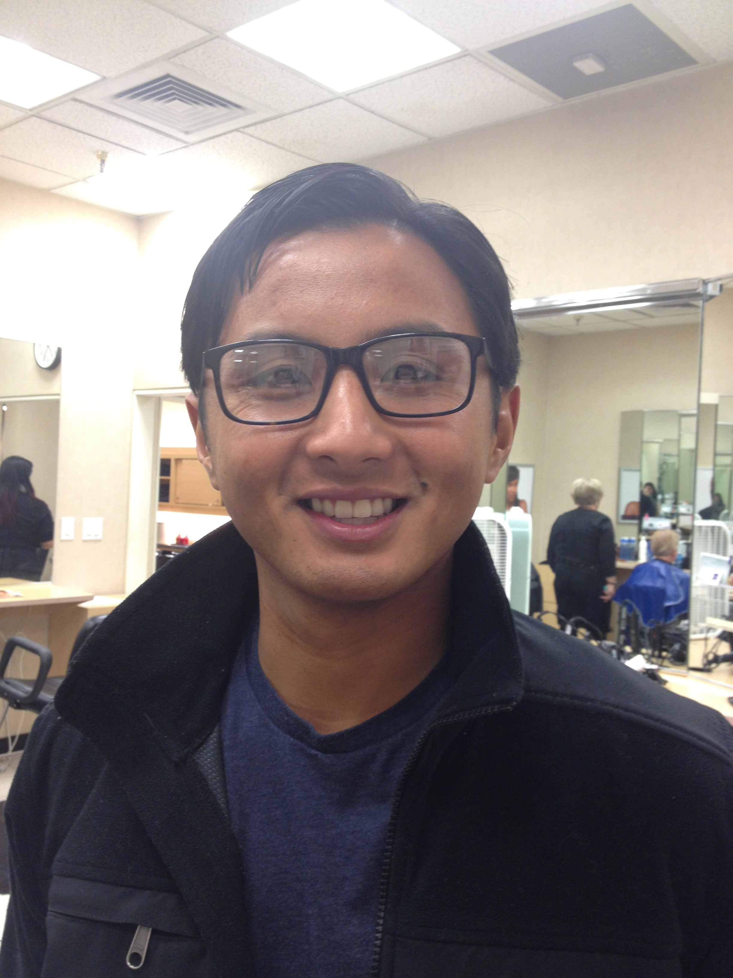

My Americorps experience gave me an opportunity to serve a community I identify with and have a deep sympathy towards. As an Americorps volunteer at Western Oregon University, I created a program to support first generation, low income and students of color as they “bridged” from high school to college. I realized that my undergraduate education alone was not enough to prepare me to have the kind of powerful impact on this community that I wanted to have. I decided to pursue a master’s degree in Public Administration at the Evergreen State College to learn the essential knowledge, skills and abilities I knew that I needed.

Because of Americorps, I found my calling in higher education. I currently work at Tacoma Community College (TCC) as an Academic Advisor serving new and continuing students. I’ve been able to pursue my MPA at Evergreen on evenings and weekends, while working at TCC. It is my intention once I complete my MPA to continue working in higher education administration. I am deeply grateful to Americorps and Tacoma Community College for the opportunity to change lives through education.